Mother’s Love
For John Number 26
By Maryanne Peters

There was always just the two of us, my mother and me. My father had left years before. She hated him and I think that she hated all men. She certainly did not want me ever to be one.

And she loved feminine things. Our house was a monument to feminine things. Every room was a boudoir. It was what I grew up with.

I had always been Amanda at home. She said the name meant that I was beloved, as only a daughter can be. That was who I was, for just about as long as I can remember, I was Amanda.

Sometimes I think that the cruelest thing was that she let me go to school as a boy. If she had raised me as a girl maybe I would never have known what life as a boy was like. But she seemed happy to let me live another life as a male child, right up until I ceased to be a child, or I started to become truly male, which really is the same thing.

From her point of view, puberty had to be stopped. I had to get off the male train before it entered the tunnel. But I had spent all those years on that track, and now I was neither one thing nor the other.

This was the toughest time of my life. To be honest, I was not sure how I would cope. The boys that I thought were my friends tormented me. Despite my protests that I was still me, that was the problem. They were changing into men and I was not. In fact, thanks to my mother, I was taking more of Amanda to school.

But through all of those tough times, there was one sure thing – a mother’s love. They say a mother’s love is the one certainty in life. In tough times you can rely on your mother.

So, what did my mother do? She had my testicles removed.

After the three toughest years of my life, agreeing that I was transgendered seemed like the answer. I mean, I had long blonde hair, no balls, and after 3 years on hormones I had a female figure including large full breasts. I had been wearing gender neutral clothes at school, but at home I wore the girliest of outfits that my mother had selected for me. Even if I had not lied to the psychologist I would have been diagnosed as being transgendered.

And with that diagnosis I was ready for the final cut.

Frankly, it seemed like such a small thing at that point. At the age of 16 I had already gone past the point of ever hoping to be a man, or a normal one anyway. At best I could have my breasts removed and have fake testicles inserted and consume vast quantities of testosterone in the hope that I might function as a man. But there were other things that had happened.

First of all, I had learned to like the way I looked. I was way prettier than 90% of the girls at school, and everybody knew it. Since I had started wearing more feminine clothes, and makeup, and things in my hair, I had turned from being a sissy into being a trans girl. Not everyone was accepting, but most were. And everybody knew that trans girls would one day become fully functioning girls.

Then there were guys. I had discovered boys, and those boys had discovered that one day I would be just like any other girl, except for the fact that I could not get pregnant.

One boy in particular, but I won’t name him. He wants to be with me, but he wants to move away with me after I have had my operation. He wants us to live some place where nobody knows who or what I once was. He wants me to move away from my mother.

It is like I said: There was always just the two of us, my mother and me. A mother’s love is the one certainty in life. She will be upset when I tell her, but I hope than when she is alone, she will forgive me for leaving her, just as I have forgiven her for what she has done to me.

The End

© Maryanne Peters 2019

New Feelings
A Story for John - Number 27
By Maryanne Peters

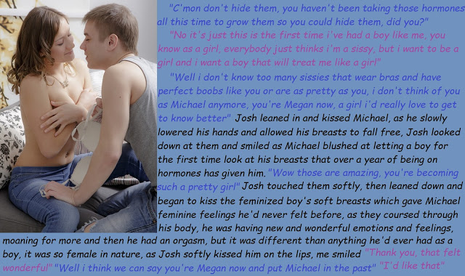

Mom said that I was not a real boy, but I did not want to believe her. I always thought that I was just the same as any boy my age, but she knew better. My father treated me like a boy, and he did not approve of the things that she said to me. But in the end, he didn’t hang around.

“You’re a sissy boy,” my mother said. “But don’t think that is anything to be ashamed of. Some boys are just too soft and sweet to be real boys. Some boys are sissies and will never become men. And who would want to be a man? A rough skinned, hard boned and bristly-faced man? Who would want to be that when you can be a sissy?”

I did. I wanted to be a man. That is what I thought then. I had pictures of men on the walls of my room. Sports stars and rock stars – real men.

“One day you could have a man like that, if you were a girl,” my mother said. “You are never going to be like them, but they could like you.”

She really did not give me a choice. I did not know what it was, but she had me on hormones from a early age so I would never develop as male. I was already soft, I know that, but I just got softer and softer.

I did my best to stay invisible. It is the best way to avoid being bullied. I stayed under cover. I grew my hair longer, not to pretend to be a girl but to hide under it. But my mother said that it was useful as well. It made it easy for me to pretend to be a girl when I was just with her.

I don’t mean that I dressed like a girl. I always wore jeans and a loose fitting top to hide my flabby body, but when we were away from my neighborhood my mother could change my sex just by putting a pink barette in my hair. It was weird – one second a long haired boy, then the next second a tomboy girl. Just one piece of colored plastic.

“You need to be a sissy girl now,” she said. “We should get you a bra and put some curls in your hair.”

I needed to have a bra. There came a point when my breasts would bounce around so much that I needed some way to hold them. But still, I hid them from everybody.

Then one day my mother and I were miles across town visiting a friend of my mother. They had been discussing what a tomboy I was and this lady had but a few curls in my hair despite my protest. We were walking out to our car and then I saw Josh, a guy from my school walking along the sidewalk, with his thumb out hitching a ride. He saw me, and I turned my head away in horror.

“Is that you Michael?” he said. I just turned away. I was so embarrassed.

Then my mother really drops me in it. She says: “Megan, or should I say Michael, say hello to you friend and then introduce us.” There is a cruel smile on her face.

No longer invisible. What do I do? I just kept my head down and mumbled: “This is Josh, Mom, and this is my mother, Josh.”

“So, you dress as a girl outside school?” he asked.

“I am not dressed as a girl,” I said, raising my head and addressing him directly. “These are not girls’ clothes.”

“Your hair looks nice,” said Josh.

“Josh, do you need a lift home?” asks Mom. She seems determined to ruin my life.

He sat in the back of our car, but he talked mainly to my mother – charming her as is his style. He is a big brute of a guy that Josh, but he knows how to charm grown-ups.

“Take that top off, Darling” says my mother. “It very hot in the car and we have a drive ahead of us.” She and Josh are in short sleeves because it is warm, but under my big loose sweater I was wearing my bra with just a tank top over. Curls in my hair and a girly chest. But what the hell? It was hot and I was already destroyed.

Josh’s eyes just about popped out of his head.

He said that he was happy to get out at our place as his house was further on. But he asked if he could use our bathroom. It was just so he could get a closer look at my tits.

“Just don’t tell anybody, and I will let you look at them,” I said.

“I promise,” he said. His eyes were as wide as dinner plates. “They’re so big. How is that possible.”

“I have been on hormones for well over a year,” I explained. My mother had come clean month’s before. Even if I avoided the doses in my food, I could not have changed what was sitting on my chest.

“There are beautiful,” he said. “Will you let me touch them?”

I was going to say no. I was going to say more than that. I was going to get angry. He could have pulled my hands away. He must have know that I was as weak as a kitten. What he did was he kissed me on the lips – as if I was a girl.

I dropped my hands and my breasts bounced down. But he was not looking at them – not straight away – he was looking at me.
“Megan,” he said. “Is that your name?”

It wasn’t my name. It was what my mother called me sometimes to make her point – the point being that I am a sissy. But I said: “Yes, I am Megan.”

I realized that my mother was right all along. I am not going to be a man. I just needed a man like Josh to show me that.

The End

© Maryanne Peters 2019

Finding Herself
A Story for John - Number 28
By Maryanne Peters

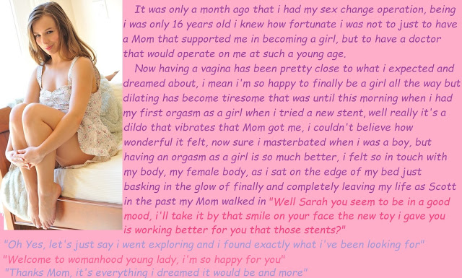

I am not talking about the toy. I appreciate what Mom was doing in giving it to me, and it was certainly better than the surgical stents, but the smile that I am talking about can only come from the real thing. It is like I said – I went exploring, and there is only so much internal exploring that a girl can do. So, I found myself a real live thing, attached to a boy who likes to use it. But I am still too young in the State of Virginia, so I need to keep Howie a secret.

The weird thing is that I was not even sure if I would be attracted to boys. My need to be female was nothing about sex. I arose before I even knew what sex was. I knew that I was different. Mom understood. Mothers do these days.

But I was only interested in girls. I mean that I was interested in being with girls. I liked everything about them, but probably because I ached so much to be one. Now I am.

Boys can be pigs. All the girls at school were at least understanding, and many were fully supportive. But a lot of boys gave me a hard time. I won’t refer to the names they used. We all know them. Although the more feminine and the prettier I became, the less appropriate they seemed. But it is always boys who were attacking me.

Why would I ever think of being with a boy?

Well, let me tell you about Howie.

I never feel more like a girl than I feel when Howie has his big strong arm around me. He makes me feel small and weak because he is so big and strong. He is not the best looking guy, but he looks like a guy, and that makes me look more like a girl – his girl.

He is strong. He likes to pick me up when he hugs me. I am soft and weak, because I am a girl.

But most of all, he has a penis to put inside me. A huge solid rod of flesh – hot and pulsating. Everytime I bring him to erection I know that this is my purpose. I excite him, the way a woman excites a man, the way that all women have since the dawn of time. My purpose as a woman is to bring a man to this state and then have him fill me with his seed. Even if his seed stops there, I am a woman for taking it inside me.

Forget plastic. There is nothing like hot flesh. There is nothing like skin on skin. As I say to him: “I can’t get pregnant. I want to feel you. I want you to feel me.”

When he says: “Baby, Baby, I am coming, oh sweet Jesus, oh God, oh God.” Then that is where we both are – in heaven.

“Thanks Mom, it’s everything I dreamed it would be and more.”

The End

Blended Family  A Story for John Number 29  By Maryanne Peters  I know the rules. You are not supposed to fall in love with your stepsister, especially when you live together, and you have lived together for years. But you don’t understand. I didn’t live with a stepsister. Until quite recently I had a stepbrother, Matt.  Then everything changed. Matt became Mandy and I fell in love. | 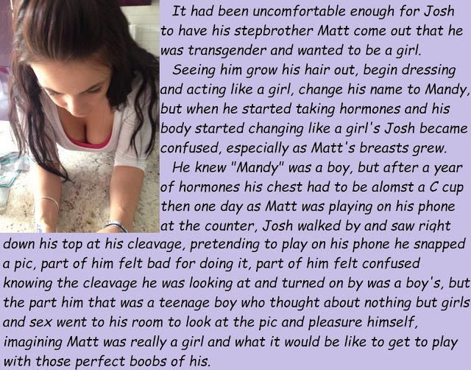

My mother left home when I was only 12, and never came back. I spoke to her only a few times a year and visited her only once. She had a new life, and so did I. My father was lucky to meet Mandy’s mother Julia, who really did make him a better person. We all saw it – my older brother and I in particular.

And with her she brought Matt to live with us.

I guess that I always thought that Matt was just quiet. We included him in our activities and he was grateful that we did, but we never felt that he was really engaged in the boy things we did. We had no idea of the internal turmoil going on. He was fighting his feelings. He did not want to be transgender, but it was only a matter of time before he needed to face up to reality.

Julia and my father knew before we did. I guess Dad wanted to make sure before there was any family announcement, but when it came, I was shocked.

“There are going to be some changes in this family,” he said. “You boys are going to have a sister.”

So, we both looked at Julia, assuming that she was pregnant. That would be a surprise, but not as big as the surprise that followed.

“Matt will be Matt no longer. He will be transitioning to living as a girl. You new sister Mandy. And that is the last time any of us will ever refer to her as he or him. Is that understood?”

Matt just sat there looking like Matt, except somehow a little more at ease, as if a huge weight had been taken off his back.

“Sorry guys,” he said, because to us he still was. “You might get some shit at school over this, but this is who I am. I have never been a boy. I just cannot live as if I am anymore.”

My brother and I looked at one another. I guess I was waiting for somebody to say that this was a huge practical joke, but Julia had tears in her eyes and my father looked as serious as a heart attack. This was real.

“Ok,” I said. My brother nodded. To show support we both gave Matt a hug. It was the last time. The following day, Mandy would be living in our house.

She made her appearance at breakfast. Her hair was not long then, but it had been combed in a feminine style with a side parting and a floral clip, and her eyebrows had been shaped. She was wearing a colorful top and jeans. Julia made a point of giving her some pills in front of us which she then swallowed with her orange juice. This would be the stuff that would work the miraculous changes on her body, although those changes were months away.

Mandy was right. We did get some shit at school. We were the guys with “the faggotty brother”. We stood up for her. That is what brothers do. We had always been good brothers to Matt and the was not going to change for Mandy. We got into some trouble, but the principal accepted that what we had done we had done “for honorable reasons”.

Mandy was grateful, but she said that she was ready to take her share of whatever came. She did not want us to suffer for what she was doing. She said: “So long as you understand, there is no choice for me. I have to do this. I am female. I just have a physical abnormality.”

When she put it like that, it made it easier to understand with every day that passed. With every day it seemed harder to believe that she even had that abnormality.

She grew her hair out, long and dark. It really was the most beautiful hair, and she knew it. She washed it and brushed it. It always looked great. My first fantasy about her was about that hair. Even when it was only shoulder length, she pulled on a jumper in front of me and then used both hands to flick it out. I was standing right behind her – close enough to smell the shampoo scent. My dick stiffened in my pants.

I told myself that it was because I had not been looking at her face. I told myself that it was not my stepsister that I was thinking about when I jacked off in the shower, but it was.

Then the breasts appeared. When they first did, they were like two perky little cones that stuck out under her tee-shirt. That was before her first bra. I just want to squeeze those little tits, and roll the soft nipples until thy were as hard as bullets.

Then they grew like crazy – bigger and bigger, blowing out of successive bras seemingly every day.

She would sit down to breakfast and say: “Mom, I need to get a new bra, next size up”. She would cup them and push them around, right in front of me.

She was so proud of those tits, she would wear any outfit that showed them off. She could not help but check them from time to time, but when she did, I thought that I might go crazy. If I did, it would be to tear off her clothes and stick my face right between those puppies.

I know that these kinds of thoughts are wrong, even if she was not my stepsister. But this kind of desire is so strong.

I read up about incest. It is called “pseudo-incest” in the case of step siblings, and it usually only arise soon after the family comes together. Once all the kids in a household are living together as brothers and sisters, the family instincts take over the sexual ones. Matt and I had been brothers for ages. But that is the problem. Matt is gone. Mandy is new.

Is it love? It sure feels like it to me. Honestly, she is the most beautiful thing in the whole world. I cannot stop thinking about her.  I cannot tell my parents how I feel. I cannot tell anyone. It is burning me up.  And then her she is, having danced down the stairs dressed in Matt’s old jean jacket, with some soft curls in that long brown hair.  “Hey Bro, do you want to go down to the park for a game of putt putt?”  What I want to do is to make love to her. That is what I want.  Life can be so confusing, don’t you think?  The End | 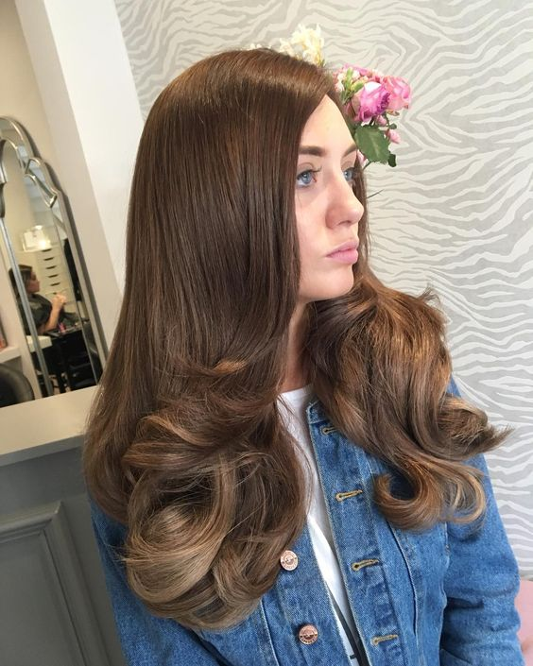

Josh’s Girl
A Story for John Number 30
By Maryanne Peters

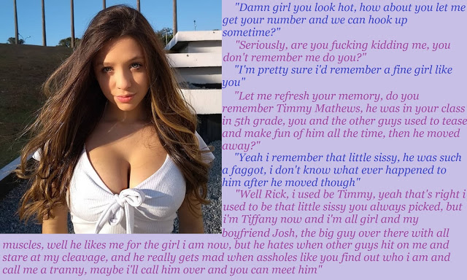

That is the way it happened. I wasn’t looking for trouble, it was just that the transformation was so unbelievable. Timmy was a sissy sure, but not so much smaller than me. No so girly looking, just a softy. Then to meet Tiffany, looking like that, with those tits and that hair … well, in my surprise, I may have said some stuff, even with Josh standing not so far away.

She called Josh over and I knew that I was in trouble. But there were people around. He was not going to do anything to me right there. And when I realized that, I didn’t make it any easier for myself.

“Whatever my girl was before, she could not have been as bigger a sissy as you are right now,” he said. “But I am going to deal with you later. I wouldn’t want Tiff or these other folks to see somebody like you in pain. It’s not going to be nice.”

I should have left town. Like I said, I wasn’t looking for trouble, but I found it.

He must have been stewing over it for a full 24 hours, or maybe he was just leaving me in painful suspense, because it was not until the following day when he found me. He must have followed me until I walked into a spot where we could not be seen. I cannot even remember where that was. He didn’t hit me – he just grabbed me and put a huge arm around my neck until I passed out.

The next thing I knew I woke up in a windowless basement room tied to a gurney and in all kinds of pain.

There was a shunt in my arm and a bag for an intravenous drip beside me, but what was totally unmissable was that my chest had two huge mounds on it swathed in bandages. I could not sit up to look beyond this mountain range to my groin, but there was pain down there too. What had happened to me?

The pain in my face was minor in comparison, but I felt like I had been in a boxing ring with a heavyweight. There were bandages wrapped around my head completely.

Where was I? Could I be heard? As I cleared my throat, I felt pain there too. I called out. Just the word “Help”. But it was not my voice. Just a squeaking sound like an angry mouse.

It was enough to draw some attention, because the door opened and in walked Tiffany.

“I’m sorry Rick,” she said. “This was not my doing. Josh has gone too far. He bullied my surgeon into fixing you too. Not everything, the way I wanted it, but enough to be permanent.”

I opened my mouth, but she put a hand to it.

“Don’t talk, Rick,” she said. “You might do permanent damage to your voice. I will get you some water to sip on. I can release these straps, but you must promise me that you will not try to run. Josh knows that he is in trouble for what he has done. If you try to go to the police he will kill you, that is certain. Why did you have to be so mean to me, Rick? Why did you have to say those things? Look at what it has led to.”

My lips moved, as if I was a fish out of water, flapping on the bottom of the boat, doomed to die.

“You need to do as I say,” said Tiffany. “If you can convince him that you accept what he has done to you as fair punishment, then you can get away from here.”

She must have seen the look of disbelief on my face. Accept this? Whatever it was, it was monstrous. Would he really let me free having done this? Ever?

She undid the straps. I was going to pull out the shunt, but she stopped me.

“Careful,” she said. “There is anticoagulant in this, together with loads of female hormones. I don’t want you bleeding out. We need to do it properly. The surgeon is coming back tomorrow to check me over. You need to wait.”

For the first time I noticed that she had bandages too – in her groin. I stared at them.

“Yes, I am all done,” she said. “I have the operation that I always wanted. Josh has paid for everything, although I think he might be a little sad to see my little pee pee gone for good. Anyway, I will get you some food and you can wait until tomorrow. There is no way out anyway, for either of us. No while we are both in recovery.

The horror of it began to make me shake uncontrollably. I started to cry.

“It’s the hormones,” she said. “Let the tears come. It is what we girls do.”

She brought me food, but I barely ate. I was left alone. I could hear movement around the floor above me. I doubted that I could sleep but I felt exhausted and I passed out.

I was still not sure what had been done to me, but I knew that my life had changed forever. It seemed so wrong that a few nasty words could carry so great a penalty. What kind of man was this Jason? So I upset his trans girlfriend? It was wrong, but not worthy of this.

I had time to think. Too much time. I went through all the phases of grief and anger. Several times over. I had no idea what the time was, but it seemed that most of the day was over by the time that the surgeon arrived to visit me.

He came alone. The door was unlocked for him and he walked in. I could see him check the room for cameras.

He came close to me and whispered in my ear: “Have you been told not to talk? Not for another few days. Then your voice-box will have healed. I am going to check on the facial work, the breast implants and the orchidectomy, but first I want you to know that I had no choice. It is my family, you see. They mean everything to me. What I have done is in breach of every principle that I stand for. I am truly sorry for what has happened to you, but I am not responsible. Please believe me. I had no other option.”

I glared at him. I think that he realized that forgiveness was not an option for me.

Stupidly, I did not even know what an orchidectomy was, but I could guess. It became clear when I was able to sit up and see my lower body. It had been stripped of all hair and all that remained in my groin was a slack penis and an empty scrotum, with ugly black stitches down the seam.

The breast implants were huge, but he said that the line of stitches under them was small and healing well.

“I have a post-surgical bra for you to wear,” he said. “They need support. The skin is overstretched at the moment, but with some time and all the hormones in your system, the skin will soften and they will be jut like Tiffany’s. Some of my best work.”

He unwrapped my head, and started to poke and pull the skin.

“I have done some work here that will give you an unmistakably feminine face,” he said. “In have ground back the brow, brought forward the scalp, reduced the chin and nose, and plumped the lips. You are going to be very pretty. And you will have plenty of hair which you can grow out just like Tiffany. Don’t tell her, but I think that you are going to be even prettier than she is.”

The thought horrified me.

And if I though that my shock was at a limit, then Josh entered the room.

“Well Doc,” he boomed. “Still a lot of bruising on that face, but I think she has potential, my new Rebecca.”

“She will heal naturally over the next few weeks,” said the physician. “I will take this drip out before I go. There are slow release implants of all the hormones that she will need for a many months, so now we are done, you and I?”

“Do it and leave,” commanded Josh.

The shunt came out and a dressing was applied to my arm. The surgeon left.

I just stared at him. I still had no voice, but even if I did, what could I say to him. He smiled. It was a smile that felt like a knife in my guts.

“I am liking what I see downstairs,” he said, pointing at my groin. “You see, I love my Tiffany. I think you must know now just how much I do. But I have my preferences when it comes to sex. She has always wanted to be a complete woman. When it comes to fucking I like my women to be not so complete. I want to marry Tiffany, but that doesn’t mean that I can’t have something on the side to meet my own special needs. So, congratulations. She has some healing to get done, but your passage is available now. So roll over Honey. From now on, you are going to be Josh’s girl.”

The End

© Maryanne Peters 2019

