Letting Her Out  Based on a Captioned Image by Latanya  By Maryanne Peters  Your problem is that you never believed that these “self-hypnosis” sites could work. You said that it was contrary to science, which is just the kind of thing a scientist would say. How wrong you turned out to be!  They told you that it was supposed to be just about creating hallucinations of a transformation, but clearly it unlocked something deep inside of you, something that wanted to reject your life of dry academia and find a simpler and happier life. Well, you seem to have succeeded there!  Is was one thing to grow your hair out and wear colorful clothes. The scientific community is tolerant of odd behavior and homosexuality, but with the hormones … well, and then the implants! What were you thinking? Now look at you. You spend more time at the dressing table than you do at the lab. |  |  | 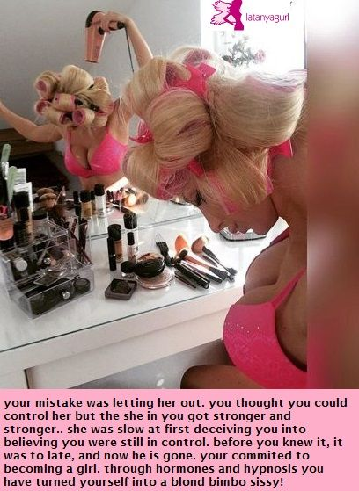
I knew that it was all over when you responded to the invitation to the scientific seminar last month, by turning up in that skin tight and busty pink dress with the jeweled choker. What were you thinking? Oh, I forgot – you stopped thinking months ago.

And when that German guy approached you, (you know, the world’s foremost authority on your area of study) and he asked you disbelievingly: “Are you Doctor Pettifer?” and you said: “Call me Fanny”, and jiggled your tits …, well, then I knew that there was no going back. The brains were gone for good, and other organs were in control.

The End

© Maryanne Peters 2019

Habit Influence (HI)
Based on a Captioned Image
By Maryanne Peters

“We need to reassess this whole feminiszation thing,” said the director. “You two are clearly in disagreement, so tell me what you think.”

“I am not againtst Habit Influence as a tool,” said Edwin Hansen. “I am simply opposed to it on on a human rights basis. Is this cruel or unusual punishment? I am sure it will be said that it is maybe not cruel, but it is unusual, and it becoming increasingly obvious that its effects are permanent.”

“Oh come on,” said Marvin Matthews. “Rehabilitation is designed to have permanent effects. If it didn’t then it would not be rehabilitation. This is not punishment so much as rehabilitation.”

“If it’s forced - it’s a punishment,” said Edwin.

“They take the medcation voluntarily. We’re not forcing it down their throats”.

“It is take the medicine, or go back into the prison system. Hardly voluntary.”

“Just like any other rehabilitation program. That is what HI is”.

“And what about the evidence of mental retardation?”

There is no physical evidence of loss of intelligence or cognitive,” insisted Marvin with a stern expression. “Unless you are suggesting that women are intellectually inferior to men? It is just that these subjects have shifted their focus. They have found a new path to advancement. It is one that does not involve violence or argument. That is why HI has been so successful. Those impulses are gone. Instead our subjects are taught to persuade through suggestive behavior and the granting of small favors. That is what you are seeing. After HI schooling they shift from anti-social behavior to a attempting to achieve their objectives through polite, if somewhat unsophisicated, persuasion.”

“You mean flirting and lewd suggestive signals. And what about that subject that I interviewed yesterday? She told me that she was given sedatives and some sort of subliminal messages while she slept. She said that your people had reduced her intelligence and removed her testicles.”

“If you are talking about Muffy, then she suffered from insomnia so she chose sedatives. We did not force it on her. As for the idea of mind manipulation, of course we encourage non-violent movies such as romantic comedies, and calming music. That is part of the process. We only allow castration on request. Muffy was dead keen, I can tell you. She wants the whole deal in due course, but we don’t fund that. She needs to get herself a sponsor for that.”

“I tell you, I gave her a book to read and she could hardly read a word of it to me.” Edwin was addressing his comments to the director.

“She was never a great reader, but she has things on her mind,” said Marvin. “She is looking for a sponsor at the moment, so she is actively seeking to use her charms to get one. I hope you didn’t fall for her newly acquired charms.”

Edwin Hansen had nothing to say. He was just remembering how good it was to be deep inside Muffy’s sweet ass, and how much better it might be to fuck the new pussy he had booked her in to get.

The End

The Firm  Based on a Captioned Image  By Maryanne Peters  Barbara and I work for Lowell Harbison and Greaves, a firm that offers specialized training services. Barbara works for Mr. Lowell, and I work for Mr. Harbison, and Sally Greaves does not need a secretary. She is just like us. A special kind of girl.  She got the whole thing started. Sally really is very clever. So much smarter than me and Barb. | 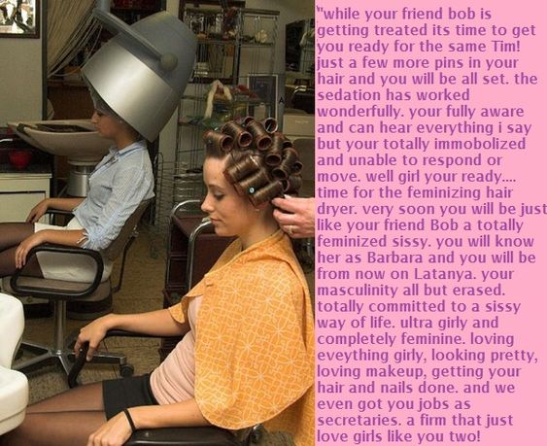

Harbison and Greaves do all kinds of training, but Sally specializes in retraining office staff to become secretaries. It might sound sexist, but most secretaries are women. Believe it or not, most executives prefer that their secretaries be female. You just have to meet the market demand – that’s what Sally says.

Lots of young men have the typing skills to do the job, and they can be tidy and organized, so that is not confined to the female gender. But nobody is hiring, or in the case of Barb and me, they hire on the condition that we submit for retaining in “additional secretarial skills”.

It turns out that these are skills relating to character that are best acquired in subliminally. That meant some initial time in the sensory deprivation tank and listening to loops of recorded suggestive chat, and more while we had our hair done.

I cannot remember when I started feeling this way, but I simply adore having my hair done. I want to grow it out so that I can do so much more with it. I don’t think that I have ever looked prettier. I like the professional makeup jobs I get at the salon, but I am also really good at doing my own. It seems as if I have only recently learned how, but I know now that a good look requires constant attention. I need to keep a mirror on my desk, a compact in my purse and go to the ladies’ room regularly to touch up my face and primp my curls.

Sally says that it is all serving to make me a truly great secretary. Certainly Mr. Harbison thinks so. He has taken to buying me little gifts to show his appreciation. Recently he bought a little pink thing to go on my penis to stop it from getting big and ugly. He likes it to be just a little tassel that he can flick with his finger when I am sitting on his knee.

Barb is getting similar treatment from Mr. Lowell. We are so lucky to work for such a great firm.

Partnered  Based on a Captioned Image  By Maryanne Peters  I suppose that we were never truly equal partners in our photo image business. Michael was always the dominant one.  He always used to tease me about not being good with women. He said it was a common failing with white men.  “White women are so pretty, white men don’t deserve to have them” he would say. “Men like me a what a white girl needs.”  Maybe I should have stood up on behalf of all white males to argue the point with him, but maybe he is right. | 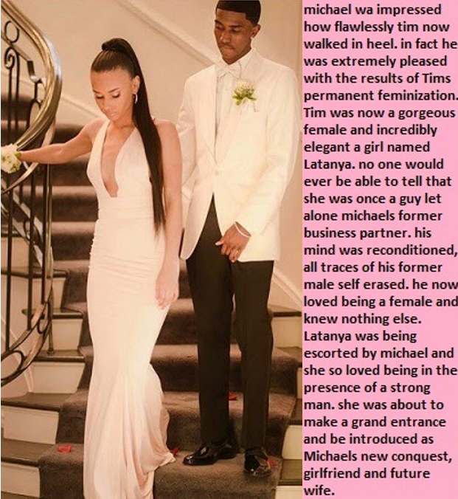

“You’d make a good chick,” he told me one day. “With that floppy hair of yours and those green eyes and that cute little nose. You just need a pair of tits and a man to look after you.”

I waved him away. I had work to do. But soon after I started using our software to play around with an image of myself. We had been one of the first to develop an app that could show a feminized image of any guy, and I was curious to see what Michael was talking about.

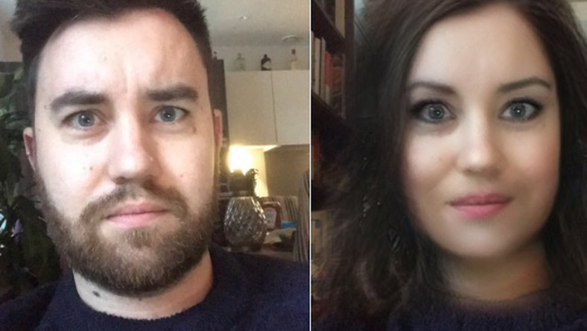 | Maybe he was right? It seemed like I could be really pretty. How good was our program? Could I look like the person in the image?  Michael too one look at it when I showed and he seemed to break out in sweats.  “That’s the kind of white chick I am talking about,” he said. “You be her and you’ll be mine.

That is not why I did it. At least that is what I told myself. I just wanted to see how close I could get.

I showed the image to the girls on the same block as our studio office,and they told me what they thought.

“You can have off the beard and shape the eyebrows, and we can pull out that man bun and style your hair, but the softness in the face comes from female hormones. You wouldn’t want to take those. If you take them long enough you will grow boobs.”

“How long would I need to use them just to soften my face?” I asked. But they were no experts. Even if I wanted to try them I would need a prescription, and the only guys who get prescriptions for female hormones are transgendered. If I wanted to see an expert and collect the pills I would need to pose as a transgendered person. So that is exactly what I did.

It started out like that, but I am not going to suggest that it did not change to something else. Clearly when I started to wear dresses to work this thing ahd got to a whole new level. I can say that it was because summer had come around and dresses are just so comfortable on a hot day. But no, that was not it. I guess that it was Michael.

I said that he was the dominant one, and that is still true, but now there is nothing that he will not do for me. There came a point, maybe not so very far down the track of my transition, when Michael strated to treat me like a lady, and that felt good

And when you get treated like a lady, well, a lady has to treat her man like a man. The truth is that Michael is African-big, but size does matter, and when he is full length inside my ass, there is nothing better. When he is spewing hot cream inside me, I am happily squirting whatever I have left in me. Surely it will run out soon.

Now I have the ring that will make sure that we will soon be partners in every sense of the word.

The End

Downside
Based on a Captioned Image
By Maryanne Peters

She told me later that she had always seen the woman in me. I suppose I should have felt insulted, but by then it was too late. I was so feminized I knew that I would never be going back.

Beauty was her life, you see. She had her own salon downtown and she had a chair in the basement with some of her older equipment. There was not a day that went by that she was not busy beautifying somebody. Those fingers could just never stop.

It seems obvious that she would start on me too, eventually.

It started with her asking me to grow my hair. I have a very full mop of hair, and she was able to use treatments to promote its growth. She said that if she was to style it, it would be returned to a male style in time for me to go to work in the morning.

The same with makeup. She “shaped” my eyebrows in a way that they could be back brushed to look masculine, then smoothed across to look feminine. The idea was that I could function as a man at work, and at all other times I could be her own private plaything. I thought that was love, and in a way it is. I was devoted to my wife and my wife was devoted to me in a way that few husbands can claim.

But functioning as a man became more difficult as she “corrected” my behavior. She said that looking the way I did, male mannerisms were just plain wrong. And she was right. There is a way to walk in heels and a dress. There is a movement to check your hair is in place, or carry your handbag.

The downside is that I can no longer perform sex as a male.

She is too busy for sex, but I’m not. I have met my Ken. No – I mean it: His name is Ken. Ken and Barbie.

The End

© Maryanne Peters 2020

