Bond Girl
A Short Story
By Maryanne Peters

“This is typical of your father,” my girlfriend Lina protested. “He is such a chauvinist. James Bond is the very worst kind of man. An abuser and manipulator of women. He treats women as something to be used as a shield, and then cast aside as dead meat – literally. And then your father throws a Bond-themed party.”

“Well, you know my father must be the biggest fan of James Bond in the world,” I sighed. “And the truth of it is, I have to go. I work for my father, and all the big clients will be there. And like it or not, you are coming with me.”

“On one condition,” she said. “I choose your costume.”

“Can I choose yours?” I asked her.

“If you like, but I was thinking that Famke Janssen Xenia character. You know, the one who almost crushes him between her thighs.”

“Xenia Onatopp,” I said. I know them all. I was bought up with them. I meant what I told her. My father must be the world’s biggest Bond fanatic. “I am good with that. So, I guess I am either James Bond or Alec Trevelyan, the villain in that move: Goldeneye. Either would be good.”

“I choose, remember?” she said. “Do you agree or not?”

“I agree,” I shrugged. I did not want to go to this party without her.

“With the right costume you can send a message to your father. A message that you disapprove of this kind of misogynistic bullshit. That you are not that kind of person - the macho fuckheads that he surrounds himself with.”

I was starting to get a little worried. I was starting to think that maybe it was not a great idea to have her come to the party at all. I just said: “So I’m not going to be a character from Goldeneye?”

“Another kick ass character, but not from that move,” she said. “An earlier one – Goldfinger, I think. You are going as Pussy Galore”.

“Babe. Maybe you don’t know your Bond Movies, but you can’t tell me that don’t know that’s a chick?”

“She wears pants, right? She’s a lesbian, isn’t she? Perfect to be going with Xenia Onatopp.”

“She starts as a lesbian and a villain,” I pointed out. “But then, with a bit of old-fashioned sex, Bond cures her of both.”

“Very unlikely,” she sneered. “But the real Bond won’t be there to turn you.”

“You’re serious?”

“More than you know,” she said. “I am talking a real makeover. We are going to make good use of all that hair you have. If I am going to a party with a lesbian, I want her to be a good-looking one.”

My hair was long. My father hated it, even though I tied it back when I wore a suit. I guess I wore it like that to piss him off. It was my only real protest. Apart from that I was dependent on him and his business - a large financial advisory firm. I had work that I could do, but it was clear that my father did not regard me as his successor.

What my girlfriend did not know was that I had dabbled a little in cross-dressing. Some evenings on my own I would wash my hair and style it in a feminine way, and wear a peignoir set around my apartment. It was just a little bit of occasional titillation. I could jack off, and sleep it a nightie, and then in the morning I would add product to slick back my hair and become me again.

I only did it in moments of stress. I would tell Lina that I needed time alone. It was when I needed to get out of my body and be somebody else for a night. She never knew. I told her that I kept my legs shaved for cycling, which was my other release – long excursions out of the city when I could be alone with my thoughts.

“There is no way that I am going to go to a business function in drag,” I said. But secretly the idea appealed to me. I would protest, but hopefully she would persevere with the idea. I was hoping that she would.

“It’s a costume party,” she said. “It’s just a costume. Just think how your father will react.”

She knew how I felt about him. I liked to push his buttons every now and again. But he was my bread and butter. Push but not too hard.

“I guess that Bond girls are more interesting than the villains,” I said. “And Dad will be going as M or Q. And almost every guy will be going as Bond himself. He is suggesting that people should go all out to make it a great show. A real makeover you say?”

“Not just that,” she said. “We have weeks until the party, and the makeover will be last minute, but first you need to use the time we have to learn how to present yourself as a woman. That means learning to walk in heels and move like a woman and effecting a feminine voice. That should be easy given that Pussy Galore had that husky tone.”

Clearly, she had been considering this since I told her about the party. She seemed to have a plan, and from that day on she was to put it into effect.

She had an outfit picked out. “It seems a pity given that you have smooth legs, but Pussy only wears pants. There is the navy pant suit, and the riding outfits with the brown suede jacket, but I am going for the white pantsuit with the gold button vest under it, so you are going to need good breasts.”

“That could be a problem,” I suggested. But she had the answer. Stick on breast forms concealed with makeup, which would be part of the final makeover.

Until then, I had to follow her instructions, and a strict regimen of exercises in feminine deportment.

When she finally let me have an evening alone, I washed my hair and dressed up, but I did not put on the lipstick and mascara as was my habit, so that I could pout at myself in the mirror with my hand on my cock. Instead I just found that I was standing there talking at my reflection in my Pussy voice:

“I have spotted a little island in the Bahamas. I’ll hang up a sign – “No Trespassing” – and go back to nature.” That was how I wanted to live. Just like my character. A simple life. Perhaps as a woman.

But the next day I was back at work, and my father seemed more agitated than usual. As was his habit, he took it out on me, being overly critical.

He was not a person to confide in somebody that he did not respect, so he would tell me nothing, but it seemed clear to me that things were not well. My job in the organization was junior, but not so lowly that I did not know that the firm was in trouble. Some poor decisions lately had resulted in the loss of key clients, and reputation is easily lost and hard to rebuild. Reputation was the core of the business. I knew that.

But I was angry with him. I was now looking forward to the party. I was looking forward to getting into that costume and thrusting my plastic tits in my father’s face.

I did not have long to wait. I went in for the makeover that began with having the breasts attached and a squeezing into a corset and shaping garments to give me a feminine figure.

“The adhesive on these breast forms is heavy duty,” the beautician explained. “You may be stuck with them while they remain stuck to you. We will use solvent, but I am just warning you.”

I did not care anymore. I did not even care when she told me that she would be shaping my eyebrows, plucking out my beard and cutting and coloring my own hair to effect the right style. I wanted to look like a woman, or rather I did not want to look like my father’s son.  I looked fantastic. In my private moments I could appreciate that I something of my face having the potential to be beautiful, but I had never placed myself in the hands of experts. Lina had found people with a true gift for finding beauty, and the transformation was truly dramatic. The hair was perfect and the makeup flawless.  I had to have my entire upper body shaved to attach the fake breasts and to have my arms prepared for the sleeveless gold top. | 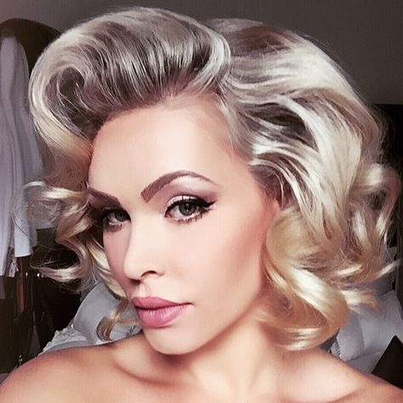
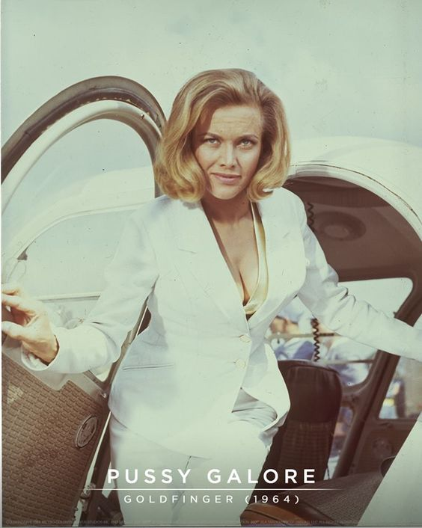 | Over that I wore the white pant suit and white heels just like Honor Blackman wore in the movie. I found myself regretting that I was not wearing a dress, as my legs looked so good. I guesss I knew then, having seen the way I looked, that I would get that opportunity later.  Lina looked good as Xenia Onatopp, my lesbian partner, even though she was not wearing the outfit worn by Pussy’s pilots.  We walked in as proud as we could be.  My father did not even recognize me. He gave me just a glance and then snapped at her: “Where the hell is my son?”  “Right here,” she said with a grin.  Initially he lokked at me in disbelief, but that quickly turned into disgust.

“What the fuck do you think you are doing?” I could see that he was looking at my breasts. They were coated with the same makeup, as were my arms. They looked so real that I could see that he was confused. Had I received surgical implants? Seeing my father in discomfort was immensely satisfying.

“My name is Pussy Galore,” I said. I had practised her opening line a hundred times. It sounded so perfectly feminine I could see him again shocked that the voice was coming from my mouth. It was priceless.

“We have important clients here,” he snarled.

“Tonight, I am just Pussy,” I said. “I am attending as required, but I am guessing I will not be recognized.”

“Just make sure you are not,” he hissed. He walked off. Lina and I giggled like the two girls we were.

We helped ourselves to drinks and mingled, initially together, but the separately. I was enjoying the attention with the anonymity.

The room was full of James Bond wannabes. Older men tried hard or settled for being villains, but every younger man wanted to be Bond, and wanted to flirt with a Bond Girl. Lina was right. The theme of the party was totally inappropriate.

Then one of the Bonds came over. He was tall and very good looking, and he had the British accent down pat.

“My name is Pussy Galore,” I said.
“Of course, it is,” he said. The right reply. “I know that it is a slow tune, but would you like to dance?”

He took my hand and placed to other in the small of my back. He was pressed up against my breasts, and in my imagination I could feel him through the latex and silicone.

My father walked by, casting me another look of disbelief.

“Isn’t that our host?” he asked. “He appears to be glowering at you.”

“That is my father,” I explained.

“Oh,” he seemed almost shocked by his ignorance. “I didn’t know that he had a daughter.”

“He hasn’t always had one,” I said with a smile.

I let it sink in. Without releasing his hold on me he leaned back to have a better look at me. I had expected him to let go – perhaps to walk away in disgust when he realized what I was saying. But instead he smiled and pulled me back towards him.

“Well, Miss Galore,” he said. “You really are as interesting as your character.”

“And you are as charming as yours,” I said.

“Who do think I am?” he said.

“You are James Bond, of course.”

“That was not my intention, but if you like I can be him.”

“Don’t tell me that you really are British? I said. “I thought you were just putting on the accent to stay in character”.

“I did not even know that I was coming to a fancy-dress party,” he said. “I dress like this when I am doing business.”

“What business is that?”

“I am here to make your father an offer for his firm,” he said. “My firm has the reputation that is needed to give confidence to your father’s clients. And we see some modest value in his client list. I came here to look at his business and possibly buy it.”

“He’s not treating you like a buyer,” I observed.

“He doesn’t know I am a buyer,” he said. “I am doing a very James Bond thing and sneaking into a party. Real espionage was my aim. But frankly, I find myself diverted, and less interested in business at the moment.”

He was looking at me. But I knew that he was looking at a woman. It is difficult to describe how great an impact that fact had on me. Clearly, he had no idea that I was just pretending. He must have assumed that my breasts were real and that I was the transgender child of the man whose business he was pursuing. But he was looking straight past any maleness, to the core of my being. And what he was looking at was a woman.

Was that what I truly was?

In that moment I felt that I was. In that moment and afterwards. Always.

Somehow, he had maneuvered me into a quit corner, concealed by some drapes, but the slow dance continued for a moment, before it stopped. The beat of a livelier number was coming through. We would not be dancing to this. Not this time anyway. I was glad. I was terrified that my tits might fall off.

He was so close I could feel his breath on my face. His breath and then his lips, on mine. For some reason I opened my mouth to receive his tongue. It should have been counter to every instinct in my body, but somehow in that moment, my body was not my own. It was hers. It seemed to have lost all rigidity, as if he had sucked out my bones and I was just a limp sack of perfumed skin in his arms, as he tongued me.

Then I found my hands in his hair, holding his face to mine, so that the kiss would not end. But it did … very gently.

“I am not gay.” I said the words, but was I really talking to him. I was telling myself, but it seemed like such an obvious lie.

“No, you’re not,” he whispered. “And you are not a man either.”

He was looking into my eyes. I could see that he was telling the truth.

I said: “Just one kiss”. I was not asking for another. I was just telling him that whatever he had done to me it had changed everything.

“Do you work for the firm, Miss Galore,” he asked.

“I did,” I said. “But maybe not past tonight.”

“It might be difficult if you were an employee,” he said. “I make a point of not being involved with employees. I certainly want to be involved with you.”

Through this whole exchange, my genitals had not responded. It was, quite literally, my heart that was missing beats. But now a strange sexual urge was rising in me. The urge to be under this man.

“My Pussy G,” he said, stroking a curl away from my face.

He still calls me that. But now I have one, the nickname seems more appropriate.

The End

My girlfriend Lina, as Xenia complete with unlit cigarette | Me as Pussy, my own hair dyed blond and styled as I still prefer it.

© Maryanne Peters 2019

Author’s Note: This one is down to Jane W who suggested: “A story about a guy whose father was obsessed with James Bond movies and would constantly harp to his son about how he represented all the qualities a man should have. After repeated failures to live up to this standard across the years, a costume party presents an opportunity to be what he always wanted to be: a Bond girl”.
Jane suggested Eva Green’s character (Vesper Lynd) but I responded that I preferred Pussy Galore and here is why:
- Great name.
- Kicks ass.
- Turns from baddie to goodie.
- Sexy with a capital S
- Honor Blackman is fantastic. She is now 95 and she still looks great.
I actually toyed with Solitaire (Live and Let Die) and the whole see the future while she remains a virgin thing. Anyway, the girlfriend had to be Xenia Onatopp - we all know that she fantasizes about castrating or poor hero.
Thank you, Jane. What a great story line!
Maryanne

