The Ten-Millionth Like
A Story By Soul-Controller

As the new year rolled around, 24-year-old Martin was eager for a fresh start. While he had a laundry list of aspects of himself and his life that he longed to improve, the number one priority for him was to invest fully into his physical health. As such, when he was walking the streets of his Mexican town one day and noticed a promotion outside of a local gym advertising a special deal for new members, the man was quick to head inside and sign-up.

In the two months since signing up for that New Year’s deal, Martin had pushed aside his own anxieties and worked tirelessly in the gym to help reshape his body. While he was still in possession of a rather average physique as evident by the few areas of flab that remained on him, there were already clear results displayed as the man’s muscles looked just a smidge thicker. Since he hadn’t expected such prominent results already, Martin was understandably quite proud of himself already for his progress given the fact that he had never been one to really workout or be physically active growing up.
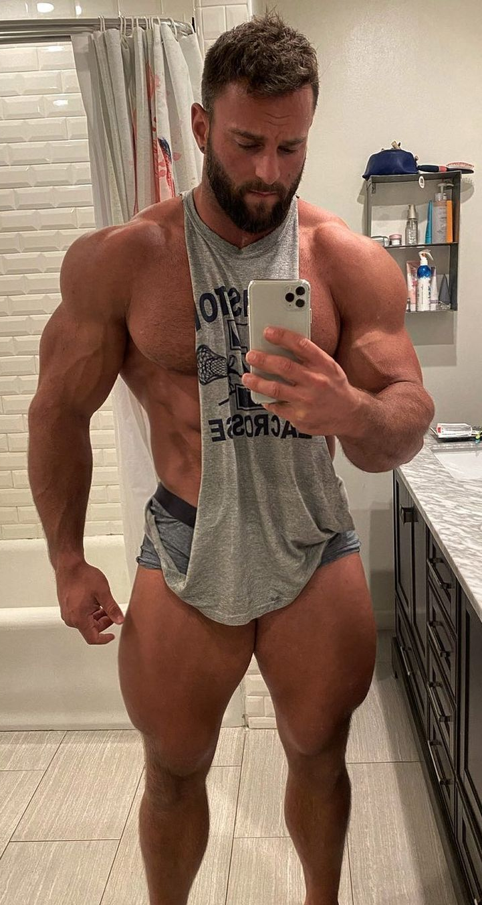
But despite his pride, the man knew that he couldn’t solely thank himself for his sudden prowess in the gym. Given the age of social media and the ability to easily search for assistance without having to pay exorbitant amounts for a personal trainer, places like YouTube and Instagram were able to easily help the man navigate his way to a rather consistent workout schedule to help him achieve his desired dream body. While there were certainly a slew of people that Martin looked into, there was no one that he looked up to more than Eric Janicki.

Not only was the man an absolute beast of bulk worthy of competing in bodybuilding competitions, but Eric was an absolute sweetheart and seemingly not as cocky as other fitness personalities like him. With all of these factors in mind, it wasn’t much of a surprise that Martin quickly fell in love with the hunk and his dorky personality. As such, Eric became Martin’s go-to account anytime he needed tips for his workouts and diets or just any sort of visual encouragement to do an intense gym session.
Since Martin had such an appreciation and crush for Eric, the man also shamelessly turned on notifications so he could be one of the first individuals to support the man’s Instagram posts. Given the fact that Martin had no real money to support the man via personal training sessions, the best he assumed that he could do was immediately like any post and jump straight into praising the man (or thirsting for him depending on just how horny he was). As Martin began to get himself ready to head out for an afternoon workout session, a ding from his phone notified him that Eric had just made a new post. Eager to showcase his usual form of appreciation, the man tapped onto the notification and allowed it to bring him straight to the brand new post. Before the video could even start playing, Martin had already quickly typed out a message of appreciation and posted a comment. Smiling to himself, the man finally double tapped on the post so he could go back to getting ready for his impending gym session.

But as soon as that logo of a white heart emerged in the center of the video, Martin’s entire body seized up. Fear quickly arose in the young man’s mind as he lost all control and found himself growing more and more disoriented the longer he stood upright. As much as he wanted to cry out for help or make his way over to a nearby chair, he remained completely stationary until the disorientating feelings grew too much to bear. Like a goat after being scared, the man suddenly felt himself falling backwards on his back of his heels until he tumbled down towards the ground. As soon as his head hit the ground in a resounding thwap, Martin fell straight into unconsciousness.

While he didn’t know how long he was out cold, the faint arrival of someone speaking was at least able to indicate to Martin that he at least hadn’t died. “Hey dude, are you ok?” the disembodied voice said, with clear emotions of shock and extreme concern expressed. Slowly but surely, the pain in the back of his skull slowly began to recede and as a result, he finally began to gingerly open his eyes. Looking straight up from the ground, his eyes couldn’t help but narrow at the sight of a smaller blond-haired man leaning down over him while continuing to ask if he’s ok. Still groggy, Martin could only extend a hand to get across the message of his desire to get back on his feet. Luckily the skittish man was quick to jump into action, grasping both hands around Martin’s outstretched hand and pulling him back up while uttering a deep groan.

Throughout his journey back to an upright standing position, Martin’s attention was fully trained on the arm he extended outwards. Somehow, the flesh of his arm was much lighter in shade, now seemingly in a lighter white shade in comparison to the rich and darker complexion that indicated his Mexican heritage. While that could have surely been just attributed to some sort of strange lighting, the sight of his arm’s bulkiness made it impossible to believe that this was all due to the lighting. The arm was incredibly wide all of the way from the hand up to the shoulder, as evident by the forearms that revealed intense vascularity all of the way up to a terrifying huge set of biceps. Was his body inflating and turning lighter in complexion due to some sort of allergy from the food he had prior to passing out? If so, he needed to get to the hospital immediately!

As if the universe was testing just how much shock the man could experience at once, the other man’s voice interrupted Martin as he looked down at himself and stared confusingly at the gray tank top he was now wearing. “Uh Eric, are you ok dude?” he said, which caused Martin to immediately lift his head up with a shocked expression on his face.

“Wha- who’s Eric? My name is Martin,” the man exclaimed, his sanity starting to finally break as he looked down at himself and started to hyperventilate. Nothing in the field of vision before him resembled his true self. He had seemingly changed ethnicities and lost all of his flab to become someone that resembled a real-life version of The Hulk (minus the green skin).

“Oh shit, I think you might have a concussion,” the other man stated, himself starting to hyperventilate as he frantically searched around and grabbed his cell phone. “Uh, stay right here bro,” he continued, “I’m gonna get a doctor to come and check you out!” Before Martin could even inquire further about what was going on, the other man had disappeared from the home gym and left Martin alone with his bulky body and frantic mind.

Everything about this scenario was so confusing to Martin, so much so that all he wanted now was answers. As such, he was eager to get out of this home gym and do his own sleuthing. So after leaning out and poking his head out of the doorway to verify that the other man wasn’t nearby still on the phone, Martin headed down the hallway in search of a bathroom. Upon opening the fourth door down, his first quest was finally fulfilled as he saw the familiar sight of a restroom. Rushing in, the man groaned in pain as the top of his forehead rammed against the top of the door frame. Given his former stature as a 5’6” man, it was quite unexpected to suddenly find himself tall enough to conk the head of his now 6’1” body against an entryway.

Regardless of the pain now throbbing at his forehead, Martin ducked his head underneath the door and finally entered the bathroom. Upon navigating his incredibly wide and bulky body into the tiny room, Martin turned to face the mirror and gasped at the discovery. Instead of his own body, he now found the vision of Eric Janicki reflected back at him! While it was surely a shock to become such a behemoth of a man, it also was quite erotic to realize that he was now in control of his biggest crush and gym inspiration. Although it was eerie to find no semblance to his former self in Eric’s own features, that fear quickly dissipated and turned into an observation that he adored. While he enjoyed his old features such as his big and round brown eyes, they paled in comparison to the gorgeous ice blue eyes that he now saw with. In fact, everything about Eric was better than Martin’s old self from his head all of the way down to his feet.

Eager to get a better look at every aspect of his new self, Martin took the opportunity to display his newfound strength by tearing the gray tank top to shreds while dropping his shorts down to the floor. Holy shit, Martin thought to himself as he got the once in a lifetime opportunity to see such a bulky physique in his reflection while also looking down. Eric’s pecs were incredible in the mirror, but they were even hotter due to just how far they jutted out when Martin looked down. Looking back up into the mirror, he couldn’t help but smile to himself as he took in his handsome model-like visage. Not surprisingly, the reflected gorgeous blue eyes immediately drew his attention, but other elements such as the trimmed facial hair and angular features of his nose and jawline became just as impactful.
Taking a moment to grab the phone that was hidden in the pocket of the crumpled up shorts, Martin quickly unlocked the man’s phone and took the opportunity to document his first ever flexing session as a now 30-year-old buff bodybuilder-sized hunk. Although he himself didn’t have much knowledge about posing styles, the combination of both Eric’s own muscle memory and Martin’s own recollection of the man’s videos allowed him to seamlessly flex for the camera.

Even though he was more than turned on by the sight of Eric’s body, the dampness of Eric’s sweaty skin quickly caused Martin to veer into documenting something much more erotic. Lifting one arm up and over his head, Martin wasted no time shoving the strong and angular nose he now possessed right into his own armpit. Taking in the scent of Eric’s own body was like the sweetest drug to Martin, as evident based on the fact that he couldn’t convince himself to pull away and inhale the non-musky fresh air.
But as a ding from the man’s phone finally echoed through the bathroom, Martin finally pulled himself away from the trimmed armpit and checked the notification. Although he wasn’t going to originally go read the message, the snippet displayed to him instantly caught his attention. “I know you’re not the real Eric Jan-” it said, which immediately caused him to frantically tap on the notification and see what was going on.

With intense fear now written across his face, the man quickly read through the message to understand what was going on. “I know you’re not the real Eric Janicki. If you want to know what happened and also keep this body, respond to me ASAP,” it read, which caused Martin to take the opportunity to check out the account of the individual sending the message. Despite the threat of losing this body, Martin’s own curiosity couldn’t be contained as he checked the account and realized that it was an apparent mutual of Eric’s. As such, the man was even more curious about how this happened and how this woman knew about it.

“Uh hi, I’m here,” Martin typed out, cautiously approaching the situation due to not knowing whether the woman was a friend or a foe.

“Well hey there, congrats on being the lucky individual to swap bodies with Eric! 🥳” the response said, which only made Martin more confused.

“How do you know about that?” Martin boldly stated, opting to be upfront about it rather than skirting around the conversation. Clearly, they both knew what had happened so there was no point in trying to play coy about it.

As such, the woman wasted no time taking credit for the swap and stating that it was perfect revenge for her “narcissistic cunt of an ex”. Pressing further for more details, Martin was able to quickly learn that the woman is a novice witch who had concocted the ultimate revenge plan for Eric Janicki. According to her, the two of them had begun dating in high school and even went to the same college together. But as time went on, his focus shifted away from school and their relationship and solely onto his muscle growth and social media following. Before long, the two of them had split rather hostilely as she vowed to punish him for mistreating her and ignoring their relationship. Eager to get her revenge, the woman soon found herself invested in witchcraft and cast a spell that would swap him with the body of an individual who would verify his success. Unbeknownst to either of them, the interpretation of the spell made it so the swap was activated once Martin became responsible for Eric’s ten-millionth like on Instagram. In fact, the only reason why the woman was able to tell the swap occurred was due to the residual ripples of the magic utilized in the body swap.
While Martin was quite intrigued by the details revealed to him, this only made him more curious about what that meant for him. Now that she had swapped him with Eric, what would the woman want from him now? As such, the man posed such a question and found himself rather intrigued by the response.

“Oh, I want nothing from you,” she said. ”I just wanted to teach him a lesson and take him away from the body that he devoted all of his time to. Obviously, I can always swap you guys back if I want, but I have no real intention of doing that. As long as you’re not an asshole to people and just act like a good-natured guy, you’ll remain as Eric. But if you become egotistical about your new body and life, I won’t hesitate to swap you with someone else. Got it?”

While the woman seemed fairly nice and approachable once they had begun talking, the final threat of undergoing another body swap was quick to get Martin to agree to her terms. “Oh absolutely, you’ve got my word. I won’t be as shitty as he was, I promise!” Martin quickly fired back, which had seemingly convinced the woman enough as she told him goodbye for now while once again warning him about her keeping an eye on him.

Grabbing the phone and pulling back on a pair of shorts, Martin was quick to push aside his former life and just embrace his status as the one and only Eric Janicki. As such, the new Eric made his way out of the bathroom with a spring in his step. While the threat of the woman swapping his body with another random individual would continue to persist for the rest of his life, Eric vowed to not make the same mistakes as his predecessor. Unlike the former Eric, he wouldn’t allow fame and notoriety to get to his head. Instead, he was going to continue to focus solely on delivering content that inspires and assists people to become the best and buffest individuals they could possibly be.

Upon heading back into the home gym, Eric soon found himself running back into the young man who had discovered him on the ground. After being asked repeatedly whether he was ok, Eric stated that he had “never felt better” and was eager to get back into filming his content. Although there was some slight trepidation on the other man’s part about whether Eric was actually ok, he ultimately took the man’s word and grabbed onto a camera sitting on a bench. Quickly, the pieces began to be put together as Eric realized that the man was his personal videographer that helped him create content for his social media.

After taking a moment to accessorize his body with a headband, the formerly average Mexican man was eager to begin his first recorded workout as Eric Janicki. Although he was most certainly eager about everything, the presence of butterflies in his stomach suddenly emerged and grew in intensity just as the director counted down towards beginning the recording. Although it was slightly anxiety-inducing to be recorded front and center, his constant viewings of Eric’s content left him feeling rather relaxed as soon as the recording began.

“What is up guys, Eric Janicki back here with another workout today…” he stated, immediately doing the man’s signature intro with a flex. Although this was his first time ever performing on camera, the new Eric felt like he was a veteran at it. As soon as he got past the intro, the man was running like a well-oiled machine as he easily navigated through introducing each workout and demonstrating it for the viewer. Throughout the entire process, he couldn’t help but feel himself growing more and more turned on by just how easy it was for him. Not only that, but the longing stares of the director left Eric feeling even more encouraged (and turned on) to be the best he could possibly be.

Upon finishing up the recording, Eric was feeling incredibly sweaty and extremely horny. Based on the looks that the director was giving him, it clearly seemed as though he felt more than just adoration for Eric’s incredible physique. No, he definitely wanted to explore that physique rather intimately. So while the former Eric had a reputation of being a full-fledged straight man, the new Eric was more than willing to break out of that mold and thus began to make his move on the director.

This newfound confidence brought on by his new body was quite evident as it was only mere seconds before the two men were pulling each other out of their clothes. Eric was eager to demonstrate his strength and show-off for his director, easily tearing off the director’s shirt and pulling down the man’s underwear and shorts. Eager to lean in further towards his own personal kink of armpits, Eric was quick to shove the nerdy-looking man’s face deep into his pit to inhale that exhilarating sweaty odor for himself. As the man’s muffled moans and groans echoed through the home gym, both men were reaching peak horniness and thus demanded immediate release.

Pulling the man out of his armpit and into a passionate kiss, Eric was even more turned on because he could both taste and smell his own sweat on the man’s lips as they continued to make out. Before long though, the director had a wide smirk on his face as he eagerly presented his tight little bubble butt to his boss. Licking his lips and staring at the submissive director, Eric was more than eager to take advantage of it. So after lining up his python of a cock against the man’s tight asshole, Eric was quick to press deep within the man and fuck him with intense passion and vigor. As the two men both rushed towards euphoric highs, the room became filled with a cacophony of guttural moans and grunts until they both came in unison.

Upon pulling out the man’s ass and cleaning himself off, Eric Janicki was quite excited for the new lease on life he had been given. He wasn’t going to let the moments go to waste, and he sure as hell wasn’t going to allow himself to ever be taken away from this glorious new life and body!

