BoardHead
(Working title)

game by Redscript

BoardHead is a fetish light-RPG game. BoardHead title comes from the boardgames that inspired many of the mechanics in the game.

SCENARIO: At the beginning of each game the player will choose a scenario. This will determine the story and the objective of the game. Each scenario will also influence the theme of the game, as well as what districts and locations will be in the game.

Example: Drake’s Errand will be played across two districts – Downtown and Lab Complex. Several locations will be unlocked within them at the beginning of the game . Small Appartment and Super Mall for the Downtown district, and Admin Building and Alpha Labs for the Lab complex. Themes will be city and labs.

Each scenario will have their own endings. The ending will depend on player actions during the game as well as in what time will the player finish the scenario. Each scenario will determine the time limit. Every action the player does will cost variable TU – time units. At times specified by the scenario certain scenario events will happen.

Example: At 30 TU the Drake gets impatient event gets activated, and at 50 TU the scenario ends and an ending is played depending on how much of the task the player has done.

SEX: The main character will be able to be male, female or futanari. This will mostly impact just the presentation of certain pictures and events, although some scenarios might restrict the choice, and some events might only be available to a certain sex.

BACKGROUND: This is what the character was before the game started. This will determine their starting stats and their starting deck. Some scenarios might restrict available backgrounds. Some events and/or choices might only be available to certain backgrounds.

Example: You can start as a test subject. They have average stats – 3 across the board and they start with 1000 money.

STATS: There are 12 stats in the game. They are ticklishness, foot-smell, domination, reflexology, worship, tech, arcane, occult, constitution, willpower, energy and funds

Ticklishness and foot-smell are highly-variable story stats. They change often and the changes are big. The player has more control over these stats than others. In case of these stats, bigger is not necessarily better.

Example: The player wants to get a pedicure, but they can’t because their foot-smell is 4. They go back to their apartment and wash their feet setting their foot-smell down to 2, an acceptable level for the pedicure parlor. Or, the player wants to hang out with some cat-girls who are into tickling, but the player’s ticklishness is only 3. With the application of full-body sensitising lotion bringing the player’s ticklishness up to 7, they can interact with the cat-girls further.

Domination, reflexology and worship are purely story stats. They all have to do with interacting with other characters and how you approach them – a dominant, neutral or submissive attitude.

Tech, arcane and occult are both story and mechanical stats. Some events might call for testing of one of these, but they also are needed to use certain items in the game (more on that in the ITEMS section). Out of the three, occult will be called the rarest but has the potential to have the most impact.

Constitution and willpower are defensive stats. They will be called upon at in certain events. Failure will result in depletion of energy.

Energy is a resource stat. When it is depleted the character will need to take a break (lose TU), or worse, get an unfavorable ending. Balancing energy is an important part of the game.

Funds or money is the second resource stat. Used to buy certain items or get favorable outcomes of events, depletion of this stat does not have any negative consequences like energy does, apart from not being able to interact with the capitalist system. Still, having money is better than not having money.

All stats will go from 0.0 to 10.0. Stats will be incremented on the decimal, but only the whole number is observed for the tests. You can think of it as the tests always rounding down or the decimals to be mini-exps for each stat separately.

Example: The player has arcane at 4.0. They get 3 points to arcane through their deck or an event, bringing their arcane up to 4.3. They’re not any better at doing tests or using items, but they’re a little bit closer to upping their stat to 5.0, the next value that really matters.

DECK: The player will have a deck of cards. Each card will have a modifier (0, -1, +2, etc.) and some will have an added effect. Each time a player stat is tested, a card from the deck will be drawn and the card’s modifier will be added or subtracted from the stat. This system replaces dice in other rpg’s and is similar to Gloomhaven’s deck drawing system. Besides just the modifier, cards might have additional effects, like adding money or pumping up a stat. In fact, the deck will be the main way for the character to increase their stats. Cards will be placed in the players deck at the start of the game, influenced by their background, and the player will add or remove cards during the course of the game.

Example:The player purchases a new gizmo – The Insta-Rejuvinator. This item requires the use of the Tech stat. It requres a stat of 4 and the player has a stat of five. When the player activates the item, the test has begun. They draw a card from their deck – A nervous disposition – that confers a 2 modifier and has the effect of +3 points to foot-smell. The player fails the tests, but gets a permanent boos to their foot-smell stat. Or, the player needs to test their Reflexology stat. Their stat is 3, and the test requires 4. They draw their Lucky Find card – it confers +1 to the test and adds 50 money to the players funds. The player passes the test and gets some money!

A word on progression – when the player does an event meant to increase their arcane stat, for example, like going to magic classes, the event doesn’t increase their stat outright. The event adds three Arcane Insight cards to their deck (+0 modifier, +1 arcane point). Through subsequent tests the players arcane stat has more of a chance to increase. Of course, there will also be events that increase the stat outright.

MAP: The map screen will be used to travel between districts.

DISTRICTS: Districts are discrete places in your scenario – like Downtown, or Lab Complex. Districts hold locations. And they determine random timed events that will happen to the player. Traveling within the district does not incur events nor does it waste time. Travel between districts forces a travel encounter that does take time. They determine the random timed events in a sense that you’re far more likely to run into a gang of punk-girls in the Downtown district then in the Lab Complex.

(You can think of districts like a map of a city in old adventure games. Look at these examples from other games.)
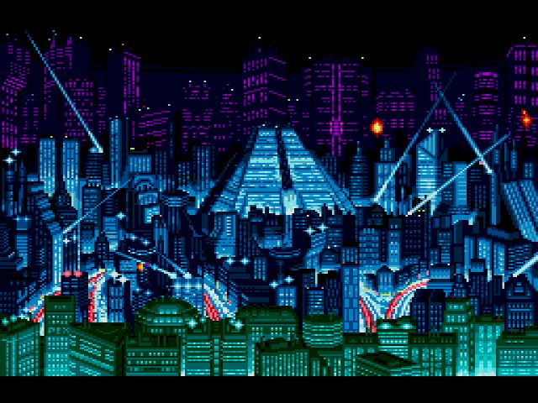
For example this might be the Downtown district.

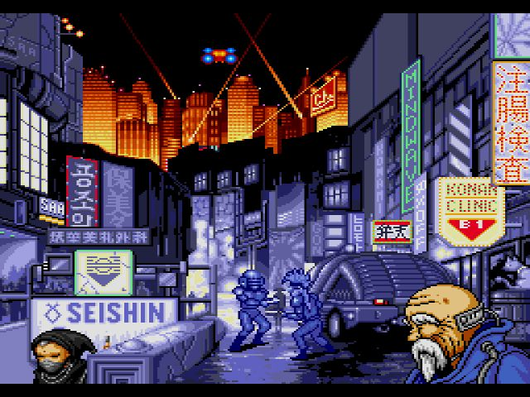
And this might be the shopping district.

Both images are from the game Snatcher – highly reccomended!

LOCATION: Locations are places within districts. The player can visit them to do various things. The locations might have fixed mechanics or they can be places to have random events.

Example: The player returns to their Small Apartment where they can rest or grab a shower. Later, they go to the Super Mall. There, they can visit the grocery shop, tech shop, and the arcane shop, or they can just wander the mall and get a random event.

EVENT: These are happenings or encounters that happen to the player during the course of the game. Events are dependent on time, district, set and location. There are several types of events – travel, timed, and location. Travel events happen when the player travels between districts. Timed events are sort of random happenings in the district that occur in timed intervals – like every 5 TU a timed event happens. Location events happen when the player enters a location or when they want to explore a location.

Special mention has to be made of the scenario events. Every district and location has their basic events (and maybe set events) that aren’t dependent on the scenario. However, when the player chooses a scenario, that scenario’s events also get activated. These are what the player wants to encounter if they want to finish the story.

ITEMS: Knick-knacks and doo-dads that help the player through the game. Gotten of of events or bought at stores, they can be divided into several categories – common, tech, arcane and occult. Common items are everyday items that are low in power, but anyone can use them, no stat check required. All other items require a stat of a certain amount in order to confer beneficial results. Tech items are reliable and moderate in power, while arcane items are slightly more powerful but less reliable, even if the character has the required stat. Occult items are very rare and powerful, but may come with a significant drawback.

SETS: These are, lets call them, theme packages. The player selects them at the beginning of the scenario. If a set is selected certain locations, events and items with a certain theme become activated.

Example: If the player selects, at the beginning of the scenario, the Advanced Tickle-technologies set, then through-out the game (and especially in the Lab Complex) they will have more tickle-torture oriented events. If they select the Urban Orc-girl set, they’ll be able to encounter a lot of orc girls in the game.

