Laundromat
A Short Story
By Maryanne Peters

Despite the fact that they were the only two people in the laundromat at that hour, she came over to use the machine next to his.

She was tall. Her hair was blonde, in a short bob with slight curls. She wore makeup despite her clothing being casual. She was looking at his load of laundry.

“My wife’s things,” said Miles, by way of explanation. He did not need to say anything, but he felt that he had to.

“She’s exactly the same size as you,” she remarked with a smile.

“I suppose so,” he said.

“And she wears full size inserts.”

He looked down and there they were in the basket. His black bra from that evening still had the gel inserts in side. The color drained from his face. Despite the fact that this was a total stranger, the shame froze him rigid.

“I am not trying to embarrass you,” she said. “I am the perfect person to know your secret. I am only saying something because I recognize somebody on the same spectrum as me.”

He had pulled out the inserts and was trying to find somewhere to put them, to hide them from further view. But as he went to his bag he muttered: “And what spectrum would that be?”

“I am trans myself,” she explained, although Miles would not have guessed it. “I have been living my life full time as a woman for almost two years now. I am loving it, and I’ve never looked back.”

“I am just playing,” said Miles. “It’s just something kinky. A little bit of fun.” He was lying, although quite why, he did not understand himself.

“Ok,” she said. “But I did notice that when you rolled your sleeve up to scrub a stain, your arm has been fully shaved. That would seem a bit radical for an occasional transvestite? But, it’s none of my business. I just like to try to help people.”

“I am sorry,” he suddenly felt very guilty for pushing her aside. Perhaps it was self-denial. “But maybe you are right. I may have pushed things a little too far recently.”

“It can be hard in those initial phases,” she said. “When you are not sure of yourself, and you do not want people to notice your feminine side. In particular if your job is not open to expressions of alternative genders.”

“I work in insurance – claims assessment,” he said. ”To be honest I don’t know what the company’s attitude would be, but I suspect that it would be “open” as you call it. No, it’s my co-workers that I would be hiding my little home habit from.”

“Why?” she asked. “Why would you be concerned what they think?”

“I suppose they think that I am a regular person just like everybody else, and I wouldn’t want them to think otherwise.”

“Why? I’m sorry, I don’t mean to overuse the word, but why would you want them to believe that you are somebody that you are not?”

Miles was getting a little uncomfortable. He was not used to being questioned like this. At work he asked the questions. But he could see that she was trying to help. She was challenging him, and the truth is that he did not like the honest answer that he had to give: “I just want to stay under the radar, I guess. I want to be normal because nobody notices normal.”

“I understand that,” she said. “But in your own home you are something fabulous?”

“Well, something different at least.”

“Would you like to go out with me,” she asked bluntly. She looked at him.

She was attractive. He could go out with her. He had not had a date for almost a year, and that last one had not gone well. “Well, I suppose …”.

“I mean as two girls,” she said.

“I don’t dress in public,” said Miles, firmly.

“You should try it,” she said. “I am not talking about going drag. I can see that you could pass easily. We could go out. You and me. Two girls out for a couple of drinks, or a movie if you like. Just to extend yourself a little. Make your life under the radar just a little more interesting. Yes?”

“I’m Miles,” he said. He was not committing to anything, but he was interested in knowing her a little better.

“Lynley,” she said, extending a soft hand. “Why don’t we go out tonight.”

“Tonight?”

“Come around to my place. I only live around the corner. Bring your stuff. I have everything that we need there to look gorgeous. It will be fun. You know you want to try it. I am sure you do. If not tonight, then when? Have a bit of courage. Let’s go out tonight.”

All his uncertain looks, shaking of the head and attempts at refusal just seemed to redouble the onslaught. But the truth is, that it had been a thought in his head for weeks. This just seemed too sudden. And the fact that he did not know this person. And where was she leading him.

“I’ll promise you this,” she said. Tonight won’t cost you a cent. Girls should not have to pay. I’ll cover the beauty costs, and if we don’t have our drinks and an evening meal paid for, I’ll pay for it myself. Now who could say no to that.”

“Well, I suppose that I didn’t have anything planned for tonight,” Miles said.

“Just wait for my things to come out of the dryer and then we are off to my place,” she said. And within minutes they were.

Her apartment was small but comfortable and oozed femininity. The bedroom was so small that a section of the living area was set aside for the large dressing table that was cluttered with hair accessories and makeup.

“Strip off and get into the right underwear,” said Lyn. “The underwear that you meant to wear.”

Miles laughed. He was in it now. Her apartment and whatever she had planned. As he slipped on his panties in the privacy of the bathroom, his hands shook, in fear or excitement, or maybe both.

He stepped out and then said: “I haven’t brought my wig.”

“You have beautiful hair. You won’t need a wig.”

Miles touch his shaggy hair. He said: “It’s not long enough.”

“We’ll wash it right hair in the sink,” said Lyn. “We give it some wash out highlights and then smooth it down with some product. Believe me, I know what to do with short hair. And its so much better than a wig. I haven’t worn one in years, and I hope I will never have to again.”

“Really?” Miles queried. “Do you think I can pass without a wig?”

“Your face is what people will be looking at,” Lyn reassured him. “You have a beautiful face, but for now we need to deal to those whiskers, and I have just the stuff.”

“I can just shave,” he said.

“Don’t you dare,” said Lyn. “Just place yourself in my hands. Tonight, you are a woman. Women don’t shave their faces, and neither should you. I have a compound to apply and it needs a little growth, just as you have now. It may sting a little, but you will be happy with the outcome.”

It did. Miles was. He could not believe how smooth his face felt. Lyn applied soothing cream all over, and then led Miles to the sink to wash his hair.

“You are not going to dye my hair or anything like that are you?” Having worked one radical miracle Miles was a little concerned that he was losing control.

“I told you to trust me,” said Lyn, perhaps slightly offended. “I know that you have to go to work tomorrow, and if after tonight you still want to go dressed as a man, then you will be able to.”

But when she had finished washing and drying the hair, doing his makeup and then combing the hair across, Miles was not so sure. He was not so sure if he was even a man at all.

She had shaped his eyebrows and applied false eyelashes and dark eyeliner, but it was the work on his cheeks and nose that were special. His face looked so womanly he was shocked. His broad shoulders did not seem to match the woman staring at him. She was, quite simply, gorgeous

“Now we just need the right dress,” said Lyn. “I have just the thing. It will be tight on you, but with the shape we are going to build, it will be perfect.”

It was. The shoes disconcerted him a little, but after walking around the apartment in them, he felt more confident.

“You should meet Mitch, my ex-boyfriend,” she said. “He would love to meet you. I think that you would be just the kind of girl he could go for.”

“Just two problems with that,” said Miles: “I am not a girl, and I am not gay.”

“I promised you that you and I would not be buying our food or drink tonight, and Mitch is the answer,” said Lyn. “We could go out a try to pick up a couple of guys, but has plenty of money and I know he likes nothing better that to take a couple special girls out on the town. And a man like Mitch makes a wonderful accessory.”

“Honestly, I am not into guys,” said Miles.

“Oh, I understand that. But when you have a man on your arm, it is just easier. I am not saying that you need a man to feel like a woman,” she said. “But Mitch is the man who can do that.”

“So why are you not together?” It was the obvious question.

“He likes his girls like you,” she said dismissively. “After my bottom surgery he was no longer interested in me. Now I am with Eddie, and I hope that it will be permanent. I think it will be. I am sure that Mitch wants me to be happy too. I’ll ask him if maybe Eddie can come too. Eddie can pay for my dinner.”

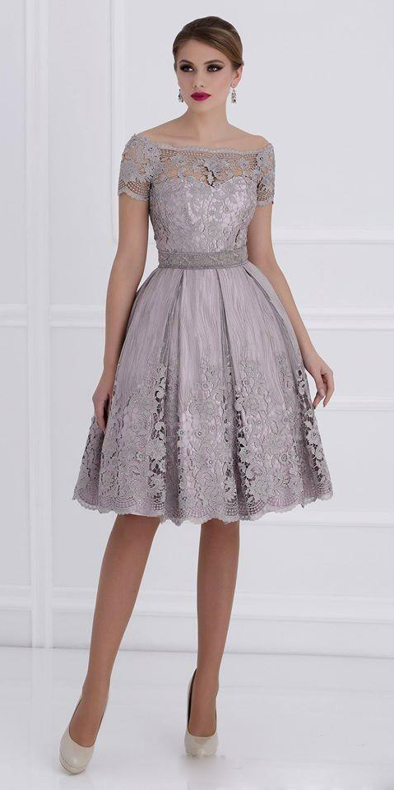 | She hurried off to make the calls while Miles admired himself in the mirror. It was a grey cocktail dress that covered up his padded body but showed an engineered cleavage through lace, cleverly enhanced by makeup Lyn has applied. It showed off his smooth neck, arms and his legs made better by pale heels. The belted middle gave him a classic figure. With the earrings and red lipstick he was ready.  He surprised himself by feeling very calm about the idea of walking out the door – if that were going to happen.  “Mitch is dying to meet you.” Lyn had returned, brimming with enthusiasm. “He is coming in. He will meet us at “Basque” which is a place we can walk to from here. And Eddie is coming in too. This is going to be great. I feel so lucky that we met tonight …”.  She stopped because she was looking straight at Miles and did no know what to call him. He was smiling. It was an innocent little girl’s smile. A first date smile.  “Millie,” said Lyn. “I am lucky to have met you, Mille.”  “Millie,” the girl in her living room repeated it back, in a voice that had suddenly risen in pitch to match the outfit that she was wearing. “Yes, why not? Tonight, I am going to be Millie.”
.
Mitch was very taken with her, and that was very obvious. He was already there. He stood immediately when they entered. The thing a gentleman would do. His eyes could not leave Millie as she walked towards him, with Lynley showing the way.

He pushed her chair in, taking the time to drop his head and breathe in the smell of her. Hair product, feminine perfume, and the hint of male sweat. Just the smell he adored.

“I’m Mitch,” he said.

Millie respond with a grin, and the word: “Millie”. To Mitch it sounded like an invitation of some kind, perhaps a call to bed.

“I was not expecting somebody so beautiful,” he said. “Lyn tells me that you are only just starting your transition.”

Millie wanted to protest. She felt that it would be right to tell him that there was no transition and that there never would be. She was not transgendered. Why would he think she was? Well, maybe the dress?

“Sit next to me,” he said. It was a curved booth. The kind where it is hard to tell where a seat starts and finishes, so when Mitch took the outside seat he could determine how close they sat.

“I am new to all of this, Mitch,” Millie said, using his name deliberately. Surely he would not take advantage of a new friend?

“I respect that,” said Mitch. “I respect you. Just because I find you desirable does not mean that I respect you.”

It was genuine. Miles did not know quite what to say. So he just made that half understanding / half agreeing noise, that comes out as “Uh huh”.

“I respect all girls in transition. It must be difficult for you. I want it to be easy. The world needs more women. We men have fucked it up. Bring on the ladies, that’s what I say. The more guys who head in that direction, the happier I will be. Make the world a pretty place. Don’t you agree, Millie.”

“Sure”. How could Millie disagree? “Happy to help. Make the world a better place. I’ll drink to that.” And she did.

She liked Mitch. He was full-on, but intelligent and attentive. Millie was not used to the latter. She ha spent a lifetime being ignored, and now she understood that she was the center of attention. The center of Mitch’s attention anyway.

“You have a nice body,” said Mitch. “Nice legs, great shoulders. Just the hint of power in those shoulders. I like powerful girls. Not as powerful as me, but not like those cis-women. But you should have a pair of tits,” he said.

“Yes,” said Miles. He was getting used to agreeing with Mitch.

“Something that I could stroke and squeeze.”

“Yes.”

Something that will hang down and jump about when I am humping you.”

Miles suddenly realized how he must sound, agreeing to everything. But It was now clear what Mitch’s intentions were. It needed to stop right now. It had gone way too far. Only hours ago, he was just another guy, at the laundromat.

“I’m not into that,” said Miles.

“But I’m into you,” said Mitch. “I would just like to be in a little further.”

“Ok”. That was what came out of Millie’s mouth. Miles would never say that. What had he just agreed to? This was getting weird. It was almost as if a feminine creature, living inside Miles’ body, like a parasite, was taking over.

Mitch seemed to see it. He seemed to sense the panic. He said: “Millie. I respect you and what you are going through. Just like I told you when you sat that pretty butt down next to me earlier tonight. I will never push you into something that you don’t want to do. Do you trust me on that? Do you Sweetbuns?”

Millie had a nickname. He had called her “Sweetbuns”, whatever that meant. It sounded nice. She liked it. Sweetbuns. It had to be worth something. Some sign of approval. She let Mitch kiss her.

That was all she intended. She was not really Millie. She was Miles. A very occasional transvestite. Just a thing. A little fetish. It could be feet, or handcuffs. In his case it was … it was her. It was Millie. So exactly who was in Miles’ apartment that night. Who was that saying: “Just be gentle, please, Mitch.”

“Baby, you are my china doll.”

But you do not do to a China doll, what Mitch did to Millie.

He was gentle. Respect. That was what it was. It was painful at first. Then respect feels good. Much better than it should.
“What a mess!” Millie pretended shock and then giggled. “I am going to have to wash the sheets and my washing machine is broken.”  “There’s a laundromat around the corner,” said Mitch rolling her over to kiss her. “We’ll fuck one more time then we can go there together.” | 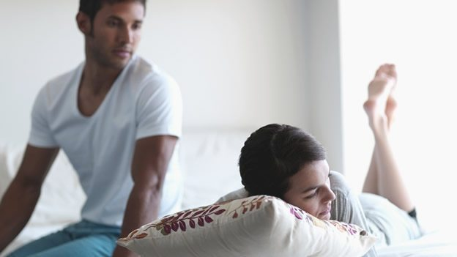

The End

© Maryanne Peters 2019

