Closet Check
A Vignette
By Maryanne Peters

Roger Tan had told Travis were he could find the kid he had hidden near his front door. It was a small unit that had been bought by Roger’s parents as an investment, and Roger paid rent to cover the loan and other payments. Travis had called to say that he was already there, and Roger was still an hour away. Travis sensed that Roger was reluctant to leave him alone in the place, but they had become friends so he could hardly leave him on the doorstep.

What does somebody do along in another person’s home? Travis was impressed with how tidy the place was compared to his own. Not only tidy but organized. He had a look in the cupboards and it al made sense. The pantry was full of things that Travis knew nothing about – all manner of Asian food with only Chinese script on it. Presumably as Roger was Asian he could read it, but Travis was not sure.

There was a TV but there was nothing on so he didn’t bother sitting down. He recalled his mother saying that you can learn a lot about a person from looking at their home. How well did he know Roger? Well enough to ask to stay at his place fr a couple of days, sleeping n the couch which looked up to task.

He decided to check the bathroom. The cabinet contained more products with Asian writing and no English. There were some with images that seemed to make no sense – what looked like creams more at home in a woman’s flat.

There was only the single bedroom with a double bed, made up with pillows arranged neatly. There was a large closet. Travis decided that there was time for a closet check.

Inside the closet there were shelves with regular clothes, and hanging us was a business suit and a few jackets, and a large, long-hanging garment bag. Something about it led Travis to the conclusion that it was out of place. One tiny peek through the top confirmed that.

He unhooked it from the rail and laid it gently out on the bed. He then unzipped it from the hanger down. It was what Travis assumed would be described as a ball gown. It was white and gold and had lines of rhinestones stitched in sweeping patterns across it. It was soft and in fine fabric. Without knowing anything about female garments, which this clearly was, Travis guessed that it would be expensive.

At the foot of the bag was a bag with a pair of high heeled shoes and a clutch bag, and on a separate hanger behind the gown hung an undergarment of some kind – a corset and bustier in a nude color, perhaps designed to fit neatly under the gown and give it shape.

What was it doing here?

For just a moment Travis wondered if it might serve as an aid in masturbation, because there was something about imaging a woman wearing an outfit like this that was causing him to become aroused. It was not that it was overtly sexy or anything like that. Perhaps the opposite – it was classy and restrained. It was meant to be worn by a sophisticated woman, tallish but the length of it, but not as tall as Travis even if she was wearing those heels. Somebody Asian perhaps, given the color and style. Somebody like Roger? Or perhaps even Roger himself?!

Could it be? Roger never gave any inkling of any queer tendencies, but then Asian guys often do not come across as overtly sexual. Are there even Chinese transvestites? They have those types in Thailand, from what Travis understood, but Travis was pretty sure that Roger’s people were from China.

Travis hung the dress on the open door and stared at it for a moment longer. He took a moment to pleasure himself.  He had only just cleaned that up when her heard a key in the door and he headed back out to the living room.  “I’m sorry about you having to let yourself in, but you did arrive much earlier that I expected,” said Roger. He had some groceries to put in the kitchen. “You should made yourself some coffee or Jasmine tea.”  Travis has slipped back into the bedroom to retrieve something.  “I was just looking around and I found this,” he said. He held it up but it took a moment before Roger looked up and looked perplexed. Travis saw it and said – “I've never seen you in this, but I would sure like to“.  “Oh that,” said Roger. “That is not mine.” But Travis could see that he was embarrassed. Those words were a lie and Travis knew it. And Roger could see that Travis knew that.  “You are an only child and your mother is only just over 5 feet tall,” said Travis. “This is yours. I know you have no plans tonight. Why don’t you get dressed. We can go out dancing. I know of a place where this kind of dress was designed to be worn. It will be my treat. Come on. Let’s see you in the beautiful gown.” | 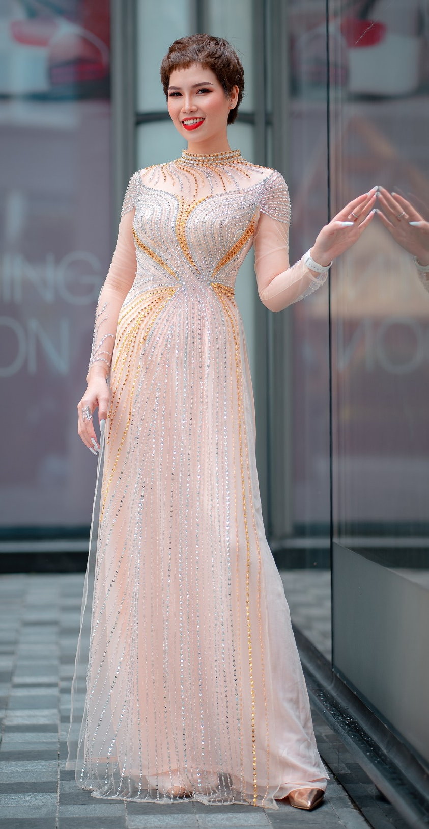

“It is gorgeous, isn’t it,” said Roger. His voice had somehow become soft and dreamy just to say those words. “I couldn’t just put it on. That wouldn’t be right. I would need to wear it properly. I would need to shave down. I would need to wash my hair, and put on a little makeup, and maybe some stick-on nails?”

“That sounds great,” said Travis. “I can hardly wait … but I will, right here.”

Roger walked over and took the garment and the bag from his friend offering them, holding both as if they were a sacred thing. That is what this outfit was - sacred and a talisman of forbidden desires – desires that Roger had concealed from his family and from everybody. He had never even worn the dress before. He had worn the undergarments and while wearing those he had taken the measurements and sent them to the dressmaker in China. It was perfect but it was not meant to be worn. It could hang in the cupboard to remind him of just how wonderful life might have been.

But Travis had taken charge. Roger liked that. He was not inclined to refuse. There was somebody who wanted to see what he looked like dressed as a woman.

He raised his eyes to look at his friend. Travis gently nodded. It was all that Roger needed.

He went into the bathroom and ran a hot shower, soaping and shaving his body and using regular shampoo to wash his hair. He used a brush and hairdryer to work some body into his hair. He struggled into the shaping garment. It was tight but the result was impressive. He knew that the dress would be a perfect fit, but he was struggling with the zip at the back.

Roger decided to apply the makeup anyway. It was in the small clutch bag – a tiny tube of foundation, a powder compact, eyeliner, mascara and lipstick. Roger took his time. He knew what to do but he was not practiced. He needed to get this right.

There was a tiny vial of perfume spray too – something more spicy than floral. An exotic scent – aromas of the East carrying the mysteries of centuries. Just a spritz or two on the neck.

He put the shoes on before leaving the bathroom. He looked at the woman in the mirror. At last she had emerged, as if from a chrysalis. She smiled. She was born to smile. It seemed as if she could do nothing other than that.

She left the room and with a small cough she invited Travis to turn and face her.

“Excuse me, would you help me with the zip?” she said.

She could see Travis’s eyes – the pupils dilated to drink in more of her. He walked around beside and then he grasped the zipper, moving closer to her as he did, taking in that perfume.

“Thank you,” she said. Her voice was high and yet husky. I was perfect, as far as Travis was concerned.

“My name is Travis,” he said to the beautiful stranger. “And you are?”

“Wo suh Mei,” she said. I am beautiful. “May”.

“Pleased to meet you, May,” said Travis. “We have a date tonight, if I am not mistaken?”

“Yes,” she said. “You are going to take me dancing. And then …”.

“We’ll work that out later,” said Travis. “But somehow I think that your life has just begun.”

And it had.

The End

© Maryanne Peters 2023

Erin’s seed: “Someone invades a guys apartment and does a closet check and finds a gorgeous gown – “I've never seen you in this”, “Well, I, uh, you see”, “Get dressed, we'll go dancing”, “Huh? you think?, “We'll have a great time”. And they do”.

1502

