Today is the Pinkie’s B-Day! Finally after days of organizing the party uselessly in secret, we can start the celebration of our favorite prankster!
You: sorry my delay!.
Sci-Twi: hey :)
Rarity: Hi darling ^^
Sunset: hello!. Hey, thanks again for help Applejack ^^
You: No problem. I couldn't allow her to miss the birthday of one of her best friends hahaha.
Applejack: Big Mac and Granny let us come anyway, even Apple Bloom is here ^^
Principal Celestia let us organize the party in the school gym. And it's not just us, but all the students and even Miss Celestia and Miss Luna herself are here enjoying the party O_o.
Principal Celestia: Everything is very delicious!! :3
Vice Principal Luna: woah! You right!! yummi!! *-*
Fluttershy: please, don't eat so fast or you will have a stomachache :(
The party is going very well, but there is something strange here ...
You: where is Pinkie?
But just when I mention that name ...
Pinkie: aww you miss me, dummy? ^^ *giggles*
You: *gulp*! oh... Pinkie O___________o''

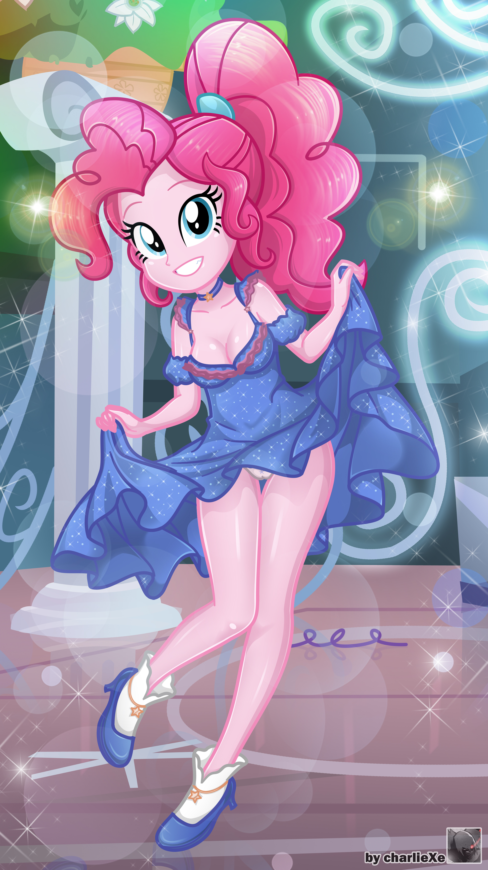
WOAH! Pinkie looks so beautiful !! I have never seen her dressed so elegant and wonderful ... it's difficult to know that she is the same girl who has made my life more difficult, more or less pleasant I guess?. But seriously, she looks great.
You:...
Pinkie: hmm? What happened? Don't you like my dress? o.o
You:... It’s not that … ahmm, you look so well in that outfit! Ahem but, where were you? o///o
Pinkie: I was only taking care of something important, but I'm already here :)
Starlight: Hey, are you okay.. IRON WALL? your face is very red ¬_¬''
You: yep… no problemo!
R. Dash: Well, now we’re all here let’s celebrate this b-day party!
Everyone: yeeeeeeeeeeeeeeeeeeeaaahh!!!
Evening go on calmly, everyone’s talking, dancing and having fun. Heh, it’s great to see them like that, I mean, look at those laughs, the joy emanates from each one of them, you can tell they have no worries to deal with. Yeah, this is definitely the kind of life I’ve always wanted to live.
As I drink my orange juice someone touches my shoulder.
Principal Celestia: hi ^^
You: Miss Celestia? :O Can I help you?
Hope she doesn’t wanna talk about my grades!
Principal Celestia: I’ve been watching you all these months and it seems like you fit very well in with the school but you must improve your grades
Ugh, I knew it!
Principal Celestia: But that's not what I want to talk to you about. It's about your friendship with the girls: Twilight, Fluttershy, Dashie, Rarity, Sunset, Applejack and the party girl, Pinkie. I have seen that you are very close to them, and you should know that they are not like other students here…
You: Oh, I know.
Principal Celestia: When they are with you, I can see their smile, their happiness and enthusiasm to spend another day with you.
You: ahm... now I don't know what you are talking about :S
Principal Celestia: Hm, I see. Let me ask you something, do you feel lucky to have met them?
You: I can see on them what’s the meaning of trusting in someone. To know I can count on them when nobody else cares about my problems. These girls have been through a lot together, overcoming a good deal of setbacks so now they’re strong and brave. Even they have defeated big enemies!!! They stay together, and I feel lucky to be part of their circle of friends. :)
Principal Celestia: It's great to know what you think of them ^^ ... in that case ... Why haven't you make a decision?!!
You: ... WHAT?!!!
Principal Celestia: giiiiiirls, come here please ^-^
Principal Celestia calls all the girls, including Starlight obviously ...
Sunset: something happens Principal Celestia? :O
Principal Celestia: Okay, now that you're all here ... *she turns around and looks at you *. Make a decision now! >-<
All girls: WHAAAAAAAAAAAAAAT?!!!!
You: really! what are you talking about!!
Vice Principal Luna: you can't be so naive -_-'
You: Miss Luna, what are you doing here?!!!
Vice Principal Luna: waiting ... I want to see how this all ends :)
Apple Bloom: It is obvious that he will choose my sister. Everyone here should have seen how they looked at each other in the apple orchard ... awww so romantic ^^
Scootaloo: hah, I'm sorry to inform you but my sister has everything to win ^^
Sweetie Belle: excuse me girls but Rarity is the most obvious choice for him ^^
Flash: Oh, what’s this? Will you finally make a decision, brother? *nom nom*
Miss Cheerilee: Judging from the hours he's spent with Twilight studying, I'd say she's the girl for him :3
Maud Pie: my sister is the birthday girl, she is the right choice for him.
Trixie: hah, are you blind? Have you not seen how he and Starlight always go hand in hand? Ugh, it pains me to admit it, but I missed my chance U.U
One at a time, everyone meets to see what “is happening”, whereas I’m speechless. They say things that I simply cannot understand. As far as I know we’re just friends! No more than that!
Sunset: What is this all about! Dx .. Hey please, let's keep order!
As she tries to make everyone see reason, something tugs at my arm. It's Pinkie!
Pinkie: *whisper* shhh! Come with me ^^
Pinkie sneaks into the "crowd" that has gathered there, and asks me to follow her. The atmosphere has gotten a little out of control, so I decide to follow her.
She takes me out of school ... and I can see the sunset, the sun is setting behind the mountains…
Pinkie: Ufff! It’s crazy in there, isn’t it? xD
You: I don't understand anything, what happened there O.o
Just then, I see Principal Celestia :O
Principal Celestia: all done, Pinkie ^^
Pinkie: thank you! :D!
You: ... ... ... PRINCIPAL CELESTIA?!!!
Principal Celestia: oh, hi again ^^ .. I'm sorry about what happened before, but it was a request from the birthday girl ^^
You: it was you?!
Pinkie: hehe, what is the problem ^^
Principal Celestia: Pinkie asked me to make a harmless little scandal, so you and she could go out without being seen by other students.
You: ... ... ...
Principal Celestia leaves the place, leaving me alone with Pinkie.
You: so, do you need something? Why did you want me here :O
Pinkie: It's been a long time since you came to this school. Do you remember the first day? You didn't know the classrooms Xd

You: I remember it perfectly, you took me to the library and told me that the class was going to be held there. And it was a lie! I spent two hours reading a quantum physics book, and it wasn't even one of our subjects!
Pinkie: hahaha! Yes, it was really funny! xD. You were very angry! And I'm sorry for that ... ... ... * she looks up at the sky * ... You know, you've never told us anything about you.
You: What's this all about, Pinkie?
Pinkie: Hey, it's my birthday! So I'm the one asking the questions here! ... It's what Principal Celestia said. It's true that we always spend time together, but with everything that has happened ... don't you feel anything different? ... I mean, for any of us?
You: something different? Hmm, I don't like talking about my past, but I knew a man, my only friend… although I don't know if I could call him "friend". I never knew the true meaning of friendship until I met all of you. I never imagined that we would reach a point where I consider each of you my best friends :)
Pinkie: hehe, what a dummy you are ^^. That's what makes you cute and lovable, your naivety :3.
You: hey, where i come from, that's an insult ¬_¬'
Pinkie: hahaha xD... ... ... *sigh* I'm sorry for all jokes that I have made you.
You: Don't worry, it's already forgotten.
Pinkie: Oh, and one more thing, remember when you asked me where I was, and I answered you that I was doing something important?
You: oh sure, it happened today!
Pinkie: well, I was planning my own birthday present ^///^
You: your own birthday present?...
Suddenly, Pinkie walks up to me and places her finger on my chest, pointing at me. I can see her cheeks are red as crimson: O
You: Hey, wa-wait. What are you going to do O_O '
Pinkie: *giggles* hehe, happy birthday to me ^^ ...
...
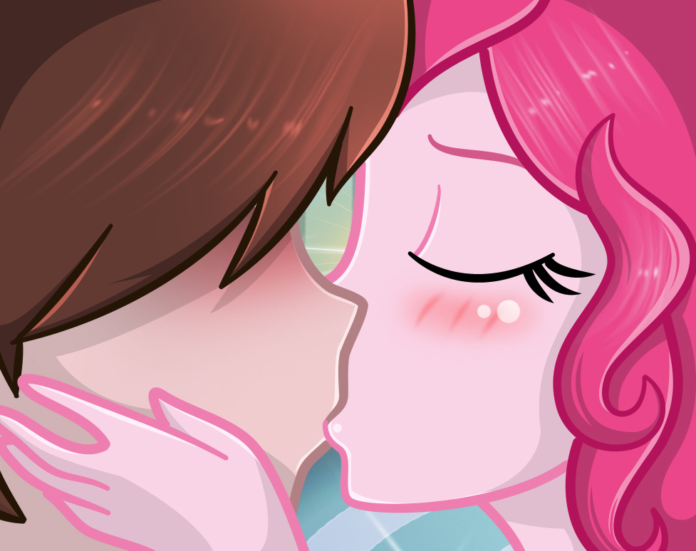
You: ...??!!
Pinkie: ...
OMG! The softness of her lips collide with mine. I can barely understand the situation ... I can't even react to what is happening right now.
Pinkie: hmmm. mmmhn...
Pinkie places her hands on my face, and tries to get even closer, pushing her lips closer to mine. I'm still numb from head to toe… WHAT!!... her reaction came out of nowhere!
Pinkie: ah .. * pant * Now you know what I feel, right?
You: ...
What the… I don't know what to say!
Pinkie: *sigh* and not only me, we all feel the same, and this feeling is something that none of us is willing to give up ^-^. Point for Pinkie! hehehe!!
Pinkie walks away and goes back to the gym. However, she turns around and tells me ...
Pinkie: You should hurry up or you'll miss the rest of the party! :D
You: su-sure…
It's true that sometimes they act very strange, but still ... is it possible that ...!? ... nah, hahaha, what am I thinking, it's impossible. I'm going back to Pinkie's party, when all of a sudden...
???: man, are you leaving so soon?
You: ...?! *you turn around*
???: It's been a long time, mate.
You: I know you??
A strange man appears and talks to me as if he knew me from somewhere, but in my life I had seen him, or at least, I don't recognize him from the hood he wears.
???: Wow, you break my heart. Heh, pathetic right? Look at you, you used to be a jerk, and now you're unrecognizable.
You: who are you…
I try to face him, but I just hear Pinkie calling me ...
Pinkie: dummyyyyyyyyy!! hurry up!
You: hmm?
I turn around to look at Pinkie, but just then he jumps on me and punches my stomach.
*PUNCH*
You: OOOFFFF!!! * you fall * ... * you complain of pain * arhggg ...
???: Heheh!! I've waited a long time for this moment ... * stands right in front of you, and looks at you * ... GET UP! NOW!
That guy hits really hard! I can barely breathe…
???: You know, I remember that day you stole this orb. Here. It’s great, right?
You: ...?! ... oh, that orb...
I remember that thing. Before coming here, I stole and sold items on the Underworld black market with a guy. That is the “null orb”, it’s an item capable of making its wearer invulnerable to magic, it was the last item I stole and it was the most valued at that moment. But that means...
???: You can call me Storm King, and don't forget that.
You: hahaha!! you, a king? Do not make me laugh. You were a beggar when I met you. King of what ... fleas?

Storm King: Brave words for a fool who lost all credibility of his actions. You and I could be the greatest conquerors in this world. We could have everyone bowing down to us ... maybe you changed on the outside, but inside you have the same putrid heart just like mine. THAT is what Cozy needs… hmm…
You: ...
Pinkie returns to the place where I and the Storm King are "chatting".
Pinkie: dummy, why are you taking so long !! .... huh? Woah! are you okay?! --- * Pinkie looks at the man * Hey! what is your problem?? !!
Storm King: hmm... on the other side, you are just as irritating.
I hear more footsteps approaching…
Sunset: What's going on here! ...
Storm King: The bacon hair, I saw you with this idiot in that park. You guys looked so cute there ... PUAJJ !!
Sci-Twi: the Storm King?!... but, it’s impossible...
R. Dash: Bah! He was defeat once, we can defeat him too!!
Sunset: Dash, wait!!
Rainbow Dash prepares to attack at high speed without even analyzing the situation. She tries to land a few blows but the Storm King evades them with ease.
R. Dash: what?!
Storm King: hahaha, Don't be overconfident, girls. Your attacks won't work against me ... hmm but it's your lucky day. I just need to him. Give it to me, and all of you will can continue to enjoy your party in peace.
Pinkie: Do you want us to give you to the dummy-head? HAH! I don't know what is your relationship with him, but that will never happen!
Rarity: You heard the birthday girl, he stays with us ^^
R. Dash: That was just luck, but now you better get ready.
Sunset: girls, now!!
A strong light emanates from the girls and their geodes begin to shine brightly. After a moment, they appear transformed :O... this is the second time I have seen them like this !!
Storm King: Do you want to protect him that badly? If all of you truly known what kind of wolf in sheep’s clothing this wretch was, I think you wouldn’t bother worrying about him.
Sunset: Starlight, you stay close to him. We take care of the Storm King..
Starlight: … … o-okay!
Starlight approaches me ... she is the only one who does not have a geode and cannot transform like them. But still, she can use magic even though it's unstable.
Storm King: you wanna dance, huh? hahaha!!
But just as the girls prepare to attack ...
You: Stop!!
I stop them.
Pinkie: dummy?! What are you doing!
You: it is useless, you will not beat him.
Sunset: What are you talking about!!
Storm King: oh look! The coward takes courage ... not bad. I congratulate you.
R. Dash: what are you going to do, you air-head! You are a mere human!
Storm King: Take this advice: listen to him and refrain from fighting against me. You will not win and the only thing you will get is to get hurt, all of you. Although being honest, I don't care. Heh.
I walk up to the Storm King and look him straight into his eyes, I have to stay calm and not let this guy make me lose my temper… As much as I want, I can't fight against him.
Pinkie: This is not the time to play cool boy, dummy! get back here!!
Storm King: the truth is that my orders were simply to take you with me, but… I want to make you suffer until you beg me for mercy !!! HAHAHAHA!!
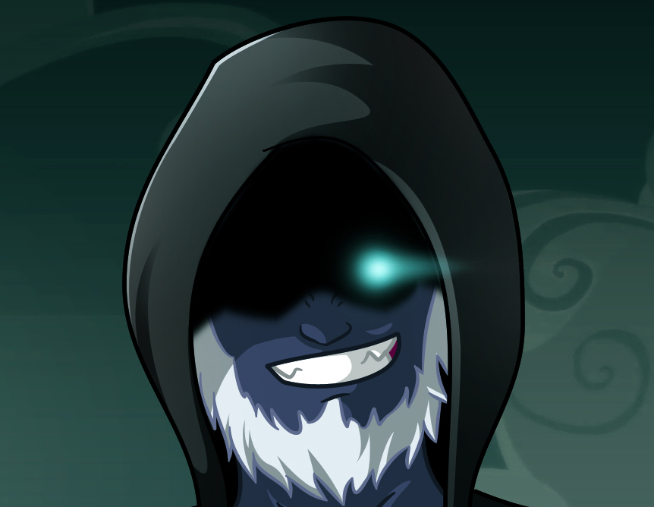
To be continued…

