Influencing The Influencer: Chris Nappi (Part II)
By Soul-Controller

In the two months since first possessing his friend Chris Nappi, Tom had been absolutely thriving in his new life as a hunky influencer. While the man’s gift of possession afforded him the ability to tap into the real Chris’ memories and persona from time to time, he had still expected to encounter some roadblocks along the way. But alas, the possession was an absolute success and Chris’ life was one that Tom was seamlessly able to take over.
In fact, Chris’ normal routines had become so easy to adapt to that they were second nature to Tom. Every morning, he would wake up and do Chris’ usual breakfast routine and workout before taking advantage of his apartment complex’s swimming pool. Of course it was a blessing to cool off into the calming and chilled water, but it was even more fun for Tom to watch his fellow neighbors stare at him and his gorgeously buff and tatted-up body. Eager to put on a show to give them more reason to stare, Tom wasn’t afraid of lifting up his arm to “accidentally” flex his biceps or allowing himself to get rock hard from the attention to cause his prominent manhood to strain against his swimsuit.

Although Tom himself hadn’t really been a super cocky individual, the time spent in Chris’ body had quickly corrupted him. While this was surely not only due to him tapping into Chris’ own confidence and inflated ego when it came time to go into “Chris Mode” and record content for his followers, a lot of this ego was gained from Tom’s own experiences in such a buff body. Everywhere he went, he was treated like a king amongst peasants, so it was no surprise that the man began to feel even more cocky and proud of the body he had hijacked. Every time he saw a mirror, this newfound narcissism was on full display as he admired his gorgeous tanned and tattooed skin, buff physique, and bright and perfectly aligned smile.

Upon finishing up and gathering all of his desired attention, the new Chris made his way back to his apartment to shower and get ready for the real work of the day. Of course, he often found himself distracted by his nude body, which caused him to jerk off multiple times to his own reflection, but he moved as fast as he could despite the vanity-centric hindrances. Upon drying off and getting dressed, Tom finally sat himself down at his sound-proofed office and began to record a slew of content that consisted of TikToks and podcasts with Chris’ friend Jay.

But unlike the real Chris Nappi, the new one was eager to build upon Chris’ follower count and came up with the perfect plan to do it. Throughout the past two months, the man had reached out to several other popular influencers or social media personalities in hopes of doing a collaboration. While most of these influences and his fans had assumed that this was just due to Chris’ desire to grow more popular by interacting with just as popular individuals, Tom had an ulterior motive behind these collaborations. In reality, Tom was working ahead by establishing connections with potential possession victims to hopefully make it easier for him to possess them himself. Given the fact that Chris would likely remain his host body to live as and possess others with, Tom had to regain connections with the people he used to know back when he was a 34-year-old Alabama native. Luckily, his plan had worked out well as he was able to get the large majority of his ideal possession choices to hang out and create content with him.

Although this posed several options for him to become someone new, Tom still found himself struggling to leave Chris’ life to take over someone else’s. But as he finished up his work for the day and sat back in his office chair, he finally told himself that the time had come to move on and become someone else for a little while. So, as he scrolled through his contacts list, the man ultimately decided on the perfect choice for his next body and fired off a message asking if they’d be up to collaborating the next day. After receiving a response that approved the idea, Tom smiled to himself as he tucked his phone back into a pocket of his shorts.

Now with the rest of the day free, Tom decided to go out with one last hurrah as Chris Nappi (at least for the time being). As such, he decided that the best course of action would be to head out to his favorite bar and get absolutely wasted. Of course, there was also the additional goal of finding a woman hot enough to go back home with him. Although Tom himself hadn’t been interested in women prior to possessing Chris, he had allowed himself to tap into the man’s psyche and become an almost exclusively heterosexual man. While Tom would have loved nothing more than to be his homosexual self and thus use such a gorgeous body to attract the attention of equally attractive men, he didn’t want to completely shake up the man’s life just in case he decided that he wouldn’t want to become Chris permanently one day.

So given his own kindness, Tom was forced to not only adopt the man’s own heterosexuality but also his specific taste in brunette women as well. As he arrived at the building and walked up to the bar to place his drink order, the man wasted no time then scanning for suitable partners for the night. By the time he had finally received his drink, his mind was already made up and thus wasted no time downing the shot and making his way over to a girl sitting by herself. Throughout the journey, he took the opportunity to alter his stance to try and look as impressive as possible to the girl (mainly through puffing out his chest so his skin-tight clothes looked even tighter on his body).
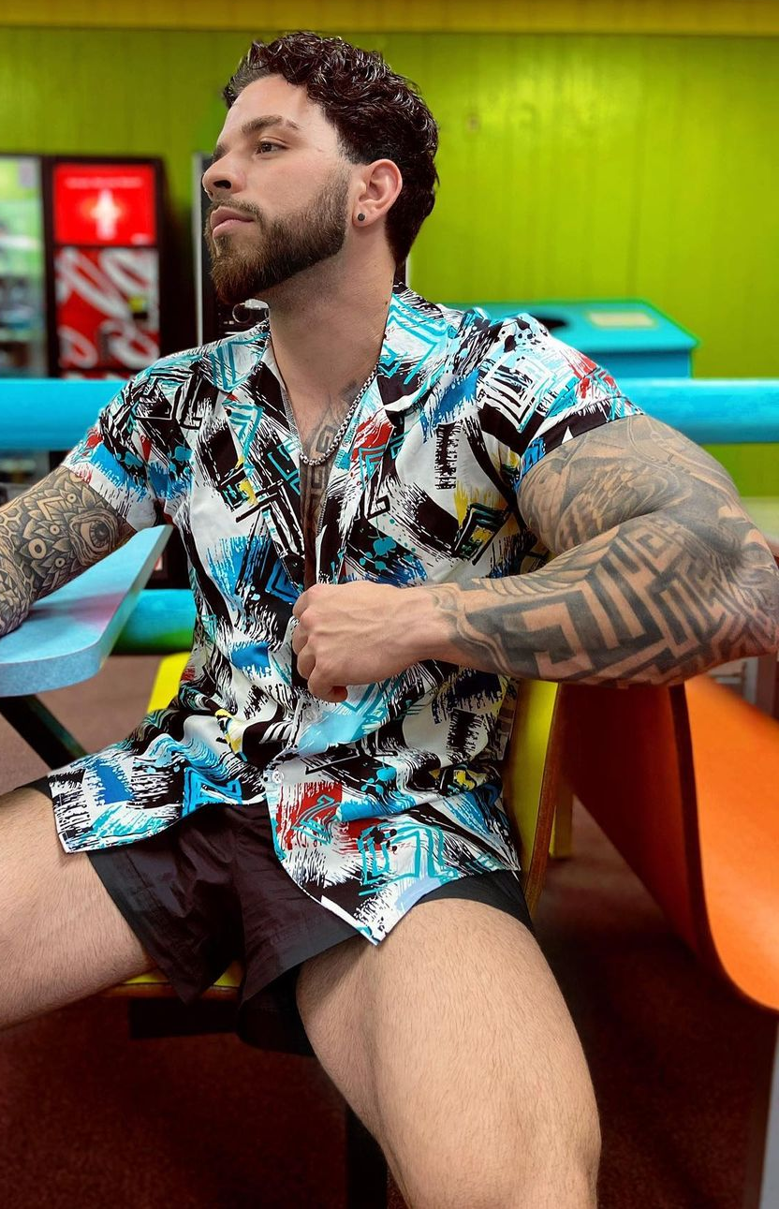
Upon arriving at the girl’s table, Tom used his countless knowledge about Chris and his content that discussed talking with and seducing women. As such, the man was practically on autopilot as he said all of the right things until he was given access to sit at the booth with her. Upon sliding into the seat, the man took the opportunity to display his gorgeous physique by spreading his legs out into the aisle and tensing up his arms. To his amusement, the woman was easily transfixed by his thick and defined quads and thus couldn’t help but stare at the small and tight black shorts he was wearing. While he was amused by the woman’s clear desire to know what was contained beneath the piece of fabric, Tom was a glutton for admiration and thus caused the woman to spend equal time admiring his tattooed arms by tensing his arms and even flexing for the woman in between the several rounds of shots that he had ordered for the both of them.

After these additional rounds of drinks, it was safe to say that both members of the incredibly photogenic duo were quite inebriated and extremely horny. Before they even made it to the Uber awaiting them outside that Tom had ordered a few rounds prior (he already could tell that she was more than willing to go home with him), the woman had fully jumped up and wrapped her arms and legs around Chris’ impressive physique. Knowing that the woman was essentially putty in his hands, he wasted no time moving his hands to her backside to cup her perky ass while continuing to passionately make out with her - tongue and all.

Upon being accosted by a few bartenders to get out before they started fucking on the tables of the bar, the couple hurled some slurred insults back at the workers before finally exiting the bar and entering their Uber. Throughout the entire journey back towards his apartment, Tom kept a cocky smirk on his face while maintaining contact with the mousey twig of a driver as he continued to peer into the rear view mirror to look at the backseat. While most times Tom would have been quick to tell the man to keep his eyes on the road, he couldn’t blame the man for wanting to glimpse it all. After all, he was an absolute stud with an equally gorgeous woman still wrapped around him. In his drunken state, it would have pissed him off more if the man hadn’t been watching him!

Before either Chris or the woman were aware of what was going on, the driver was already parked outside of the apartment complex and telling them to get out. While both of them could have been pissed by the man’s bluntness, they weren’t going to complain about it too much since it just allowed them to get to the main event sooner. By the time Chris had unlocked the door and entered his residence, the two of them were back at it making out and peeling off each other’s clothes. While she was quick in removing the man’s shirt, Tom was feeling especially cocky and thus eager to put on a show for his female companion. So, with his thicker hands, the man purposely fumbled with the woman’s button-up top for a few minutes before deciding on a much hotter alternative. Licking his lips while staring down at the shorter woman, the man suddenly grit his teeth as both hands wrapped around the top of the shirt and tugged. Immediately, the fabric split down the middle, creating casualties in the form of small buttons that popped off of the garment and tumbled down onto the man’s tiled floor.

To the man’s amusement, the woman attempted to stifle a moan at the erotic display of strength. These moans only began to grow more intense as Tom took the opportunity to unclasp the woman’s bra and free her sizable breasts. Smirking at her exposed and perky melon-sized breasts, Tom took a moment to give her a reward by getting onto his knees and running his luscious lips down her chest and across her nipples. As the woman groaned and moaned above him from such undeniable pleasure, Tom showed no plans of stopping as he progressed down the woman’s taut torso and found himself staring face first at her lace-covered crotch. Despite not actually being into women prior to becoming Chris, Tom’s tapping into Chris’ personality had caused him to start second-guessing his identity as a gay man. So with an animalistic desire filling his mind, the man couldn’t resist moving his lips up to the waistband of the panties and lightly biting down on them before pulling them down. Keeping his eyes staring upwards at the gorgeous brunette, he couldn’t help but chuckle through the fabric in-between his teeth due to just how horny she looked. It was erotic as hell to visually see how much pleasure he had given her before he had even fucked her senseless!

But upon letting go of the panties and allowing them to tumble onto the floor, the woman was quick to step out of them and prepare for the next round of foreplay. With such an inflated cockiness within him now, Tom was eager to have his ego stroked by the woman. So as he got back up onto his feet, the woman was totally content with having him take control and force her down onto her knees. “That was fun, but now it’s your turn to put in some work. How about you start admiring these muscles to show just how much you want me…” he slyly teased, relieved as the woman was quick to jump into action.

Tilting his head back, deep moans began to escape from Chris’ mouth as the woman eagerly did as she was told. This hadn’t been the first time that Tom had his female companions worship his gorgeously buff body, but this woman was by far and away the best at it. Her lips and tongue were a killer combination as they ran along the curved musculature of his biceps and even ventured deep into his sweaty armpits. Continuing downwards, the woman peppered kisses from her bright red lips as she went from the man’s pumped up pecs to his cobblestone abs. At her lower elevation, it wasn’t much of a shock that her mouth took advantage of the opportunity and began toying with Chris’ thick manhood. “Aw fuck,” Tom groaned, turned on by just how well the woman was pleasuring him while using her well-manicured nails to grasp onto his firm yet perky ass cheeks for support.

Given the fact that he felt himself rushing towards orgasm, he was quick to pull the woman away from his cock and instead lead her directly onto the bed. As such, the two individuals didn’t even bother to grab a condom before he plunged his thick rod into the woman’s tight pussy. As the two of them grunted and groaned in near-unison, it only took a few minutes before the main event had finally ended and Tom had shot a thick load deep within the woman.

After such a physically intensive day even before their rendezvous, it wasn’t much of a surprise then that the two of them were quickly growing tired from the exhaustion. Still eager to be a gentleman, he allowed the woman to stay the night as they both fell back into the bed and almost instantly fell asleep. While the woman’s final thoughts before passing out considered the potential of a future relationship with Chris, the man next to her wasn’t thinking the same things. Instead, he was thinking about an even better relationship on the horizon, the one that would begin tomorrow when he possessed a brand new man and took over his life…

