Big  A Short Story  By Maryanne Peter  Guys my size can never become girls. That is what I thought.  When I was little, I would cry myself to sleep wishing that I had been a girl, but then I would wake up and face the reality. I was male, just like my father and my two brothers.  I often wondered why I was this way. My mother had a stillbirth between my older brother and me – a girl. Can a mother wish so hard for a girl that the next boy in her womb is born to feel like one?  She never treated me like a girl. I was just a boy like my brothers. We were all big and strong. Muscularity was in the family. My father was a wrestler and a college football player. We all followed him into the sports he loved. It was just expected. | 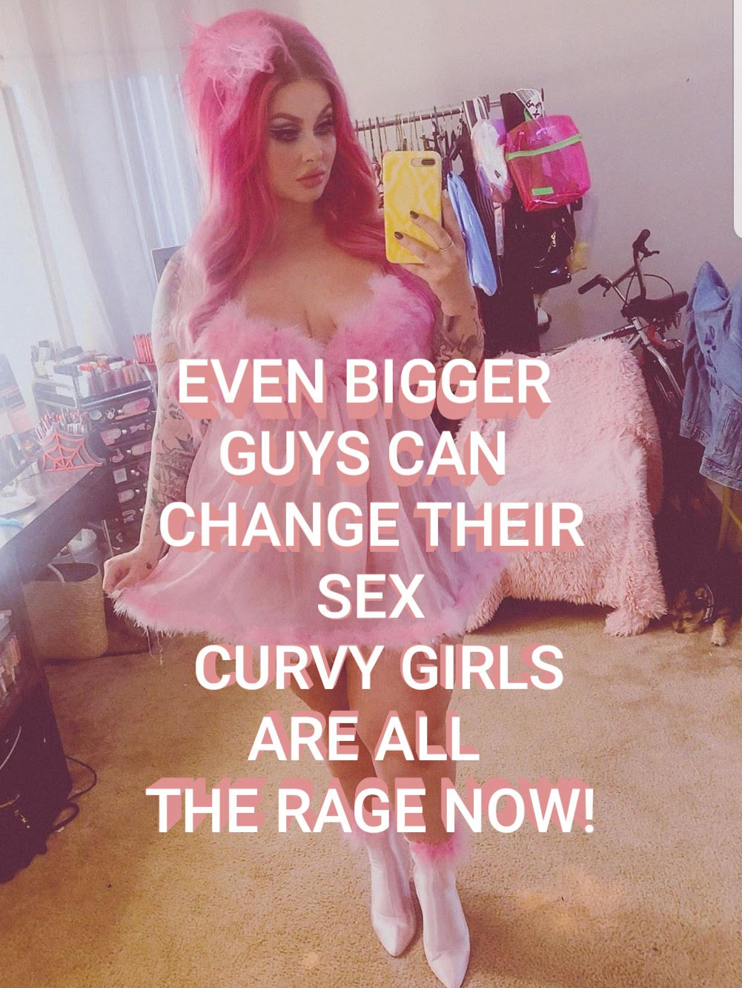

He built and raced stockcars as well and hiked and hunted in the woods. He took his sons with him. We loved him. We wanted him to love us back, and he did. A real man and his three sons – all chips off the old block.

In that environment, you suppress any thoughts of being a girl. And when those thoughts pop into your head, you look in the mirror and you see what you are. Your father’s son. A real man like him. You can’t hate yourself for being just like somebody you love.

I decided that I was not going to cry myself to sleep any more, I was going to be the best man that I could be and make my father proud. You must live with what you have got. I mean, some people are born without arms or legs. Do they cry? They just get on and live life with what they have. Some of them say: “I don’t need legs. I wouldn’t have them if you offered them to me”. That is the spirit. My curse is that I don’t have a pretty little vagina between my legs. So what?

But then you see pretty girls who used to be guys. It seemed to me, because I kept thinking about it, that they were all over the place. Somehow, I just had to tell myself that I could never be one of them, because I was a big guy.

I messed around with girls because all my friends were doing it, and after all, I was just like them - a guy. I met a great girl and we formed a relationship just like any other. Guys do some things as just guys, like going on the town together, and some things as couples. That is the way life is.

My feelings about the woman who was to become my wife were complicated, I guess. I mixed with men but loved women from afar, so as far as I was concerned I was never attracted to men sexually. I liked everything about women – their clothes, their hair, their makeup, their bodies. So why did sex seem wrong? I could function sexually, but it did not seem right.

Because I was a big guy, I would let her go on top. I would close my eyes and imagine that I was a girl being fucked. That would send me off to another place, and the orgasms where from another planet. How would she know what I was thinking?

We got married because other guys were doing it, my brothers included. But I had trouble going through with it. “Do you take this man?” She said yes, but it occurred to me that it was a lie. I was not a man at all, inside anyway. But her oath came second. I had already agreed to take her. It was done.

I felt that I needed to tell her. We had a special relationship of trust. But I could not do it straight away. I did not want to upset her, but I had the feeling that I had betrayed her by marrying her in the first place. She could have a real man. That is what she deserved.

I had picked a truly good person to be my wife. She is the example that I have tried to live up to ever since. She was sad but sympathetic. I told her that if she wanted to shout and abuse me, she should.

“No,” she said. “You need to be the person you are meant to be.” Who would say that?

“Look at me,” I said to her. “I look like a man. I could never look like a woman. And I way too tall – too big.”

“Your shoulders are not as broad as your brothers,” she said. “Your hands and feet are not as big as theirs. Those are the things that surgery cannot change.”

Surgery? For the first time I started to consider that. My whole life had been spent wishing or wondering “if only”. Surgery is real. A knife into flesh. If only there was magic in the world. Instead we have cuts and stitches, and pain.

Really it never would have happened without her. She gave up her husband so he could become a woman. It was just that he was going to be a big one.

But she was right. The parts of me that I could not change could be concealed or disguised, and everything else could be changed by modern medicine: Surgery and hormone therapy. I just wanted to be pretty. I felt that if I had to be a big woman, I should be a big beautiful woman. There are plenty of examples to strive towards. Plus size models proud to be big. Transwomen who look more like women that most women.

I worked hard and I made money, and I saved. And when I was ready, I took the plunge. I told my family. My father was disgusted with me, but my brothers were strangely approving, as if one of us had been eliminated from the competition for Dad’s approval.

My mother was just confused. I think that she still is. She still doesn’t know what to call me. If she asks my father for guidance, on this point he ignores her, as he ignored me as I went through my changes.

I had facial feminization surgery first. I only wanted to prove that I could be attractive enough. It seemed that if I failed in that, maybe I could become somebody other than me - perhaps some kind of sexless in-between creature, without need of further surgery. But as it happened, when the swelling was down my wife and I were both surprised at how beautiful I was. It almost seemed to confirm that I had made the right choice.

The hormones were equally surprising. They seemed to eat away my muscles leaving in there place the most wonderful soft flesh under my newly smooth skin. My growing hair seemed thicker and soften, and lighter in color.

Some big girls are self conscious of their height. They wear only flat shoes and often they stoop or bow their heads. That is not me. I like to walk proud. My legs look great in heels. But you could see people whispering – probably imagine the words: “That has to be a guy”. My challenge was to make it hard for them to believe it. “It could be girl, just a big one”. That was the whisper I wanted to hear.

I suppose that makes you pay more attention to something they call “deportment”. I took some courses. The trick is not to overdo it. No effeminate flourishes, just grace and elegance.

The voice is important too. To be totally convincing and then open your mouth and know the game is up, can be disheartening. I decided to have surgery to tighten my vocal chords. I was lucky there too. After almost a month of silence the tone developed into something perfect.

I discovered that being a girl is expensive. I was still able to work, but the woman I wanted to be needed more money than I could make. It was aggravated by the fact that my wife and I agreed to separate. We still love one another, but as girlfriends. She needed a man in her life, and I was no longer that. And I soon discovered that I needed one too.

She stayed with me through the final bottom surgery. She wept for the penis that she had lost, because it was no loss to me. I could not wait to test myself for depth, and pee sitting down. It was what I had always wanted. She understands because she loves being a woman. So do I.

I am not sure that I ever went looking for a man. It was just that once I knew that I was a complete woman, I am sure that I exuded it somehow. That combined with my now statuesque figure, long blond hair, long tanned legs, and no-nonsense attitude, attracts a certain kind of man.

I think some men look at big girls like me and say: “She would be a challenge to bed”. Sometimes I would tease a guy by wrapping my legs around him to pull him in, just letting him know that I had the strength. But the truth of it is that guys like their girls feminine, and that is the way I like me too.

I never wear pants, unless they are short. I have great legs, and I like to have a summer breeze breath directly on my gossamer thin panties so that my pussy feels almost totally exposed. I suppose it reminds me just how good it feels to have one.

Anyway, after dating a few guys I met Gilberto.
Of course, he is smaller than me. Actually, much smaller. When I am wearing my heels, his face is level with my tits. He doesn’t mind. He likes being level with my tits. He likes to put his face in between them, and I like that too.
I told him once that if I put my arms around him and fell on him it would be a killer body slam. He said that to die in my embrace would be to die happy. That is my guy.  But I am so girly that he knows that he could make me cry with a few nasty words, but he doesn’t do that. It is just my nature now. My aggressive past is all behind me now. I am a girl, which all I have ever wanted to be.  Just a big girl.  The End  © Maryanne Peters 2020 | 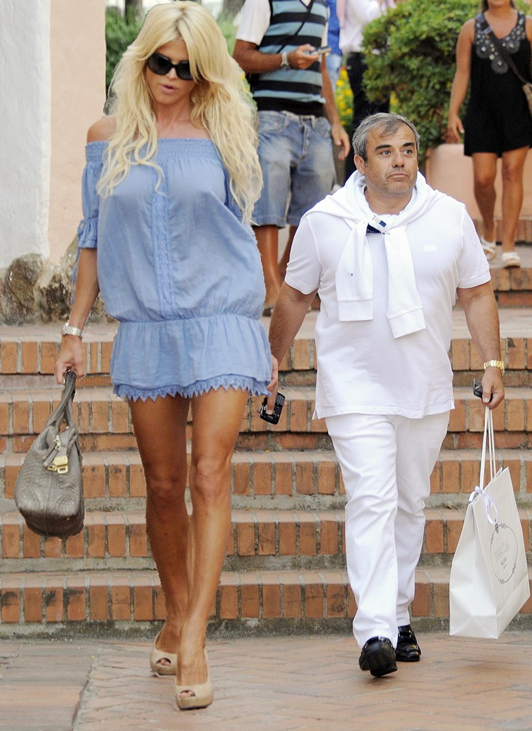
Author’s Note:
This is for all those out there who have asked for a story about a big transwoman. Unfortunately the image is of cis-woman Victoria Silvstedt and her husband, but it is just perfect!

