A Wife to Geoff.
A Short Story
By Maryanne Peters

I thought that what happened to me was so totally outrageous that nobody would believe it was true! Even I would have trouble believing it, if it were not true. Completely and utterly true. And I now understand that there are others who have had similar experiences.

You see, I never knew much about what “transgender” actually meant. I can’t say that I never heard about it, but I did not know about it. In fact, it might well be that I did not want to know about it. People conceal their feelings when they are embarrassed about them.

I am not saying that I was secretly transgendered all along. I was just busy having fun. That is the kind of person I am. I am ready for anything if I think that it’s going to be fun. Sometimes I just never thought too much about the consequences beyond the short-term laughs. Honestly, even now if somebody told me that: “From now on you have to go through life dressed as a rabbit” I would say: “How big are my ears?” I mean, I am concerned about my appearance. If you stay positive the way you look and how others look at you, should not be important.

I was Travis. Just a simple guy, trying hard to make a living (but not really succeeding) who liked to dress up as a girl every now and again. That doesn’t make me gay. I still had sex with girls, sometimes when I was in drag. They liked it, some of them. That does not make me transgendered either. Transgendered people have got a hang up. It seemed to me that they were the people who saying: “Life is so cruel, ‘cos I should be a chick”. I wasn’t like that. I was having fun.

It was crossdressing, not drag. For me it was not about being outrageous, it was being convincing. I suppose that is the difference between drag queens and cross dressers. Drag queens are mimicking a female ideal, in a way that does not disguise that they are men. They want their audience to say “wow’, and maybe laugh out loud. A cross dresser wants their “audience” to have a double take. “Is that really a guy?” That’s what they want to hear.

What I liked to hear was: “No way. You’re not a guy. Are you?” Man, oh man. The thrill of hearing that … that’s my thing. Or it used to be.

I had an idea of what a woman should look like which some might say was planted in the 60’s. I think the reason is that for a man (as I was) that was a simpler time, when women had a place in the world. You might say that it was subservient to men, but women of that time sure did not think so.

Well how would I know? Not even my parents were alive in the 60s. I just liked the look. Women were unmistakably women. Men were unmistakably men. Nothing in between. Nowadays everybody is in between. Including me, before Geoff.

Before Geoff, I was just a regular guy with a flamboyant hobby. A hobby that does not come cheap.

If I had only one problem in the world, it was money. I mean, the lack of it. Dresses cost money, but as long as I could get the style of dresses (I liked from second-hand shops) and spend some time cleaning and sewing them up, I could pay for that. I got to be handy with a needle. But good wigs were expensive. Believe it or not, that is why I grew my hair out – to save money on wigs.

Getting the right look costs money but posting it on social media costs nothing. I am not the only cross dresser to post a picture of himself as herself, but I might just be the prettiest. Geoff thought so anyway.

He told me right up front: “I am not gay”. He said that he liked women who want to be women, just like the look I was portraying. Somebody who relishes in femininity. Somebody who is not ashamed to accept all those old-fashioned notions of what a woman should be. And somebody who does not turn into somebody else once a month.

I could understand that. I think most men can. It is just that there are not many real women out there who want to be the kind of woman Geoff wanted. They don’t understand. I did.

He asked me whether I had ever fantasized about being a wealthy man’s wife. Somebody who could live a life of leisure. Somebody whose only function in life was to be pretty and attentive. What cross dresser would not say yes to that question? It’s a fantasy, right?

I mean, I told him the same thing he told me: “I am not into guys”. I told him that I had a girlfriend, but the truth is she had been gone for weeks. Initially she had been happy with my “hobby”. She liked to help me with the dresses and my hair, and we even went out on the town together as two girls. I think it easier to pass when you are with a born girl.

She used to hate it when I would say: “One of us is a guy. Guess which one.” That was because 50% of the time they would pick her as the guy.

I used to say that we split “because of differences in style” – she liked a modern look and I preferred retro. But there were other factors. I think that she felt that I was becoming less of a man in other ways, and that was way before Geoff arrived on the scene.

I guess when he first made contact, he was just another cyclone in a perfect storm. I had no money when I needed to fund my hobby, no girlfriend when I needed intimacy, no support when I needed purpose. Geoff just ticked all the boxes, filled all the holes, whatever.

He started by buying me stuff and having it sent around. Initially it was just dresses and shoes, but then he bought me skin treatments, and wanted me to accept hair and beauty appointments at a salon he had chosen in my city. That was when I told him that I had a job as a man. I could hide shaven legs and even (only just) my smooth face, but I could not hide a woman’s hairdo or shaped eyebrows.

“No problem”, said Geoff. “Your job sounds like shit. I have attorneys in your city. They are looking for a lady just like you … or rather they will be as soon as I call them.”

I laughed and did not take it seriously, until I received a call from someone in the law firm he mentioned, making me an offer I could not refuse. It was an administration job like the one I was doing, but they were offering twice what I was getting for a job that was way more interesting. I just had to turn up in a dress. Geoff sent me an entire corporate wardrobe.

I found out later that Geoff had a fee deal with the law firm, and he was basically funding my employment. But he never really liked me working. He never really liked the clothes that I wore to work. Even the skirts he thought were too masculine. He wanted me to dress like his ideal woman.

But I liked working as a woman. I said before, that I got off on people believing that I was a woman, and I had that every day. And I am not talking about sitting in a bar with plastic tits and showing off my legs (which are pretty damn good, if I say so myself) I am talking about looking like a woman even in ordinary clothes.

Only maybe two or three people knew from Geoff that I was not a woman, like his main lawyer and some people in HR. For the rest I was Miss Lisa Fortune, Administration Executive. I was classy and professional, and always wore heels, even on casual days. And I did pretty good work too.

And when I walked out on the street, I could see, and maybe even feel people looking at me, and they were thinking (I would think): ‘There goes one super sexy office lady’. Man, oh man. That is what I like.

I always made sure that my hair looked good. Geoff loved my longer hair. It was blonde and styled as he had chosen, straight on the top and curls at the back, or sometimes just a flip. I suppose a 60’s style. A regular shampoo and set, almost every morning before work, all directed and paid for by Geoff. On mornings when I did not go to the salon, I did a pretty good job by myself, with a brush and spray. Geoff never liked a hair to be out of place.

All I had to do was take selfies and send them to Geoff. All around shots with my mirror cam morning and night, and the occasional shots with my phone during the day. Just for Geoff. No more public posts of me looking hot, now my look was just for my man Geoff, and him alone. I mean, he was my man, not “my man”. Not then, anyway.

Still he said that he did not like the thought of me working. He said that a woman like me should be in charge of administration of a big house, not an office - looking after a husband, meeting his needs and being pretty all the time.

I laughed, but he said that he had just that house - in Austin TX., his hometown. He wondered whether I would consider coming to Texas to have a look. He told me that he ached to touch and smell my hair. Just my hair, he promised, and to look at me in the flesh. He wanted to meet me. Up until that point everything had been at a distance. He offered me first class tickets to fly to Austin, which was the closest airport to both his ranch and his city apartment on the lake.

Somehow, I knew that I would be flying into something that there was no getting out of – like a fly who sees the spider’s web but flies into it anyway. The thought was just so soft and inviting. He had everything. I had nothing, or damn close to it. And my hair did look, feel and smell very good. I wanted him to touch it.

So, I got on the plane and arrived in Austin. That is where I am now. I never went back. He said forget everything I had left behind, but I asked him to have the movers collect just a few things. Only the clothes and shoes I just had to have. Nothing male. Never again.

You see, that is who I am now. A wife to Geoff. Oh, he wanted changes, of course. He liked breasts and did not like penises. I can understand that.

I am not saying that I agreed to anything drastic on day one – Hell no. He was a gentleman. When he met me at the airport, he kissed me on both cheeks, and told me that I looked better in real life. Awww. I loved that. I asked him to smell my hair like he promised he would. He told me that he wanted me to go blonde. Of course, I agreed.

I don’t know what I was thinking. I guess I just thought we would have some fun. I was not thinking about anything physical. I just sort of moved into his place and had my own room. It was a big bedroom with two large beds side by side. It was just like those sixties shows when the married couple sleep in their own beds like that. I thought that it sort of said: “This is not a physical thing”.

But when he came home one day, and I had some Matt Monroe playing (I don’t even know who that guy is!) he came up and took my hand and we danced close together. I just sort of melted into him. He was so big and strong, and I was feeling super girly – small, soft and weak. When he kissed me, it seemed like the most natural thing in the world. It was not gay at all.

Once you think of it that way, then you kind of look forward to him getting home and giving you a real kiss. Not like a peck on the cheek. What does that say? A real kiss, with tongues touching, that says: “You are beautiful and sexy and I can’t keep my hands off you”. It’s what a girl wants – right?

And it turns out, he couldn’t just do that. He had to have more of me. But I’m not saying he forced himself on me. That would be an injustice upon the greatest guy in the world. No, I wanted him to want me. I wanted to be just like the wife he wanted me to be. What is being pretty all about if not to make a man desire you? And then what are you going to do? Swat his cock away? No, you are going to take that thing and stroke it until it explodes. Maybe even lick it a bit, just to make it slippery. I am not saying that I am a cock sucker, but … well, maybe just a little.

He said that he was not into anal. I understand that. Me neither. But what is a girl going to offer? I had to read up about it. I had to break myself in. I didn’t want him to cause me pain. I figured that I would do it to myself until I felt that I could offer him my sweet little ass. But when I did, I guess maybe I underestimated his size. When he was in me up to the hilt, I thought his cock was going to push my head off. Anyway, the sound he made when he exploded inside me was the sweetest sound a girl can hear. It was worth 20 “I am so lucky you’re mine”s and at least 10 “You are the most beautiful woman in the world”s.

I was getting that, and more. I am not talking about material things. OK maybe that is why I moved in, but it is not why I stayed. I fell in love with Geoff. That’s it. I don’t think love is about sex. Sex can be an expression of love, but you don’t need to have a sexual relationship to fall in love, do you? How would I know? We had both. Bucketloads of both. We had a love bigger than Texas.

When he asked me to get the breast implants, I said: “How big do you want ‘em”. Just big enough. I am just so proud of those girls. I don’t think that I have worn any clothese since that do not scream out: “Look what I have here”.

Then he asked me to marry him. On his knee, with the biggest diamond you have ever seen. I knew what to do – squeal a bit, say yes 100 times and then burst into tears of joy.

He wanted to make it real. He wanted our fantasy to come true. Just one little condition. One tiny thing. One tiny thing that did not belong.

You cannot say no to a man like Geoff. You might start that way, but it will not last. He could talk a dog off a meat truck, that man of mine. God knows, he talked my meat off me.

The End

© Maryanne Peters 2019

Me in a wig | And another wig

My own hair - Starting with a pixie cut then growing it out before I left for Texas

Going blond and getting the implants | Wearing my hair up, at the ranch
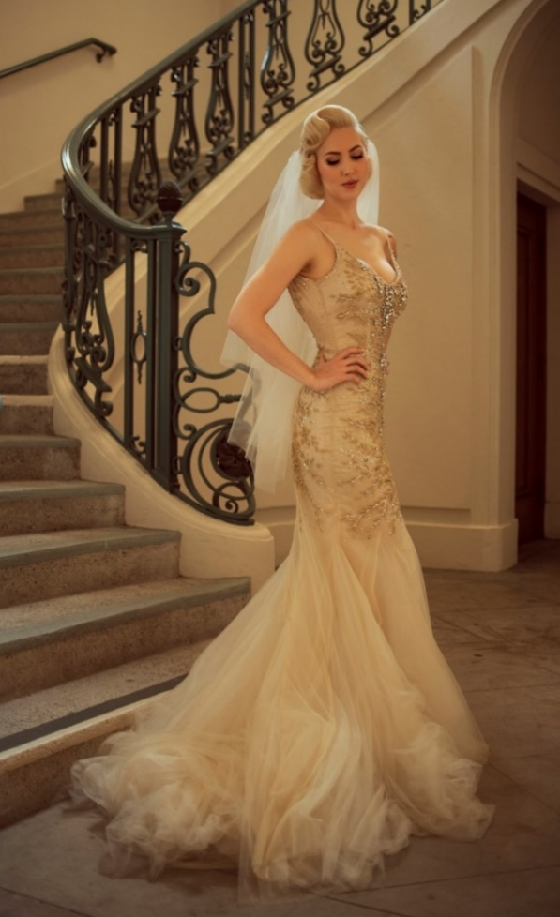  Ready to marry my Geoff | Marrying Geoff
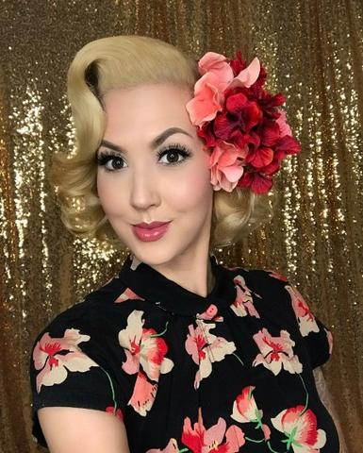  Glamor girl | Super fem photo shoot
I like my hair longer | 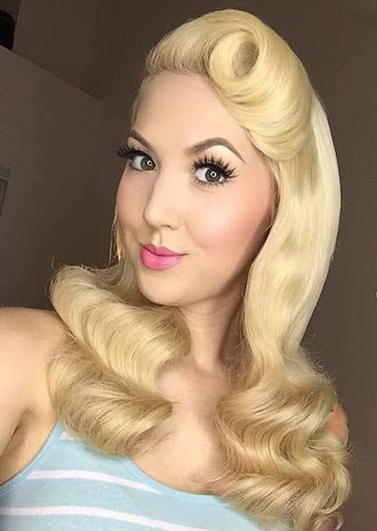  But Geoff insists retro styles

This story has basically been drawn from reviews of “Texas Wife”. When I posted that on Fictionmania, SassySue said that “it is totally unbelievable to me that someone who was apparently completely heterosexual at the beginning of the story could be enticed to make love to another man and surrender his manhood. … The story would be more believable if the protagonist were not a CD to begin with, but a TS.” Well, can I suggest that all the subjects of my stories are TS. It is just a question of realizing that.
Roberta also asked: “Please do another like this but longer, with a R or higher rating if you would be so kind. I hate to ask this but I cannot do what you do …”. For you Roberta, with sex but not X rated.
Also, with apologies to Lisa, my Lisa lost her meat. The images show just how old-fashioned I am.

