Salon Supplies
A Vignette
By Maryanne Peters

My business is business. I buy and I invest, and where I need to manage my investments, I do that too. I try not to get too involved in what I buy. You always need to be ready to sell and tell the staff that you are leaving and so are they. There is no room for sentimentally – no room for attachments.

I liked the salon supply business from the moment I understood it, but it has its peculiarities. The business I bought had exclusive agencies for some European brands – equipment and consumables. Nowadays some salon equipment is expensive and margins can be good, but the best thing is consumables. You get the salons you service to brand themselves with your labels and then you keep selling product to them – not shampoos and conditioners so much, but hair dyes and curling chemicals, setting and straightening compounds, sprays, lacquers … everything. The key is to build your customer base and then it becomes a cash cow.

The business that I bought had gone through all the hard work in building a customer base across the country, but was then running out of money to maintain the stock levels they needed. It was like building a hotel and not having money to run it. But unlike a hotel, a customer list has no inherent value, but brand tied clients do. They were in trouble, and I knew it. I screwed them hard, and I bought the business at a bargain price.

Part of the terms of purchase was to keep on the manager, David Bewley. He was a nice guy, but as I said, I am not sentimental, or I wasn’t then. He needed my money and that meant that he had to lose his equity. It’s as simple as that.

“You need to learn about the business,” he said. “You need to understand how a salon works. Yes, our business has been to supply salons but you still need to know how a salon works and how products and equipment a reliant on style trends.”

He was not wrong. In every business I have ever been involved in, a visit to what people term “the coal face” has proved more than useful. With distribution that means visiting the warehouse (the obvious problem there was that it was empty) and meeting some customers. Sometimes when you do that you discover what is really going on, and adjust your thinking. I agreed that I would venture into the female territory of the beauty salon, purely for business research.

“I suggest that you visit Cherise Golbendian,” David said to me. “They say she works magic with our product. She is a major customer of my business … I mean, your business.”

“You have done a great job building what you have, David,” I said. Like I said, I liked the guy but I felt that he needed to understand the reality. “You need to move on and find another business. You should treat this as a new beginning.”

“Like I said, go visit Cherise Golbendian,” he said. “It might be a new beginning for you too.”

We shook hands. I am not sentimental but who doesn’t want for both sides to be satisfied – that is just good business.

So, I went to Cherise Golbendian’s salon “Beauty by Magic” the very next morning, in a very positive state of mind. She was a mature woman, tall and raven haired. She looked a bit like the evil queen from Sleeping Beauty – very attractive in a slightly malevolent way.”

“David told me that you might come,” she said. “He said that you want to pick my brain and learn the secrets of my success. I explained to him that I am happy to talk but I only talk to customers while I am working on them, so If you want to hear it all, the take a seat right here.”

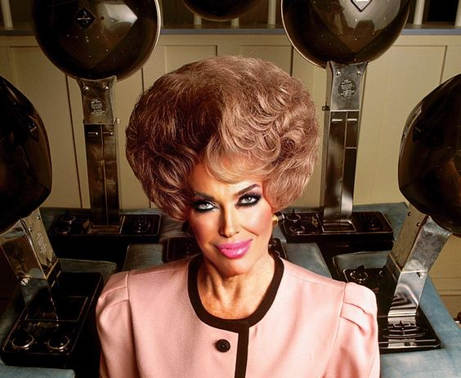

Of course I don’t believe in magic. I am in business. I base my decisions on rational analysis. Sentiment has no place in business and neither does superstition, so what happened to me? My only explanation is that the desire to be a woman was inside me the who time, just deeply repressed for a lifetime. Perhaps those childhood memories that transwomen talk about of crying themselves to sleep when they realized that they were doomed to be male were deliberately wiped from my my mind? It seemed that all that Cherise needed to do was to show me that I could be a beautiful and even glamorous mature woman and all that inner gender dysphoria returned to make everything clear.

I remember that the first time I saw the woman that I needed to be in the mirror in front of me I burst into tears. I am sentimental and I was meant to be. All that repression was a waste of years.

I have decided that I cannot waste another minute. I need to live the life I had almost lost. There is always somebody who can run a business, and I happen to know just the man.

I know it is not good business practice to get involved with hired staff but I have actually discovered that David Bewley is not just a capable manager who just needed an injection of capital, but he is a charming and virile mature man, who is just what a woman like me needs.

Th End

© Maryanne Peters 2023

