Enchantment Park
A Short Story
By Maryanne Peters

Have you heard of it? Enchantment Park. A place where children can be in their favorite fairytales.

I suppose it is more of a girl thing than a boy thing. The big attraction is the princesses. They are always described as being “serenely beautiful” and “larger than life”. What little girl would not like to be alongside them.

To be honest I would have taken any job. I had been out work since I left school and the offer of a professional gaming contract fell through. I was just moping around the house, driving my Mom crazy. She was working all hours as we were basically broke and there was a mortgage. Mom would say stuff like: “You’re sitting at home all day at least you can clean the house”. But I’m no good at that kind of stuff.

I was getting desperate for a job so I sent in my application with education (poor), skills (none) and photo (yes) to the Enchantment Park HR department. I guess I expected the usual rejection letter, or maybe nothing at all. Instead I received an appointment time for an interview.

They seemed to spend more time looking at me than anything else. They ran some tests on me using a PC. They said that it was to “assess how receptive I was to subliminal training” whatever that meant. When they started measuring me and doing 3-D mapping of my face I knew that I was on the short list. I asked, but they told me not to bother cutting my hair, so that was all cool.

I went home and I received a call only a day later. I was told that I could report on Monday for training, that I would be living in for a minimum of two weeks, and that I did not have to bring anything but the clothes I stood up in. I guessed whatever I was doing, uniforms would be provided. My mother was so pleased to get me out of the house, but on the promise that I called at least every third day.

They even sent a van to pick me up. I did take a toothbrush, a comb and a shaving kit, but they told me that I would not need any of that. They said that I would be sleeping in teeth whitening trays, my hair would be attended to by experts and I would never have to worry about shaving. They threw everything I had in the trash when I arrived, including my shirt, pants, socks and shoes.

The first thing I had to do was sit down for an orientation session in front of a PC again. Computers were kind of my thing (not how they worked, just the things I co do with them) so I was cool with that. I just followed the directions, and the screen just kept on telling me that I was doing great.

I had to speak into a microphone, but I could not advance to the next level until I had got my voice up really high like Alvin the Chipmunk, although I don’t think he was one of the characters in the Park. I had to keep talking like that to stay in the game. I had to make faces, and do hand gestures and stuff, and build points.

Then I was shown pictures of the people I would be working with. Now let me see, there was Andy and Manny, and …, I can’t remember all the names because we would have characters and we needed to get used to using the character names. There were Princes Ariadne, Maria, Carlotta and I was to be Astera. We were not the only princes in the Park, but we were “within the same universe”.

So, I was ready to get into costume, because I suddenly realized that I had been sitting in front of a screen stark naked for maybe … well, it was nighttime, and I arrived in the morning. But I wasn’t tired. They gave me some injections and energy drinks. It must have been intravenous caffeine. I was wired.

The next thing I had to do was go in for some face treatment. I have to say that whatever they did I walked out of there with my face tingling. They washed my hair and I slept with it wrapped up, and just as the guy said, no toothbrush, just a mouthguard thing that I slept with. They were right. I didn’t need any of that stuff.

In the morning I looked in the mirror and decided that I looked great. Different, but good. I can’t quite put my finger on it.

I had slept in a night shirt thing but in the morning, I was given a tight one-piece thing to wear. It was like a wrestlers’ outfit, or more like an old ladies’ swimsuit with padding in the front and the back, and tight in the crotch. Then over that I put a … what would you call that. Anyway, I can show you later.

So, when I was ready, I went out to meet the other guys. I recognized them straight away, from the images on screen. Princess Ariadne had long pretty blonde hair and he was a really nice guy – very welcoming and friendly. Princess Maria was dark and very attractive – nice but can get a bit catty when things don’t go her way. Then there was Princess Carlotta. I guess you could say that he was a little confused. He kept saying things like: “Hey, this isn’t right. We shouldn’t be dressed like this, or talking like this, or dancing.”

Well, Carlotta, what’s wrong with dancing? Am I right? Dancing makes you happy. Dancing makes everybody happy. That’s what we are here for. Like that the whole purpose of Enchantment Park. Der, Carlotta, der.

I called Mom and she asked how things were going, and I said that the Park was beautiful and this was like, the best job ever. She asked me why I was talking in a funny way and I told her that this was just my character, I was a princess. I got that wrong. Not a prince but a princess. Only two extra S’s but basically the same thing, right?

She asked if she could come and see me, and I said that would be OK, but I was very busy. I said that I was very happy, and I would be staying on as long as I liked, but I could quit at any time. I told her that I had no need for the pay I was getting so I suggested that it be sent directly to her. Times were tough for Mom so she was happy for that. And I was happy to help.

As I said to her, I don’t need the money. Room and board is included for all princesses employed at Enchantment Park. All expenses paid for including free healthcare and regular injections every month or so, and checkups. The medical people a very concerned for our health and every week they check up on us, like measure if we are getting flabby on our chests or our butts. The way they tell it, flabby can be good if its in the right place, and when It is we won’t need to wear that uncomfortable wrestler underwear anymore. Instead all we will need to wear under our costumes is silk against smoothly plucked skin. How good is that?

Well, I got my silk slip last week and a supported for my breasts. It’s been months, maybe even longer, since they started to grow, but now they are hanging off me like squishy softballs that make me gasp when I squeeze the nipples. Man. Was I glad to see that wrestler thing go in the bin.

Princess Carlotta is even bigger in the chest than me, bigger than any of us, but still crying a bit. Princess Maria says it will be much easier for all of us if we just start calling Princess Carlotta “she” and “her” and she was right. I talk about everybody at the park that way. Except for Prince Adrian, Ness the soldier, and Pavel the woodsman.

Sometimes we get to go up the tower, sometimes down in the cave with the maze and sometimes in the horse-drawn carriage. Adrian, Ness and Pavel can take turns rescuing us. It seems so real when they do it. I mean, I know it is only make believe but when Pavel does it, things just seem different. Sometimes he has to kiss me, as part of the show, and he likes to stick his tongue in my mouth. I let him because it feels kind of neat. I know I shouldn’t, but …

I haven’t forgotten about sex. I mean, I used to watch a lot of porn. It is just that princesses are not into that kind of sex. We are on another level. We’re special. And I don’t mean that because we have peckers, because those things are so tiny that they hardly count.

The word is that they can be fixed so that we can go to the toilet properly. Have you see the outfits we have to wear? The only way to pee is sitting down, and for that you need a pee stream that points down, not forward and all over your petticoats in front – messy and smelly. I always say I can’t wait for the correction, although Carlotta thinks I am crazy. Hygiene Carlotta, der!

To think that I used to have such a grubby life. Dirt and whiskers and yuk!

Now I am a clean. Every morning I get up do, my face, and my neck and cleavage, I put on my petticoats amd crinolines and my dress, I arrange my hair and put on my crown, and sometimes I just look at myself in the mirror and I squeak with delight, because I have the best job in the world – I am a princess at Enchantment Park.

The End

© Maryanne Peters 2019
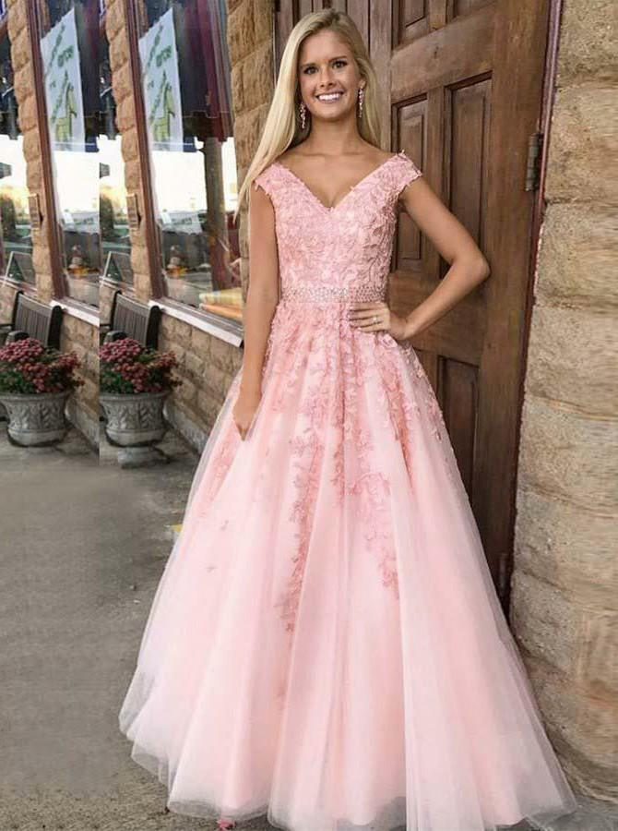  Ariadne, previously Andy (no makeup!) | 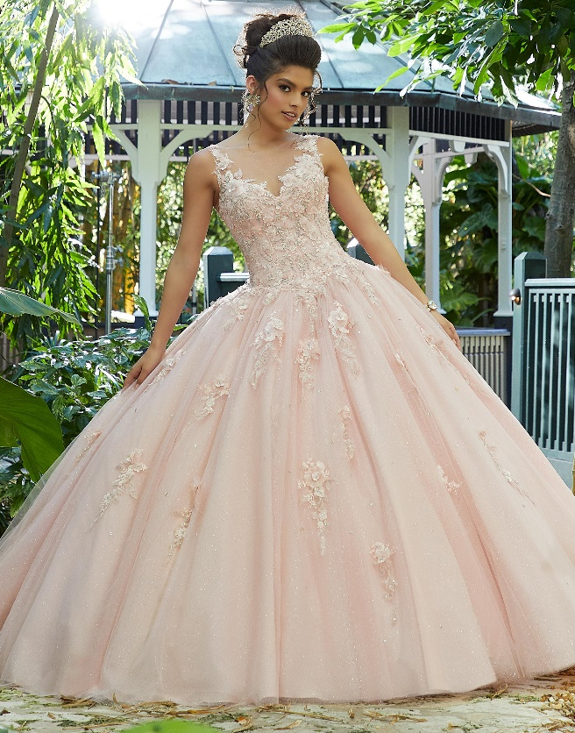  Maria previously Manuel
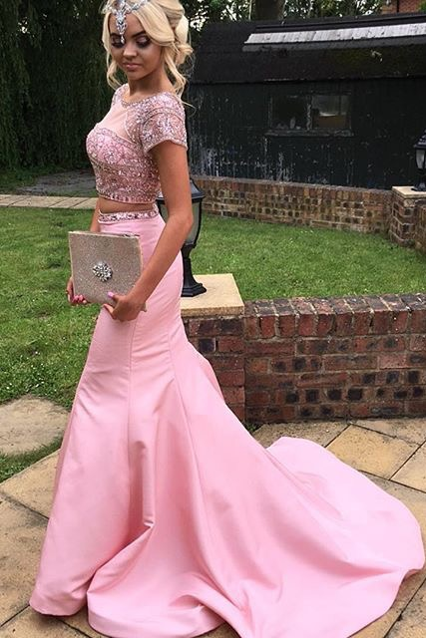  Carlotta previously … I forgot. | 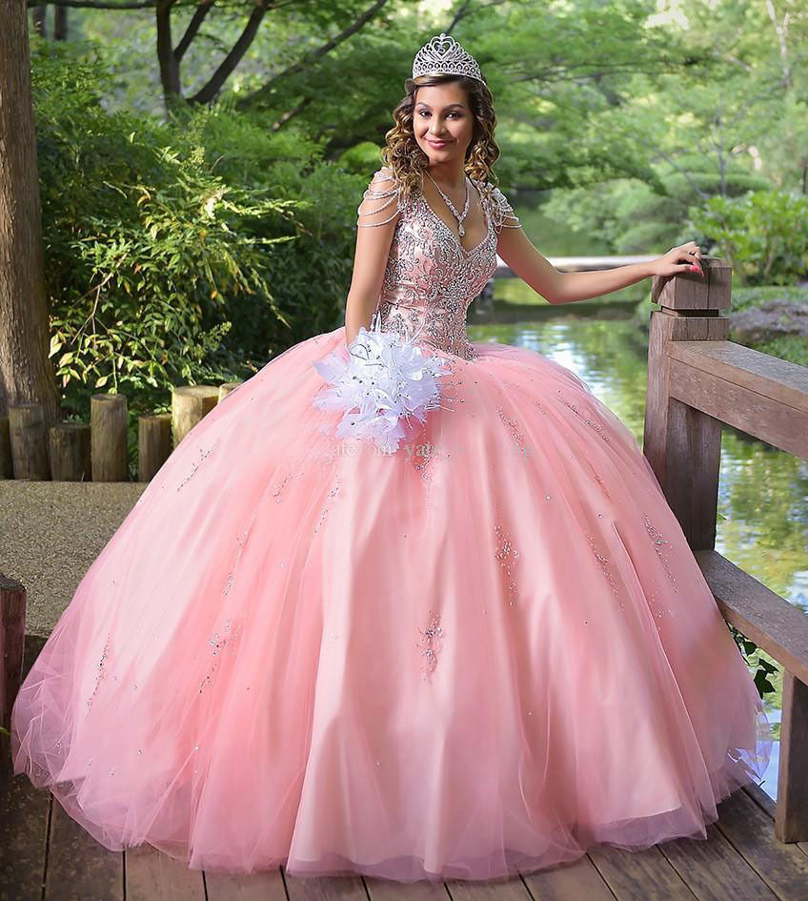  Me! Previously … who was I again? Anyway, look at my breasts, aren’t they gorgeous? And the crown! And my hair in curls! Life as a princess. I am soooo lucky!

