Champion
Inspired by a Captioned Image from Courtney Caps
By Maryanne Peters

Being in North Texas our school had more than its fair share of rednecks, but I was never one of them. Sometimes I felt that it was my duty to stand up for minorities. The way I figure it, democracy only works if you look after minorities. Otherwise majority rule means enforced bullying.

The reason that I was the most popular guy at school because I had stood up against bullying, and that includes bullying by the teachers. I was on the football team and was not one who could be called a victim, but I put myself in the same group as them – you have to join them to champion them. From there I could call out the bullies. It actually resulted in two very unpopular teachers being fired, and some of the worst pupils being expelled.

Some people called me a crusader, like that is a bad thing. I call myself a person of strong principles, who is prepared to go to extremes to stand up for what I believe in.

So when Alison started at school and got a hard time for being trans, I felt the need to do it all over again. She had basically been hounded out of another high school across town. The problem with transphobia is that it is not as simple as bullying. There are some people who bully people of different genders or sex orientations, but many just lack the understanding or suffer from misapprehensions.

But it is like Alison said – “I cannot blame people for that. Nobody understands what it is like to be trans unless you have lived it”. I felt that the kind of support that she needed was to have somebody sharing her experiences right alongside her.

“If you are not trans then you will never understand what dysphoria is,” she warned me. “But maybe you will see what it feels like to be stared at, or to receive indecent suggestions, or even to asked intrusive and stupid questions. That is what it is like for us.”

“I am going to be your BFF,” I told her. “We will be transgirls together for as long as it takes to get you accepted. I guess that I have some accumulated goodwill in this school, and I am going to put it work for you, and for all other gender variant people in our school, and our city, and our state.”

It is like I said - I call myself a person of strong principles.

Alison was grateful for the support, but as she put it, it do neither of us any good if I did this by half measures. I mean, I had to turn up to school dressed as a girl rather just say that felt like one, and if I did not appear to be the best-looking girl I could be, it would just lead to us both being ridiculed. I needed her help, and some professional help as well.

I went to get hair extensions. I told my parents what I was doing, and while they had reservations, they both understand the kind of person that I am, and they admire me for it. Still, there was enough resistance that I decided that it was better not to discuss the hormones. I just felt that I needed to follow what Alison was doing, so I arranged to have the same shots that she got, albeit from a different source.

Apart from that I depended entirely on Alison to help me through it. It gave her a purpose. Plus we asked some of the girls from school for help with clothes, styling, hair and makeup. We ended up with some stuff that Alison could rework – she is a whizz on the sewing machine. I am bigger than Alison so I needed some of the donated clothe re-sized.

I knew that I could depend on a bunch of girls who had benefitted from my anti-bullying campaign. Like I said, I was popular so I was sure that when I turned up at school as Maddie right beside my friend Alison as “transgirls together” we would both get proper treatment.

Everybody was shocked. Everybody except that small bunch of girls who were in on it. We just hung with them – “all girls together”.

The principal called me in and asked me whether I was going to be using the girls bathrooms. He said that Alison was registered as transgendered, but I was not, so he assumed that this was just one of my “stunts – although probably well-motivated”. I said that I wanted to be registered as transgendered too. Sure, I would be using the same bathrooms as all the other girls. I avoided being too aggressive. That is a guy thing, after all.

So it all worked out really well. I thought that acceptance of me and Alison would take some time, but as it happened, it took no time at all. It was a bit disappointing really. I was hoping that I would get more time living as a girl, especially when Kevin from the team started to chat me up and ended taking me out on a few dates.

In fact, as he is talking about becoming more serious, maybe I will just put of changing back for a few months, or maybe even the rest of the year?
The End
He Woke Up
Inspired by a Captioned Image from Courtney Caps
By Maryanne Peters

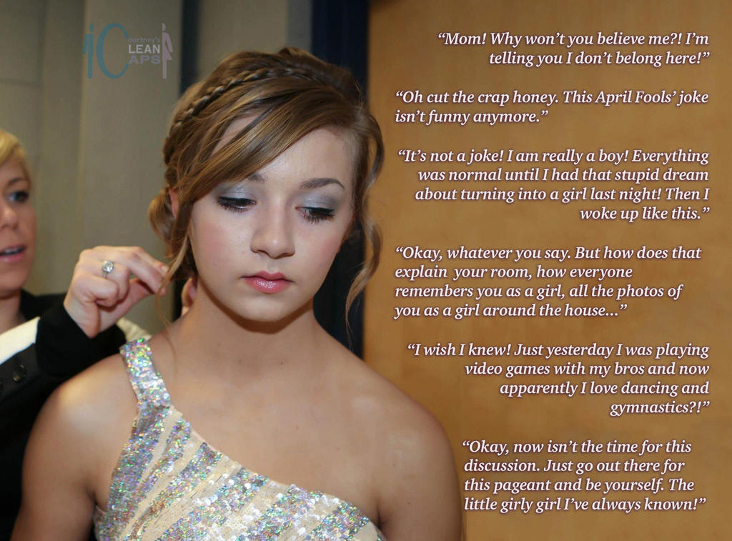

I just despaired for my son Patrick. He spent all his time on his PC playing computer games. He had no friends other than his “bros” on line – people he had never met. Contrast that to our neighbor whose daughter always had friends around, and was active in dancing and gymnastics, and about to compete in a beauty pageant. I just wished that my child could be more like that.

There are people who will say that I went too far to change his life, but boys of his age are not open to reason. If you truly love your child you have to be prepared to take radical steps to force change upon them. I am not talking about threats or blackmail. That won’t work. I am talking about changing their reality. I felt that I could do it.

Through work I had access to drugs. I just needed three of them – male hormone blockers to reduce his pecker to almost nothing, and female hormones to soften his skin and hair, and have him develop a new shape. The crazy thing is that the boy was so absorbed in his games that he never noticed anything.

The last drug was a serious hypnotic drug similar to ketamine. It would render Patrick unconscious for long enough for me to change his room and remove all traces of the young male, and create his new female identity. As for the female form, that took considerable research to find the tools that I needed for a “glued in tuck”. This is something that serious crossdressers or drag queens can do to make their genitals appear female even when stark naked, using surgical glue.

None of this would cause my son any permanent damage. It was simply to show him that he could have a different life by letting him wake up as somebody else – somebody about as different from Patrick as you could get – Patricia.

I even went on to his video games with a message to all his bros from “Padditron” asking for support for his entry into the beauty pageant coming up … “And by the way, Guys, my real name is Patricia, but you can still call me Paddy if you like”.

Isn’t it marvellous what you can do with photoshop? You can take every photo that you have in the house and change the gender of one of the people in the photo. You can bring Patricia to life by giving her a past. And you can add a few extra photos, of her dressed as a princess aged eight, with Patrick’s face feminized, or collecting a ballet prize, or as a junior school pom-pom girl.

I had enrolled him in dancing and gymnastics. The dance teacher was a friend of mine and I had explained the whole thing to her. What she needed to do was pretend that she knew Patricia well and that she had been dancing for years, and that she should get the rest of the class to play along with it. The gymnastics teacher I also knew, but she hardly knew anybody in her class so I just told her that “Patricia will be coming back for her second season with you.”

As he had his final sleep under the influence of that hypnotic drug, I had a suggestion playing on loop from the speaker near his bed. It was the dream I wanted the boy to have. The dream where a boy turns into a girl.

The key was that first morning. That was the morning on the first day of spring break, the week after I said his April Fool’s joke would be next week, when Patrick woke up as somebody else.

I added just one final touch – a throat spray that made his first sound in the high notes. It was a scream.

“Mom, what the fuck!” I can still hear it in my memory. “Mom, my hair is in curlers, and my room has been fucked up, and … where is my dick!”

“What are you talking about Patricia?” I said running upstairs. “Your hair is in curlers because we are trying out hairstyles for the beauty pageant coming up in two weeks. We will go down to the salon after breakfast, and when we are done there we will do some shopping. And remember we have dance class this afternoon.”

I was expecting confusion, but I assumed that it would turn to anger. But instead there seemed to be a little sadness, and then after Patricia went on line and discovered that all of her friends thought that she was a girl and were giving her full support for the beauty pageant and asking for pics to be sent or posted, sadness seemed to become resignation.

I think that was the look on her face when I was doing her hair for the heats.

But somehow everything changed when she won. After that when the glue failed she was horrified. She said that it was like waking up into a nightmare. She wanted me to book surgery right away. I tried to explain it away. It was an April Fool’s joke. But she was having none of it.

“I have made so many friends with the girls at the pageant, and one of the boys on line wants me to be his girlfriend, and then thins awful little things pops out! Mom, I just want to cry myself to sleep and wake up again as me.”

It has not turned out the way I intended, but I can’t say that I am too upset about it.

The End

Dads Phobic Friend  Inspired by a Captioned Image by Courtney  By Maryanne Peters  I can’t say that I knew a lot about trans people, but I knew that they got a raw deal from people like Veronica. Dad seemed to make a habit of picking up the wrong type of women. She was mouthing off about gays and trannies as a way of giving me a hard time about having a long ponytail down my back.  “Long hair on a man is for fags,” she said. “Are you a fag?”  “Well, I have long hair so maybe I am?”  “If I marry your father I suppose I have to put up with a queer stepson, but when I am running this household I won’t have any gay strangers in here.”  Dad backed her p on that – I suppose because he felt that he had too. But I decided that I needed to send her a strong message while not breaking that rule. | 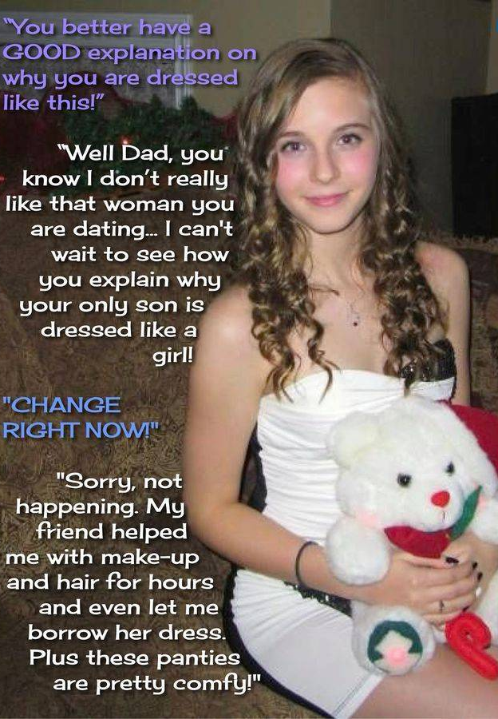

My occasional girlfriend Lisa said that she would help me, and I roped in my friend Dean to be my guest.

Lisa loaned me a dress and a padded training bra, she washed and curled my hair and did my makeup. All I had to do was to shave down completely. Then I arranged for Dean to pick me up from Lisa’s place and go home with me.

Dean thought it was going to be a huge joke, but then when he saw he standing at the foot of Lisa’s staircase the smiled fell from his face.

“Is that really you?” he said in disbelief.

I have to say that I struck one of those poses to show off my long legs and threw back my curls. You know the thing – every guy has seen a girl do it – the classic turn on. It worked. His mouth fell open and his face went pink, and I swear that the front of his pants looked very tight for a moment.

My own junk was tucked away tightly, but it felt pretty comfortable.

He drove me around to my place and I sauntered in just moments after my father.

“You better have a good explanation on why you are dressed like this,” he said, loudly enough to bring Veronica out from the kitchen to see what was going on.

My response was barely a whisper so she could not hear.

I told him that I was comfortable wearing what I was wearing, and that Dean and I were going out together on a date.

“I said no queers in this house,” shouted Veronica, bustling over to us.

“Dean is not gay,” I said.

“That is right,” said Dean. “I am straight as. I am taking a girl out tonight. Look at her. This is a girl, not a guy.”

He was right. I didn’t know it at the time, but Dean was right. By the end of the evening, I knew it for sure. We made so much noise in my bedroom just so Veronica could hear, but also because I was experiencing the true joy of sex for the first time.

She never got over it. She did not stick around. My dad found somebody else a little later – somebody I met at transgender support, in fact. But that is another story.

The End

© Maryanne Peters 2021

Two Anniversaries in One
Inspired by a caption Image by Courtney Clean Caps
By Maryanne Peters

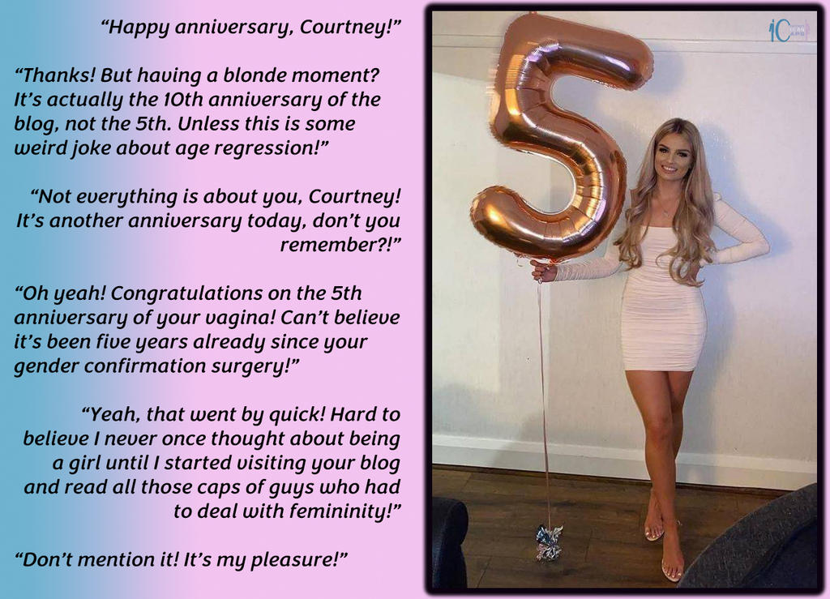

Okay, I tend to be one of those people who get over-involved in things. I am a product of my generation I guess – so tied up in everything online. I was into gaming in a big way. So much so that my Mom suggested that I get some counselling.

Of course they want you to go cold turkey – or they try that for a bit. Then they move you on to shifting to another online activity – something real world, they said. Just pick something at random. Avoid games, fantasy worlds or pornography. Something without violence. Something nice.

I just thought it was a pretty girl site. All the girls seemed pretty. Sexy too. It was just that they were not girls … well, not completely. At least, that was what I thought when I started.

I made contact with Courtney, who was running the site. I had to find out whether it was real. Had all those beautiful women really been born boys.

“Advancement is not just about computers, Silly,” she told me. “Hormones and surgeries have been advanced too, and beauty treatments. You don’t have to be ugly anymore. Everybody can be beautiful. Everybody can be female, if they want to be.”

That was not what I wanted. Not then, anyway. I just wanted to look at them. I wanted to read about these guys who were confronted with living just a bit of their lives as women and then finding themselves unable to back out and go back to being male. It seemed to hard to believe.

Okay, so I can’t really remember how I decided to try it – to reach into the screen and pull back out that first tube of lipstick; that first mascara wand; the first bottle of nail polish. Of course, I didn’t do that. It just arrived through the mail, courtesy of Courtney.

Mom said I should go back to the counsellor. I did, but they won’t interfere with gender issues.

“Find you own place,” they told me, and Mom too. “You are engaging with real people in activity that is not insular or antisocial, and that is good. Just try to get out more. Leave your screen and get out into the world.”

Courtenay agreed with them.

“You are so pretty,” she said. “You need to dress up a little. Grow your hair and grow your breasts. Take hormones. You know the drill. Check out my site for links. Once you step out you will find out what it feels like to be admired and pampered by admirers.”

She was right. But they were all guys. I had thought that I was attracted to pretty girls, but now it seems that I am only interested in where they got their dresses from or in how they styled their hair.

But men always want more, so five years ago I got myself a vagina.

Mom was shocked, but as I pointed out, there is no going back from that. Not that I want to. I am very happy being a girl.

So on the anniversary of Courtney’s site I took around my own balloon … as a thank you, but also to have my own celebration.

The End

© Maryanne Peters 2021

What Boys are After
Inspired by a Captioned Image by Courtney
By Maryanne Peters

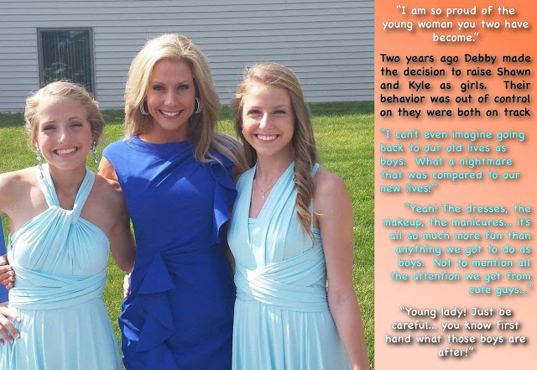

We are what boys are, after they become girls. Now we are what boys are after.

We were a handful for Mom, and we knew it. We actually came close to driving her to having a breakdown. We knew that we had gone too far, so we offered to do anything to put things right – anything at all.

“I was never prepared to be a mother to sons,” she said. “Even when your father was alive I had no idea. If you had been born female I could have made a household for all of us. I was mean to be a mother to daughters. I am a dressmaking and a beautician. Why couldn’t you have been girls. Why can’t you be girls now.”

She just burst into tears. We just went over to her and she wept – her whole body quivering. It was like we could not touch her and hold her because we were guys and guys don’t do that. My older brother Shawn just sort of looked at me and extended his arms and said – “We can be your daughters Mom.”

We both put our arms around her and burst into tears too. We were just like three women – like a three-way estrogenic cry-in. It felt wonderful. It was as if we had been set free. It was like invisible chains of maleness had been broken from us.

It was real. It happened. Shawn became Shona and I became Kylie. We just cut off all of our relationships with troublesome guys. We stayed at home with Mom and let her introduce us to living as girls, being home schooled and learning all the feminine skills that she had always wanted to share with daughters she never had.

We were ready to learn and how to cook and sew and be beautiful, but the other knowledge that Mom had to share with us was about men. She knew a thing or two about men. Dad had been a catch. The only thing wrong with him was the hidden heart defect that killed him,

I guess as boys we had always thought that we would have sex with girls, because that is what boys do. But that was before. This is after.

The fact is that when you know what we know, you know that life is easier for girls. You don’t learn about men from your mother without being ready to put her teachings to the test.

You don’t even have to let a guy get into your pants to work him and win. We know that a time will come that a guy will want to pop our cherries, so by that time we will need to have cherries to pop, but that comes later.

For now we know what boys are after, and we know what we want too.

The End

© Maryanne Peters 2021

