Legacy
A Short Story
By Maryanne Peters

I was nineteen when my grandfather died. It was on the news: “Drag Artiste Dies Suddenly”. Some of you may guess who I am talking about, but I am not going to tell.

It was indeed, a sudden death. He collapsed during a performance – the one that was to be his last. He recovered consciousness for a time, but he was dead within a week. My father took us to his funeral – his own father’s funeral – but he was not comfortable there. He had spent a lifetime trying to live down the shame of having such a performer as a father. He attended out of duty, but did not feel at home among the drag queens (even out of costume) and other entertainment types.

My father’s relationship with his father was difficult to describe. I think that he loved him. There was no doubt that my grandfather loved his son, very deeply. It was just that my father was, if not ashamed, then deeply discomforted, by the performer my grandfather was. There was not a single photograph of my grandfather in costume, anywhere in our house – except for a few that I had in my room.

I saw my grandfather very differently. He was always a kind and loving person, with a marvellous sense of humour. It was his warmth and humour that came across to his audience. I never saw him perform live, in fact I never saw him in drag in the flesh, but my aunt had hundreds of videos. We would watch them together at her house, even while my grandfather was still performing. She worshipped him.

His act involved singing and dancing, and comedy, including bringing members of the audience on stage. It was not really my thing, but there was no doubting his talent. Unlike my father I was proud to be a member of my grandfather’s family.

I was very sad at his funeral. My father seemed upset, but perhaps a little relieved.

The day after the funeral we went to his house to clean some things out. My grandmother was still alive but in care, so with the death of my grandfather we knew that we would be packing it up and selling. My father did not want to be involved in reviewing his father’s things. Probably if he had his way everything would be burnt.

By everything, I do not mean the furniture and decorations, but all the things associated with my grandfathers showbusiness career in his study and heaped up in his large attic storage area. So, it was my aunt and me who went to the house and through everything.

We took up folded boxes to sort some of the stuff into. My aunt said that we should sort into things to keep, things to donate to his memory (some places were interested), and junk. It was a daunting task. There were costumes, playbills and other souvenirs of a lifetime in entertainment, plus family photos and mementos of family generations prior to my grandfather. There was a lot to get through, but I was excited to be involved.

We started in the study and we found lots of stuff that my aunt was keen to keep. I was offered some things for my father which were not associated with my grandfather’s vocation. I put those in a box with my father’s name on it.

Then we went up to the attic. Near the top of the stairs I found a metallic grey suitcase. It did not seem as old and dusty like many of the other things up there, so I opened it up and had a look.

It had women’s clothing inside and two wigs carefully wrapped in plastic. But there was something different about these costumes. In fact, they were not costumes at all. They were just regular women’s clothes, although in a distinct retro style. In another compartment were two body stocking garments, used to create a female shape. But these were different from the ones that my grandfather used on stage. These garments only covered chest to groin and the shape they were designed to achieve appeared modest when compared with the buxom shape favoured by drag queens.

“Let’s hang onto that,” my aunt said. “Everything looks in really good condition. Unfortunately, it looks to small for me. My father was lucky to be slimmer in the waist than me, just like you.”

We continued fossicking around.

“I know what this is,” said my aunt, holding up a bag with two plastic jars inside. “This is dangerously effective depilatory.”

“De-what?” I asked.

“Hair removal cream,” she explained. “He used it sometimes. This stuff is illegal now. It practically burns the skin. But it is effective. Put it in your suitcase.”

I am not sure how the grey suitcase had suddenly become mine, but yes, I ended up setting it aside to take it back to my house. My aunt took all the memorabilia. My father would not have liked that in our house anyway. I ended up with a small amount of stuff that allowed me to construct a modest scrapbook of my grandfather’s career that I would keep to myself, and the grey suitcase with its contents.

Then, not long after the funeral, my father called my aunt to discuss a telephone conversation he had with a man named Rodney Gaspard. It turned out that this Rodney, who had unobtrusively attended the funeral, had been mentioned in my grandfather’s will as receiving a small legacy. Apparently, he was claiming to have had some kind of relationship with my grandfather. I think that nobody in our family doubted that my grandfather was exclusively heterosexual, so the suggestion came as a shock. My father refused to meet with this Rodney to discuss specific requests arising from bequest in the will. Once again it was up to my aunt to deal with it, and she suggested that I go with her, just as support.

Rodney was conscious of her uncertainty, so he suggested that we meet in a public place – a café near to my grandfather’s house. My aunt had no trouble recognising him. She said that he sounded very quiet and shy, and there was a man who looked just like that sitting in the corner.

Having said that, he was quite a big guy, dark and swarthy with a moustache. He could have been handsome, but he was a little overweight and slightly bedraggled in a worn out pullover.

We took a seat and made introductions. Then my aunt got straight to the point, asking what was the nature of his relationship with her father – my grandfather.

“I loved her, and she loved me,” he replied. There was a tear in his eye. Clearly, he was speaking from the heart. His words seemed the very essence of truth. But it was the words ‘her’ and ‘she’ that seemed out of place.

“I am sorry,” my aunt prefaced, “But I find it hard to believe that my father was in a homosexual relationship with anybody.”

“No, no,” he said. “It was not like that. She was more of a mother to me. I am not gay. We didn’t have a sexual relationship. She just wanted to be the woman in my home. Or have me as the man in hers.”

“My father only cross-dressed for his show,” my aunt insisted. “Apart from that he would never dream of dressing as a woman.”

“I am sorry that it was kept a secret from you,” he said. “She must have felt it necessary.”

My aunt looked at me for some kind of supportive statement. So I asked: “So, you mean to say that my grandfather, who has been married to my grandmother for almost 50 years, lived with you as a sort of housewife?”

Now his tears were really starting to flow. He whimpered: “She was the most wonderful woman. I think that the world should know just what a wonderful person she was.”

“Why are you calling my father ‘she’?” My aunt was getting angry.

“She was always a woman as far as I was concerned,” he said.

“If you tell your story about this, my father’s reputation will be destroyed,” said my aunt with rising fury. “If you really cared for him you would give more thought to his legacy.”

“People should know that the woman was not just for show,” said Rodney. “She was a real person. A loving caring person. And a woman. Not just pretending.”

Again, I was impressed that his words and his sentiment seemed entirely honest. If we wanted to keep this story under wraps, we would need to think of a way around this.

“What was her name?” I asked him.

“Her name was Emma,” he said. “A she was a wonderful person. And I miss her terribly.”

“Do you want money?” my aunt interrupted my measured approach to the problem.

“God, no,” he said. “I have money. I just want some memories. And perhaps to spend time in the home we shared. Her home. Not permanently. You’ll probably want to sell it. Just until you do.”

I was a little surprised that he had money, but I knew that it was not about that. My aunt might have thought he was milking us, but I knew what he wanted. I said: “We can do that.”

“We can do what?” My aunt turned on me. “He cannot stay in the house. Not alone anyway. You’ll have to stay there too.”

“I can do that,” I said. “And you can choose some mementoes from what we have been collecting together. But family has first pick, of course.”

“I have no problem with that,” said Rodney. He held his hand out to me to seal the deal, while my aunt looked on, a little annoyed that her young nephew had taken over the negotiation.

“I am Joe, by the way,” I said. “And if we do this you will sign an agreement not to disclose your relationship with my grandfather?”

“I respect Emma’s family,” he said. “Of course. Have something drawn up and I will sign it.” So we did.

***

Rodney sat in an armchair with the box of mementos on the floor. He looked up as I came in with mugs of coffee for each of us. He asked: “Can I choose anything from here?”

“My aunt has taken just a few things,” I explained. “Choose what you like, and we will take the rest.”

He took the mug with a nod of thanks. He was already selecting items and placing them on the floor on either side of his chair.

“Can I ask how you met?” I said. “How you met Emma?”

“It was when she visited the hospice just before my mother died. It was a charity visit. She was very giving of herself that way. She sat and talked to my mother who had been a fan for many years. My mother ended up asking her if she would look after me when she was gone. It was just the ramblings of an old woman on her deathbed, I guess, but Emma seemed to take it seriously.”

“So, what did you have to say about that?” I asked.

“We talked,” he said, with a look of fond recollection in his eyes. “I just said that I did not believe that she could be a man and that I would not want to see her as anything other than a woman.”

“So, what next?”

“She came around to my house a week or so after my mother died,” he explained. “She just was there for me. I was very upset at the time and she knew it. She just comforted me, and we formed a bond.”

“Well, here’s to their memory,” I said holding my cup towards his. “Your mother and my … and Emma.”

Our mugs chinked together, and I found myself looking into his eyes, or rather him looking into mine.

“There is a lot of Emma in you,” he observed with a look of affection. I found myself warming to him. “I wonder if there are any of her dresses among her belongings?”

“There are some clothes,” I admitted. “What are you looking for particularly?”

“Sort of vintage style – floral and polka dots and stuff like that,” he replied.

I knew immediately it was all in the grey suitcase. “I go and get something you can look at,” I said.

When I got back he was looking through some other photos. He said: “This is how I remember her. Can I take this one?”

It was a photo of my grandfather at some public function – perhaps the opening of a theatre or some charity event. He was in full drag, but not a showgirl costume – just day wear. He was crouching to talk to a small child. He was smiling and happy. The child looked confused.

“She told me once about when she was walking in the park she found a lost child,” Rodney mused.

“Is this what you are looking for?” I asked, holding a dress up against myself. It was not the polka dot one. It was burgundy red with black facings. It was the one in the photo he was looking at.

He looked excited to see it. He said: “Would you put it on?”

I must have looked at him in horror. I must have. But then I said it. I said: “Okay.”

What kind of crazy was this? I could say to you now that it was just a bit of fun – just two guys going through the junk in the attic and playing a bit of dress up. But with what followed you will know that is a lie. There was something more deep that made me put on that dress.  I had never had any urges to dress in women’s clothing – transvestitism I think it is called. This was not a kinky thing. The best I can say was that it was some kind of tribute to my grandfather. That might explain why instead of just throwing on the dress and the blond wig, I took the time to look more like him – my grandfather. I shaved my calves and I put on a little makeup – just brushing my eyebrows and using a little eyeliner and lipstick.  Everything fitted perfectly. Not only was I the same dress size as my grandfather, but the same shoe size too.  “Emily,” he said with a smile. “Like a little Emma.”  I put a hand a hand on my hip and pouted at him. “Is this what you want?” I asked. | 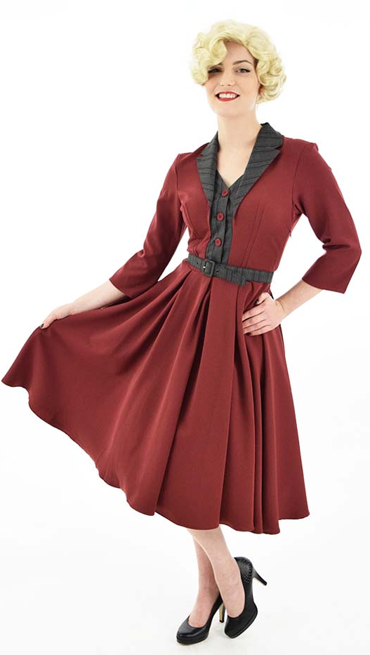
He looked suddenly uncertain. He said: “I am not sure.”

I was suddenly deeply disappointed. I thought that I looked good. I had gone to such effort. I almost felt like crying. Crying, like a girl. It was confusing, but somehow thrilling to be in such a state. There were a whole bunch of emotions flooding through me.

“Take the wig off,” he instructed.

My mousy brown hair was up in a cap beneath the wig. I took that off too. I fluffed my hair a bit. It was way too long. I had a natural kink in it that made it appear slightly shorter and woolly, but when my hair was pulled straight it was shoulder length.

“Some color,” he suggested. “A redhead maybe. That would be perfect.”

“I don’t think my grandfather ever wore red hair,” I said. “Blond mainly, like this one, and sometimes dark wigs.”

“But you are not her,” he said. “You are something better. Not old motherly Emma. Young and exciting Emily. Isn’t that who you are?”

“Yes,” I said, again without thinking – just feeling it. I felt like Emily. I felt young and exciting. I looked at Rodney who had risen out of his chair, standing tall over me, and he looked at me. I thought for a minute that he was going to kiss me! I found myself hoping that he would. Joe would never want that, but it was as if I was not Joe anymore.

“We need to do something about these whiskers,” he said. “They just don’t belong.”

“No. They don’t,” I agreed. “I think that we have the stuff.”

I went through the suitcase then I followed Rodney down the hall.

“I still don’t know why I’m doing this,” I said, as I stood almost naked in my grandfather’s bathroom and he painted me from nose to toe with the “dangerously effective depilatory”.

“I know,” he said.

“You’re not bewitching me somehow, are you?”

“Don’t be silly,” he said. He paused to kiss me tenderly on the cheek before he painted that too. “This is all you. I think that you have been like a caterpillar for all of your life so far, blindly munching your way through life. This is your chrysalis. Tomorrow you will be a butterfly. All will be clear skies to fly in.”

The compound that covered me was now starting to burn. I knew that I had to wash it off and then use a neutralizing cream. Even after that was done I felt as If I had bathed in chilli sauce. My skin was smooth but inflamed.

“We need to get you into bed” he said. He had in his hand a nightie and small pair of pink panties. Had these been my grandfather’s too?
***

“This is what we want her to look like,” he said to the lady at the salon, keeping the morning appointment that he had made for me the night before. I somehow felt proud of him. He and I were together, and he was in control. I adored him.

“We can do that,” the hairdresser said. “The makeup too. I know exactly the look you are after.”

“I’ll be back in a couple of hours,” he said.

I said: “Okay”. I had to stop myself from adding the word ‘darling’ even though I wanted to say it. I wanted him to know how I felt.

The hairdresser seated me and said: “I could not help but notice, and I hope you wont be offended, but you’re a boy, aren’t you?”

“Yes,” I said. “For now.”

“You have such a handsome man,” she said as she prepared the washing station.

“I know,” I replied, as I leaned back.

“Now lets get your hair washed and colored,” she said.

“Colored?” I said. “Is that really necessary?”

“That is what you both wanted,” she said. “A vintage style with red hair. It is going to look fabulous. Once it has been straightened you have great hair for this style. So, let’s get you in curlers, and then apply some makeup.”

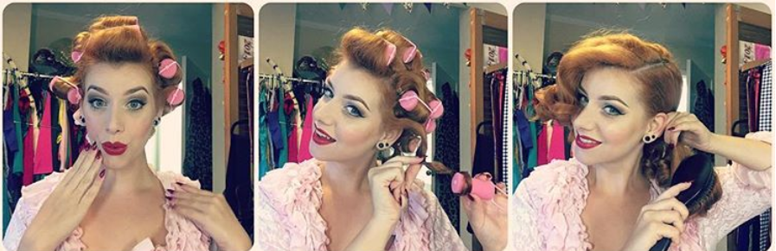

I called my mother from the salon: “Tell Dad and Auntie that I am going to be staying at Grandad’s house for a few days,” I said. “But this guy Rodney has signed the document we need so the realtors can come around and get started. His hanging around for a week seems like a small price to pay for getting his cooperation.” Then I added: “Actually, he seems a really nice guy.”

As I hung up I thought: He actually is a nice guy.

I felt that I needed to look good for Rodney. I played around with a few styles, in a silly kind of way.

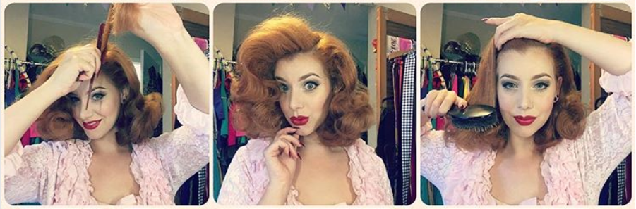

“This is what we are looking for,” said the hairdresser.

I bounced a little with my hand as I looked at myself in the mirror. I had never felt so good in my entire life. In fact, I began to wonder if I had ever had a life that day.

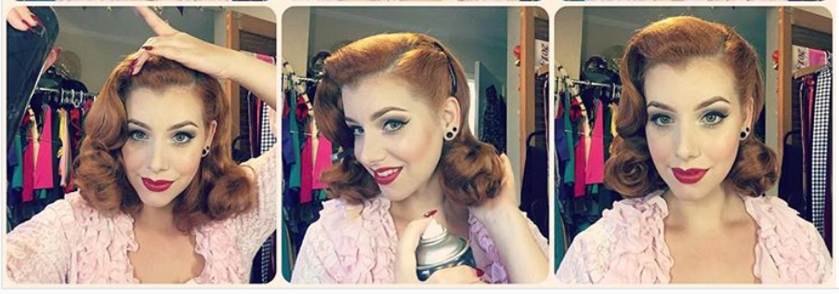

I could not wait to get home and show Rodney.

I waltzed in. He was sitting in his armchair, reading. I did a twirl for him, my full skirt lifting. My pink top suggested that my chest should be fuller than it was. But the hair and makeup were perfect.

“Emily,” he said. Just that. But in a breathy sort of way, so it sounded like an indecent suggestion. “Emily”, now almost an expression of love. He stood up and came towards me. I felt my heart flutter. Have you ever felt that? I have, now. “Emily?”.

“Yes,” I said, coyly. “That’s me.”

He took my shoulders in his hands, and looked me full in my perfect little face. He seemed so powerful. I seemed to weak. I liked the feeling. He kissed me.

Could it be genetic? Is this my grandfather’s legacy? Had it jumped a generation over my manly father? What was ‘it’ exactly? Is it a fascination with things feminine? Or the desire to appear female? I was never aware of it before. Maybe that first time in the attic, pulling those clothes out of the grey suitcase, something may have nibbled at my masculinity. Then when I put on the red dress and the blond wig, a huge bite was taken out it. Now I wondered whether there was anything left.

I was standing in my grandfather’s living room, in my frilly top, skirt and heels, with my new hairdo, being kissed by a dark handsome man, with his impressive moustache brushing my smooth feminine face, and I was loving it.

In fact, I loved everything about it. I wanted everyday to be that good. I wanted to learn to do my own hair and makeup. I wanted to pull out the curlers and shape the style. Always a vintage style, just the way Rodney wanted.

From there all it took was to say yes to the pills and the injections. It was so surprisingly easy to do that.

I would have thrown myself in front of a train if Rodney had asked me to, so of course I would let him mould as he pleased. And mould me he did. Top and bottom, eventually.

I never went back home, I knew where my home was now. Rodney had money all right, enough to buy my grandfather’s house from the estate, without debt. My aunt visits us often, and my mother too, but my father seems to have difficulty being in the same room as me. Sometimes I feel that the way he looks at me is not revulsion but jealousy, or a kind of longing. Perhaps that legacy did not jump a generation after all.

But even he needs to face the reality that this is who I am now – the pretty and slightly old fashioned wife of the man who once called his father a mother figure. We have to be understanding. It may be a little hard to follow.

Well, enough of nostalgia. I have work to do. Rodney is taking me out tonight and I need to do my hair and otherwise pretty myself up. So please excuse me.

The End
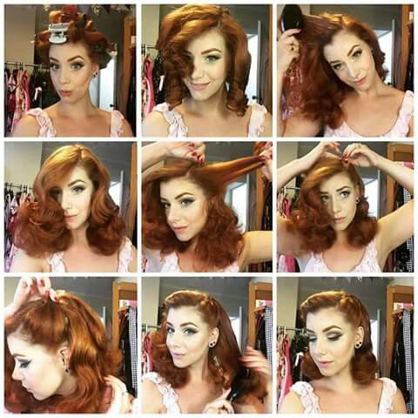

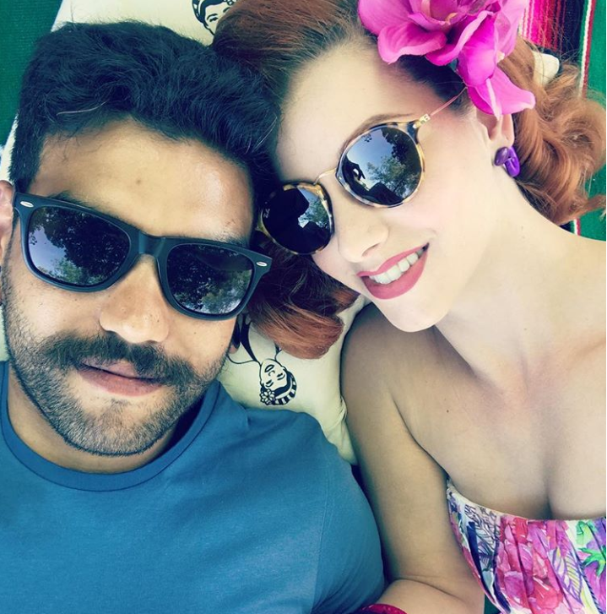  With Rodney | With my aunt

