-mini-story- (again) :D!
Juniper: I'm so bored :(, and there's no good movie to watch today Dx ... F for me.
I'm alone at home and with nothing to do.
Hmm, I guess it's time to continue working on my career, I still have my dream of being famous, and I won't rest until archieve my goal! :D - I'm looking at my smartphone to see news of some casting ... however, I find some photos of the girls enjoying the day at the beach. Pinkie uploaded them to her Ponistagram account. :O
Juniper: Hmm, the girls seem to be having fun. Well, it's the vacations so I guess it's normal ... wait, what is that ...
I notice something strange in some photos... NO WAY!!
Juniper: W-What is he doing there!!
That jerk also appears in the photos! Is that the reason why he didn't answer his cell phone when I called him ?!
Juniper: Grrr.. Huh?! And the girls think they can "earn points" with that? I will not allow it!
Fortunately, when Pinkie uploaded the photos, she tagged her hotel of lodging. So I pack some bags and go on "vacation" too hehe.
It didn't take long and finally I arrive at the Hotel, however the receptionist tells me that there are no more rooms available :(
Juniper: Oww, okay thank you.
Damn bad luck... Within my sigh, I see that jerk approaches together with the girls, the panic of the moment makes me quickly hide behind the plants. >_>
Rarity: yay! The morning was a lot of fun!
You: So it seems ... although your skin still looks a little pale, you don’t like sunbathing? hehehe xD
Rarity: Did you say something darling? :) *Step on your foot*
You: Awwawawawawawawa!!!. SORRY SORRY! I meant you look pretty good...!!
Rarity: I know, but it's always good if someone else tells you. Thanks ^_^!
Sunset: Alright guys, it's time for lunch and then we can head back to the beach :)
Everyone seems very happy, especially that insensitive that was not able to answer my call! >=(.
There is no other choice but to find another hotel ... however, I fix my gaze on a girl who, like me, has apparently been peeking at them.
Juniper: Wallflower?
She acts very suspicious, but before I can move, she sees me with a surprised expression...
Wallflower: Eep!
Juniper: hey Wallflower.. what are you doing here :O!
Wallflower: Nothing, I just enjoy my vacation that's all hehehe..
Obviously she's lying, her forced laugh is terrible xD.
Juniper: okay, lies are not necessary, I suppose you came for the same reason as me, right?
Wallflower: same reason? You mean...
Juniper: Yep. They are our rivals and we are losing points.. that's why I need your help.
She accepts my help and lets me stay in the same room with her. That will make things easier for me, I owe you a Wallflower!
We are on our way to the beach since I have an idea that I shared with Wallflower... Little hint?: We have to be there before them! To make the trip more enjoyable, we start to chatting a bit.
Juniper: Tell me Wallflower, since when?
Wallflower: ... You already knew it?
Juniper: No, but you were just like me: hiding while you looked at him.. You were jealous right? e.e

Wallflower: *sigh* It seems that we have something in common after all. I would have liked to invite him again you know? I remember when we went to the park ... I bought a dress just for that day, I spent hours looking for something cute, and I tried to work up the courage to confess how I feel about him ...
Juniper: And did you tell him? O_O!
Say no, Say no, Say no, Say no, Say no, Say no, Say no...!!
Wallflower: Nop :(
Ufff... Thanks God Dx!
Wallflower: But he gave me a beautiful rose ^///^. What about you Juniper?
Juniper: He's a fool and a jerk... I asked him to see a movie with me, and he fell asleep! I had to take him to my room, and boy he's too heavy!
Wallflower: Did you sleep with him?! O.O!
Juniper: of course not! Pinkie told me he was a pervert and to be careful around him. But, I'm not so sure ... he didn't do anything wrong.
Just at that moment, we arrived to the beach :)! It takes us 5 minutes to change into our swimsuit.
Wallflower: Ahmm.. Are you sure this is going to work? O_o!
Juniper: trust me ^^.
I put my smartphone in selfie mode to take a picture of us. They have to know that we are here! huehuehue! xD
Juniper: ready? Say cheese! :D
Wallflower: AAAAHH!! no Juniper wait!!...
Just when I press the button and take the photo, I immediately send it to him, however, Wallflower desperately yells at me.
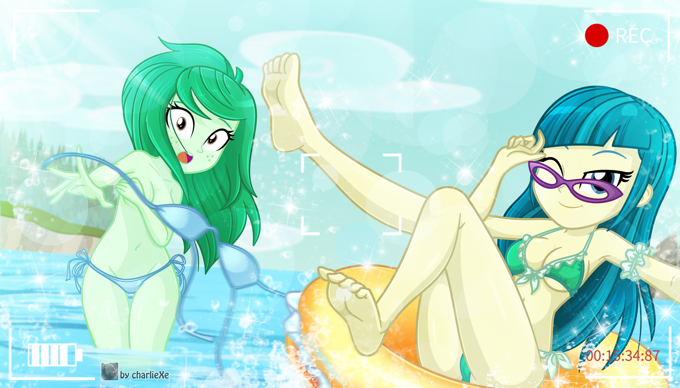
Juniper: What happens Wallflower? ... WOOOOAAHAHAHAHAHA!!
Is Wallflower naked?! Her bikini top is completely gone! She covers her breasts with both arms, her face is very red hehe. From broccoli to tomato.
Juniper: Wallflower??!!
Wallflower: It looks like I didn't tie my swimsuit right! and the wind definitely didn't help me! Dx
Juniper: Okay, just hide under the water and I'll find the top of your swimsuit.
Ahmm.. wait a minute. I didn't even check the photo I sent, that means ...
Juniper: Oh-oh o__o''..
Sorry Wallfie :S!
---------------------------------------------------------------------------
*Riiiing* *You got a new message*
You: huh? a message?
Pinkie: Is something wrong dummy?
You: I got a message from Juniper... let's see what we have heWOAAAAAAJSHADKJSAHDSKAJDSHAKDSHJKHJWKJDKSAUB!! O____________________o''.
Sunset: That was weird even for you, what does it say?
You: N-nothing.
Pinkie: Come on dummy, that make us more curious... and you are very flushed! Show me!
You: NO! Pinkie! Get off me!
Pinkie: Show me!!
You: I said NO!
Pinkie tries to pick up your phone, however your "panic ninja reflexes" allow you to remove the photo before the girls see it.
Pinkie: mine! hehehe let me see! Huh? Hey you deleted the message! Dx
Rarity: Oh my... Pinkie, that was very rude. You don't know anything about privacy?
Pinkie: Aww, but weren't you curious? What can Juniper want with him?
Rarity: ...
All girls: ...
*The girls look at you*
You: ... Oh.. Ah... I mean... heh... Ahem... Hey look at the time! It's too late, I have to study! See you later! *run!!*
Sunset: Stop right there!! Since when do you like to study, that is the worst lie you have ever told, come back here right now !!
-END- x'D!

