Fulltime  Inspired by a Captioned Image by Tiffany  By Maryanne Peters  Yes, that's the way it started, I guess. I was married to Diane when I was laid off, and I ended up at home while she went out to work. It was a very depressing time for me. A low ebb, they call it. I felt worthless, and Nancy did not help one bit. She was constantly hassling me.  Maybe the underwear was my way of saying that I felt less than a man. Instead of being sympathetic she used it as a club to bash me down. That was where the while maid thing came from.  "If you can't be a husband then you might as well be my servant," she said. The maid outfit was her idea.  But then the neighbor Lyall caught me. He came over through the back garden to chase his dog and saw me cleaning in my little outfit. There was nowhere to run | 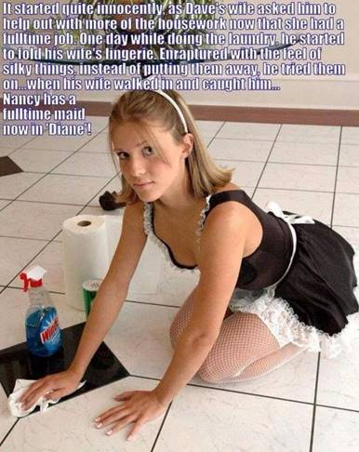

He did not say: "Hey Dave, why are you dressed like a chick?" as maybe he should have done. He said: "What's your name Sweetheart?"

"Diane," I said. I really don't know why. I guess I felt like Diane in that outfit. I fact I had been feeling more like Diane for quite a while and I was good with it.

"You're really pretty," he said. "Too pretty to be a maid. You should be a wife to a man who knows how to look after a girl."

And now he does look after me. He just likes to play a game with me, every now and again, to remind us both of how we met, Lyall and Diane. The maid uniform is nicer now, and fits my new body shape. And the white fishnet stockings are just for show. I never wear panties in this outfit. These sessions usually end up with noisy sex in the back garden.

He took this photo to send to Nancy to remind her that I am fulltime these days, but not a fulltime maid.

The End

© Maryanne Peters 2021
Sales Boost  Inspired by a Captioned Image  By Maryanne Peters  I read it somewhere that if you want to have somebody like my aunt do something you want, you have to convince her that it was her idea all along. Well I certainly did that. She tells everybody it was her idea to double prom gown sales at her store, but it was my idea all along.  I wanted it so bad, but being the guy I was I just could not come out at school. Across the who year group we had this strong macho ethic that made the whole thing impossible. The real me was being bashed down, mainly be myself, and it was getting so that I could not cope.  I told Aunty Vera that there were people out there that said this attitude was backward and destructive, and that the only way to straighten it out was a good old compulsory womanless beauty pageant. Something that would put those testosterone laden seniors in their place. “Isn’t that a stupid idea,” I said. “Although you would end up selling a power more prom dresses.” | 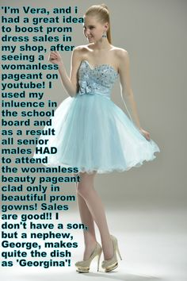

“How is that?” she asked. Aunt Vera was noticing a drop is sales. It seemed like not as many girls go for that look any more, and that was the look that she sold.”

“Well, every guy would need a dress just like the ones you sell, but all the girls will still buy theirs. That means at least double the sales. Plus, don’t you charge more for big sizes?”

I could see her on the hook. “But how would that happen?”

“That Chairman of the school board fancies you, doesn’t he?” I said. “You just need to use your feminine wiles to influence him. Tell him that the best thing the school can do is to equip the senior boys for the modern world by tempering their toxic masculinity. At least you could try. Maybe they will make us all dress up as girls? I hope not, but maybe they will.”

But I was hoping they would. And I was hoping that my Aunt Vera would rise to the challenge. To be told that she has influence makes her want to go out and prove. That is the kind of person she is.

She was just as persuasive as I thought she could be. A week later we were standing around the lockers with most of the guys looking horrified.

“We’re going to have to turn up to this thing in drag or we miss out on the prom,” said Jack, the football team captain, and the kind of guy any girl would fall far, and not just girls. “And the board says that the one putting in the most effort will get the Board scholarship through to college.”

“To be honest, I need that scholarship,” I said with mock morosity. “You guys may get academic or sports scholarship, but it seems that the best I can hope for is to win the transvestite crown at this thing. Just be ready guys, because I have to go all out.”

Well look at me, why don’t you? My blonde hair grown out long enough to pull back with a fake pony tail attached, pierced ears and makeup, and all over body shave and just enough hormone promoted breast to allow for he strapless bodice over the tulle skirts, and look at those legs and heels.

I had become Georgina, and I hoped that I would never have to be Georgina again.

And surprise, surprise, Jack prefers me as Georgina too.

He has his football scholarship and now I have my school board scholarship as the prize.

But first we have prom next week. Jack says he wants me to wear the same outfit, but he better get used to the idea that his girl is not going to wear the same ballgown twice, at least not in the same season. Men!

I guess I will have to go back to Aunt Vera. She owes me anyway. It was my idea behind her sales boost.

The End

© Maryanne Peters

Looking Out  Inspired by a Captioned Image by Tiffany  By Maryanne Peters  It is true that I liked to play practical jokes on the girl next door, but I think I now understand why. I could never express myself with her. I could never tell her just how beautiful she was. My pranks were just trying to get her attention – to let her know that the boy next door was an admirer. I just had a strange way of expressing myself.  Was my attraction to her sexual? I guess that I thought it was. She was older than me by some years and she was working while I was still in school. I thought that the only attraction that a boy could have for a girl was sexual, but I guess I was wrong. | 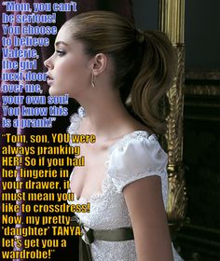

She caught me lining up some trick on her. She called my Mom, but not before she had somehow got into my house and my room and planted some of her things in my drawer. She accused me of being a pervert – a transvestite, and Mom believed her!

But perhaps she was smarter than the both of us? Perhaps she saw something in me that I couldn’t see myself? Maybe even my mother saw it and I didn’t. All I know is that when she had me in a dress and with my hair curled a little and with lipstick and mascara, I knew this was me. I just looked in the mirror and decided this is who I wanted to be. Not bullish ignorant Tom, always teasing and pranking. Not him. I wanted to the glamorous and mysterious Tanya, somebody desired to distraction by the man I am waiting for.

No that’s not Tom looked out the side window at the girl next door. That is me Tanya, a few years after all that, looking out the front window to see his car roll up. I mean the hair is real now, and so are those breasts. The dress is mine and so is the bra underneath. But I am wearing the panties that were planted in my drawer all those years ago, as kind of a good luck charm.

I am hoping that he will pop the question tonight now that he knows that I am complete down there.

Mom still has trouble believing it, but sometimes pranks don’t turn out the way people plan them to.

The End

© Maryanne Peters 2021

Secretaries’ Day
Inspired by a Tiffany Captioned Image
By Maryanne Peters

I was up for up. People know that I am good fun, it is just that I am too busy to have anytime for things like “Secretaries’ Day”. What is that anyway? Just the girls holding out to be taken to lunch one day a year.

So, when they said that I was going to spend Secretaries’ Day dressed in drag and attending to those duties for our new CEO Pamela Haywright, I was prepared to go with the joke. At least it would silence them.

“I am not having you make fun of women, Joe,” Pam said. “You will present yourself properly at work. I will arrange for the salon I use regularly to take charge. Make an effort. If you do it right, I might just take you to lunch.”

So, I went to the salon. They had instructions on what to do. This was not a smear of makeup, a bad wig and an old sports bra with rolled up socks in the cups. No way.

As I said, I was up for it. I could go along. I could take the stick-on breasts. They were so convincing with that string of pearls hiding the edge, that you would never guess they were’t real. The black bra and the unbuttoned blouse was my idea. No, that was the kind of secretary I could approve of. And the skirt a little shorter than the one Pam had approved for me, simply because if you have good legs and the salon has waxed them free of hair, why not show them off? And how better to do that than super high red heels to have me tower above everybody else in the office.

I just walked in, trilling a cheerful “good morning” in my practiced high voice. I took my seat outside Pam’s office and checked my lipstick – perfect. What more does a girl have to do?

But the truth is that there was a lot that was wrong about the way that Pam ran her office. After being in the manager’s seat for a while I know what she needs and when she needs it. I found that I quite liked this job. It was a chance to show how things should be done.

I suppose that I sort of found my place. I am sort of the Queen Bee around here these days. I work for Pam and I lead by example. I show the other secretaries how they should do their job, and also how they should present themselves. I am not saying that the they should all adopt my own “professional and sexy” style, but they should be turned out properly.

They joked about the 5 years, the other girls, but a day was just not enough to nake my point. It sort of extended for the week and then … well, I guess it has been a while now. I need to get my roots done and Pam has offered to by me breast implants before summer when the sticks ons will become unbearable.

And you know – I think I will take her up on that. She is such a thoughtful boss. I could not imagine her forgetting secretaries’ day.

The End

Hypno-Tapes

Based on a Tiffany Cap

By Maryanne Peters

Let me just say it right now, in case there are insecure guys out there who think that listening to music containing subliminal messages might turn them into sissies – It cant happen. Hypno tapes are not real. But it seems Mom will believe anything. Her room is full of stuff that she buys on line, including vitamins that they told her would make her smarter. Yeah, right!

The tapes to make my sister behave in a more feminine way were just the latest. It had now got to the point that Gabby was striding around in jeans and work-boots just to piss Mom off. In fact she had a boyfriend and had started looking at dresses in the shops to please him.

“What doe you think about this one Mike?? She would say. “You are always a much better judge of fashion than I am.”

And I was, just because.

Because I am trans. I always have been, but I only shared it with Gabby. I am not sure why. I guess I thought that she wanted me to be her son. I never would have thought that she wanted me to be her daughter almost as much as I did.

I just thought that if I told her that I had been listening to the tapes and that they had turned me in a girl, it might be easier somehow. It really is a crazy idea, but like I said, she believes this stuff.

I just got some ideas from the tapes. Just stuff about how to grow out your hair, and what clothes to wear, and how to carry yourself as a woman. I feel that these things have always been inside me, but it was nice to hear a reassuring voice that I had it right all along.

I did have it right. Look at me – in the grey dress.

I am now Michelle, the person that I always wanted to be.

That is right – isn’t it. All that Billy stuff that I have boxed up and put in the attic was not me. All that stuff is just so un-feminine that it is positively awful.

I have always been trans – right?

Hypno tapes are not real – right?’

The End

© Maryanne Peters 2021

