MAINSTORY WALKTHROUGH V 0.26

INTRODUCTION
- Wake up and finish talking to the servo skull
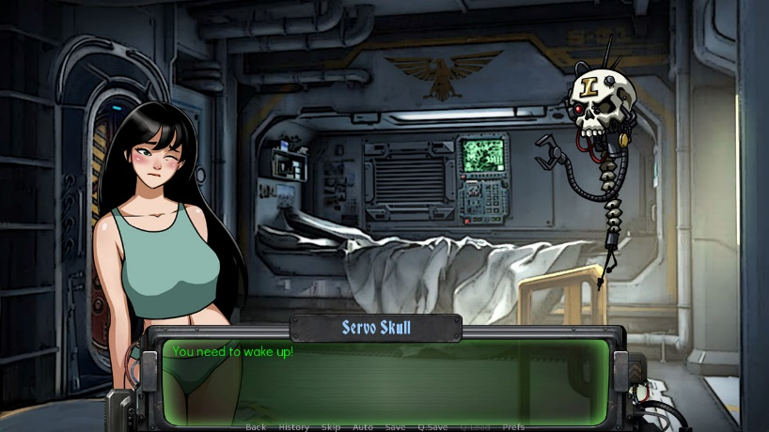
- Exit your room and exit your apartment building
- Go the Headquarters
- Talk to the Imperial Guardsman to confirm your ID
- Your name is: Heidi Eltfmann
- Your rank is: Acolyte
- You are here to: See Inquisitor Cordelia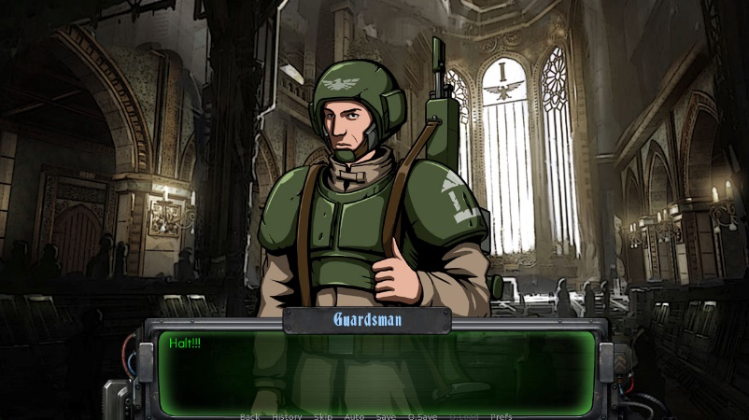
- Go to the Inquisitors Office
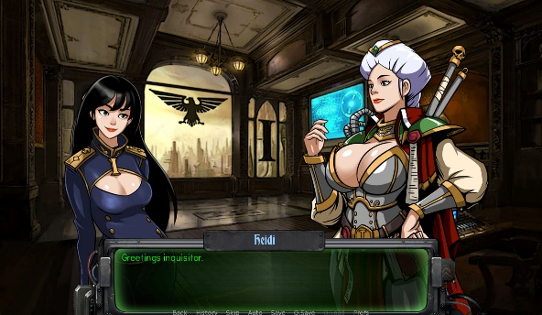

- Talk to the Inqisitor and begin the Interview. Each answer will have a score and the aswers with the best scores are:
- Occupation : Prostitute
- Xenos culture familiarity : Dark Eldar
- Daemonette body part : Breasts
- Chaos God fear : Slaanesh
- What to do with heretics : Strip them naked
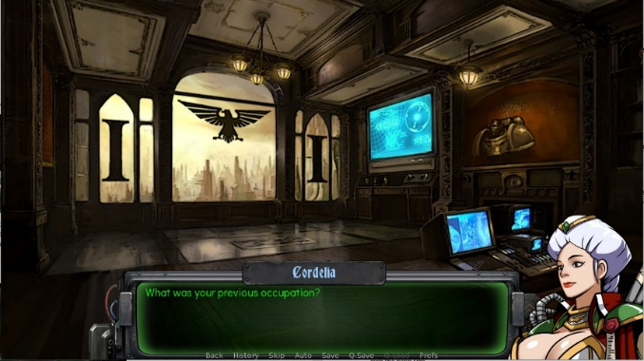
- After the sex scene, leave the building and return to your apartment, masturbate, and sleep.
Missing Daughter Quest Part 1 (The introduction of the case)

- Wake up, talk to the servo skull and then you will automatically go to the Palace in the upper spire.

- Talk to the Inquisitor and she will take you to the throne room and talk to the governor. After you exit the throne room, you can start your investigation.

- Investigate the bedchamber, you will see a Lirieth (The Dark Eldar) in the room

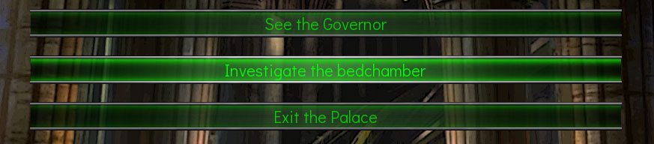

- After Lirieth is gone, do this inside the chamber :
- Talk to Thalia 3 times
- Look for clues 3 times

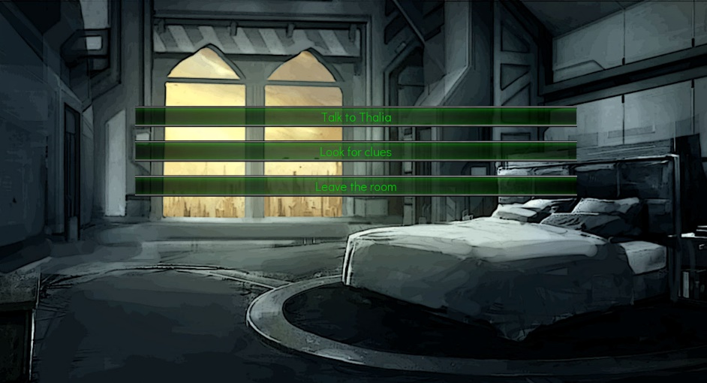

Missing Daughter Quest Part 2 (Go to the undercity)

- See the governor again after you finish looking for clues in the chamber.Talk to him to get the pass to the undercity.

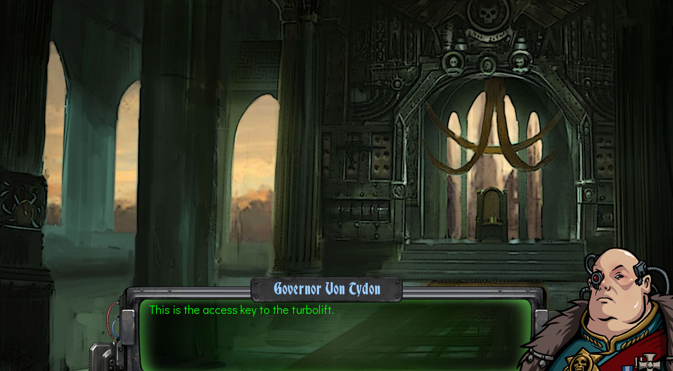

- After you get the access, go to the undercity from the main map screen

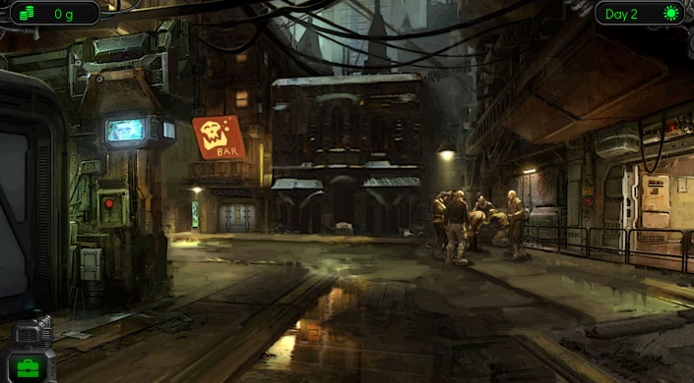

- Then Go inside the bar and talk to Vugnog (the Barternder).
- Talk to him the first time to introduce yourself to him
- Talk to him the second time and he will tell you more about the undercity and ask him about Lirieth.
- Talk to him the third time and he will tell you that Tyranids have come there and they’ve been making a lot of children.
- Talk to him the fourth time and he will tell you about where he came from.
- Talk to him the fifth time to ask him if he knows any other news. But he had nothing for the time being.
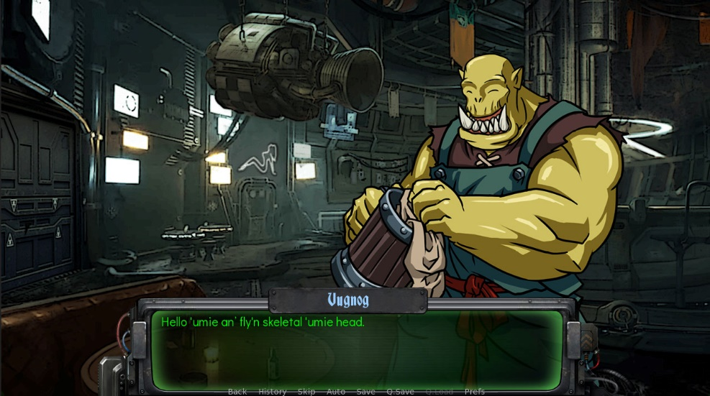

- Go back to upper level and wait untill the evening by Clicking the time icon on the bottom left of the screen. Then go to the bar.

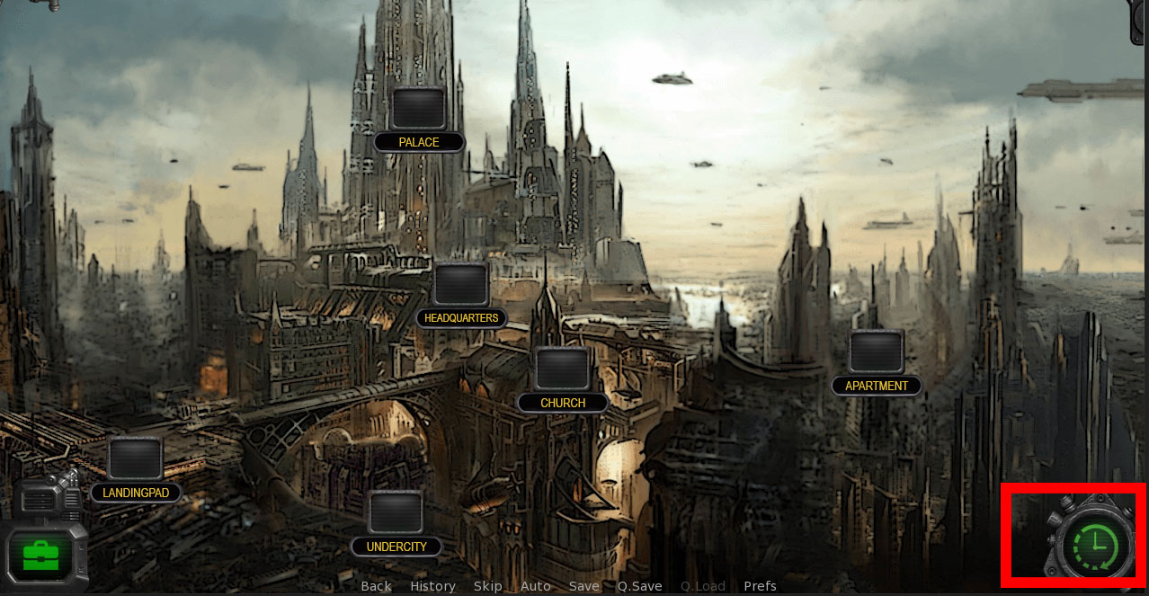

Missing Daughter Quest Part 3 (The Lirieth Dungeon)
- Go to the alley in undercity at the evening and look around.
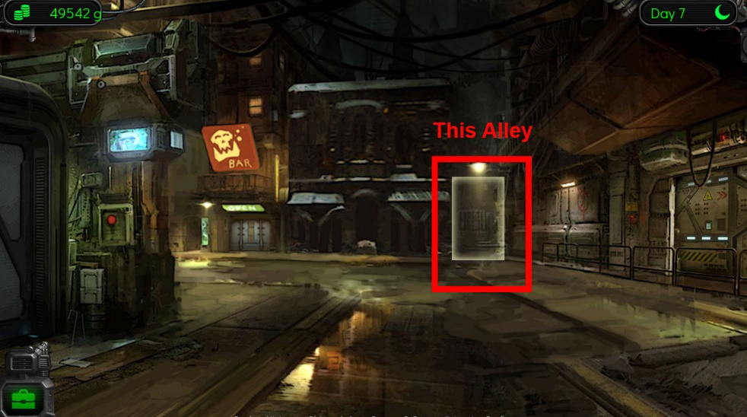
- Go to the bar and ask Vugnog about the Dark Alley behind the bar. He will tell you someone saw Lirieth had activated purple portal in undercity.
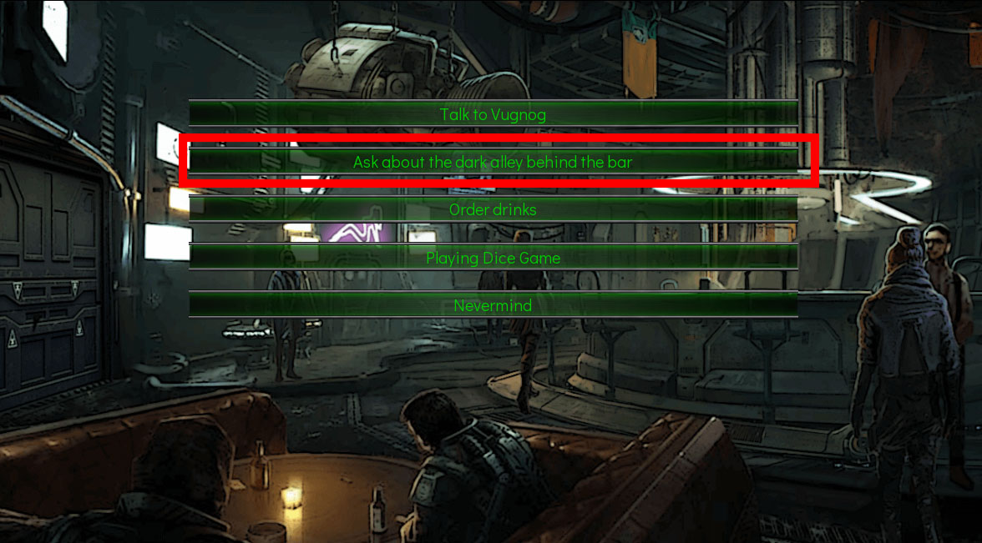

- Go back to the alley and you’ll find some debris on the ground and some purple color substance.
- Go to the shop in undercity and ask about the debris that you’ve found.
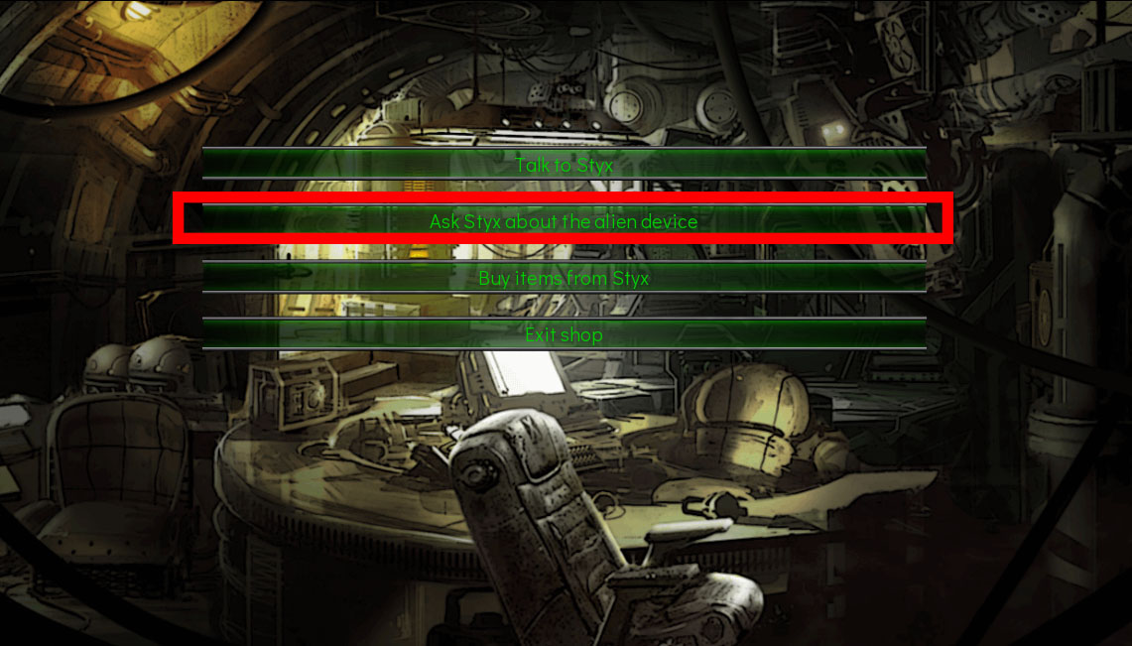

- Pay him 500 Credit to fix the broken device that you found in dark alley.
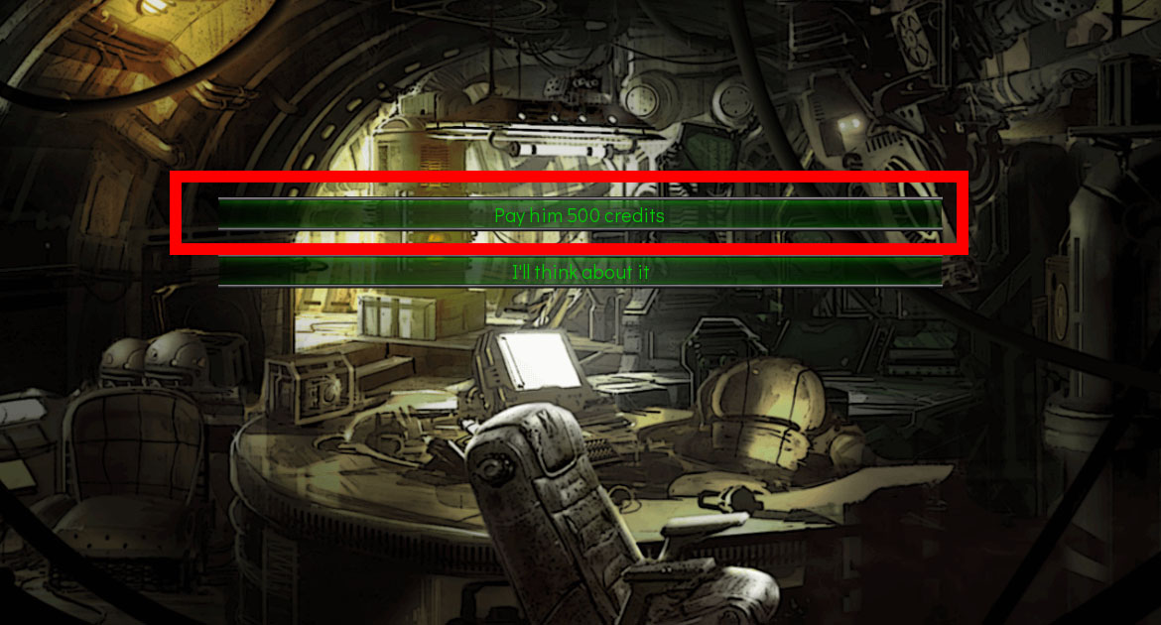

- Get the device from him and go back to the alley to activate the device.
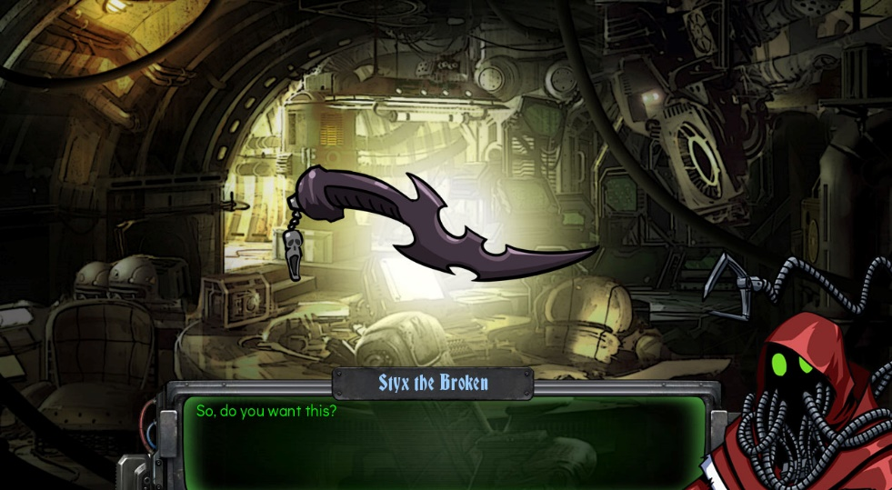
- You will be teleported and meet Lirieth. Ask her about the missing daughter and what she was doing in the chamber. She would then tell you that she didn’t know anything about her disappearance and give you the picture of her.
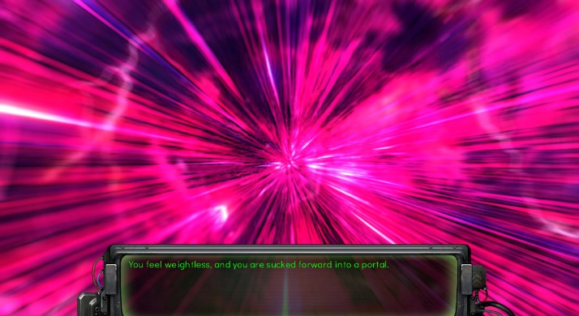
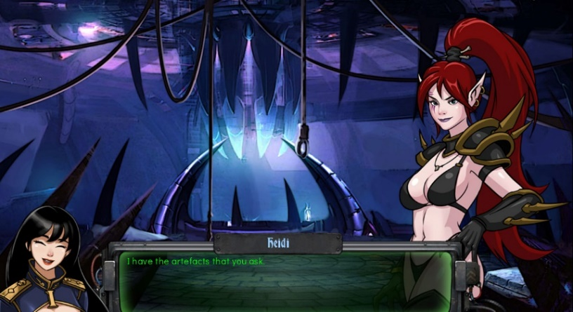
Missing Daughter Quest Part 4 (Chasing the Creeper Cultist)

- Wake up and there will be another incoming transmission from Inquisitor Cordelia. She wants an update regarding the status of the investigation.
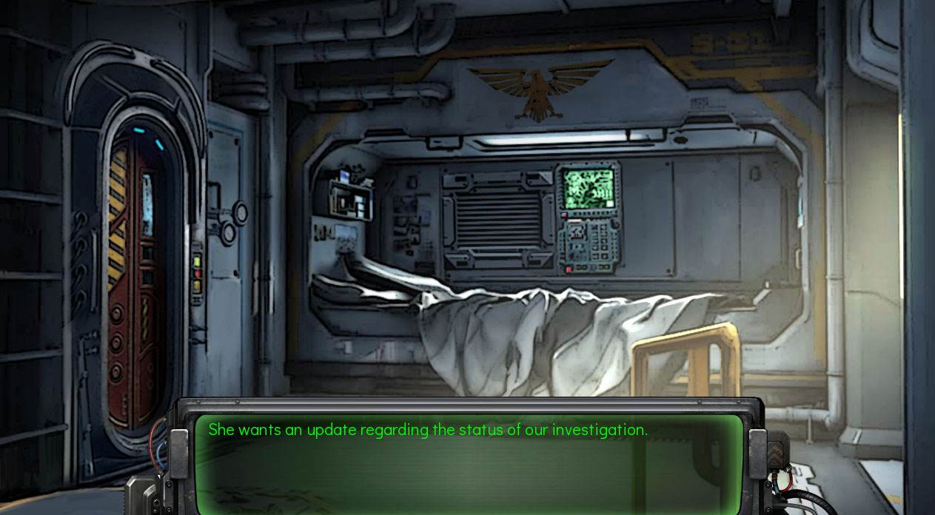

- You will directly go to see Inquisitor Cordelia to report your progress and see her Servitors. You will tell her that you believe that the daughter was kidnapped by the undercity gang or xenos cult. And Cordelia asked you to find them.
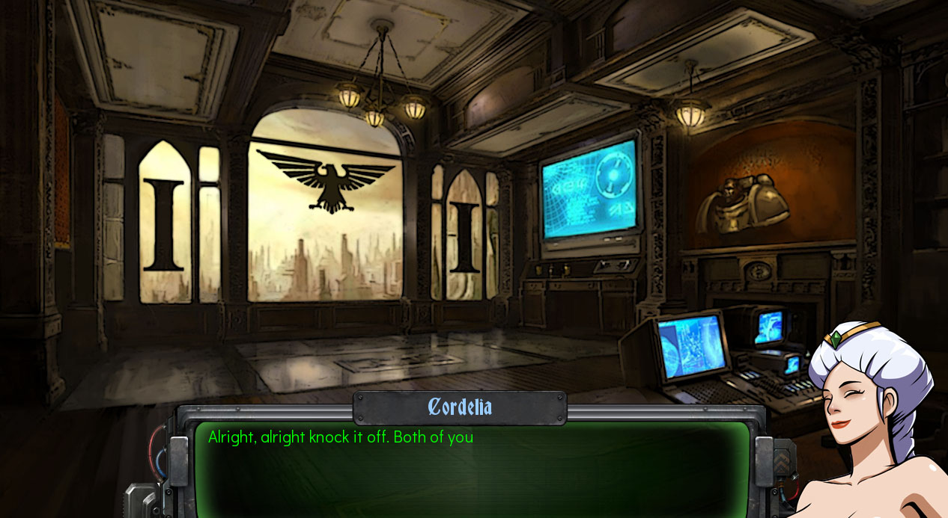

- Go to the bar and ask Vugnog where to find the gang and the cults in undercity. And Vugnog will give you the broken datapad. You pay him 400 credit and bring it to styx to decrypt it.
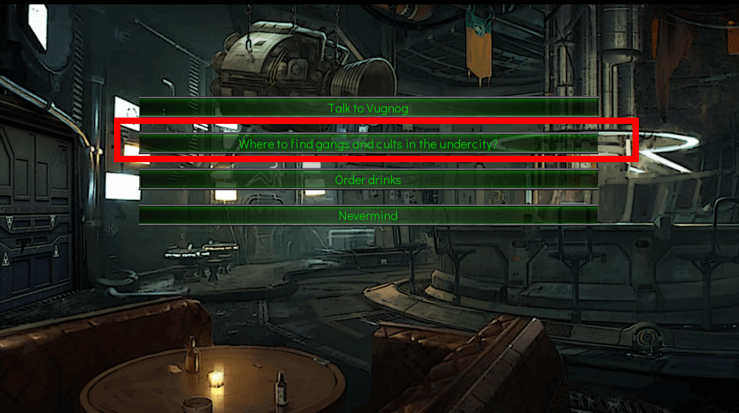

- Equipped yourself with armor and weapon that you can buy from Styx and go to the alley and choose “Enter the maze alley to look for the secret location”. You will meet the cult and fight them.
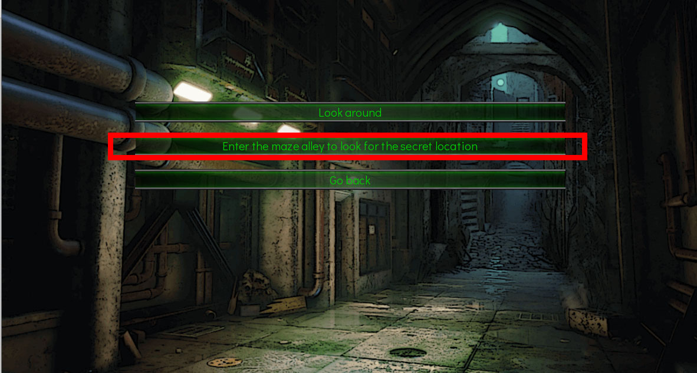
- Win the fight and they will run away after you win the combat.
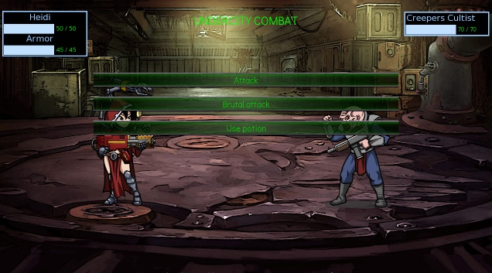
- Ask the servo skull to detect where they might run. Follow the Cultist into their hideout, and into storage area.
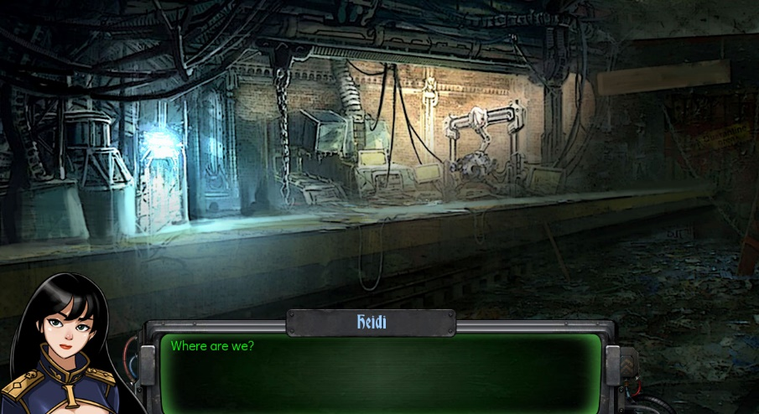

Missing Daughter Quest Part 5 (Finding The Missing Daughter)
- Rescued the girls and go back to your apartment. Go to sleep

- Go to the palace and report that you have found the cultist hideout to the governor. And he will tell you to stop the investigation. Your servo skull will tell you there’s something fishy about the governor and encourage you to rescue those women. Go back to your apartment and go to sleep.
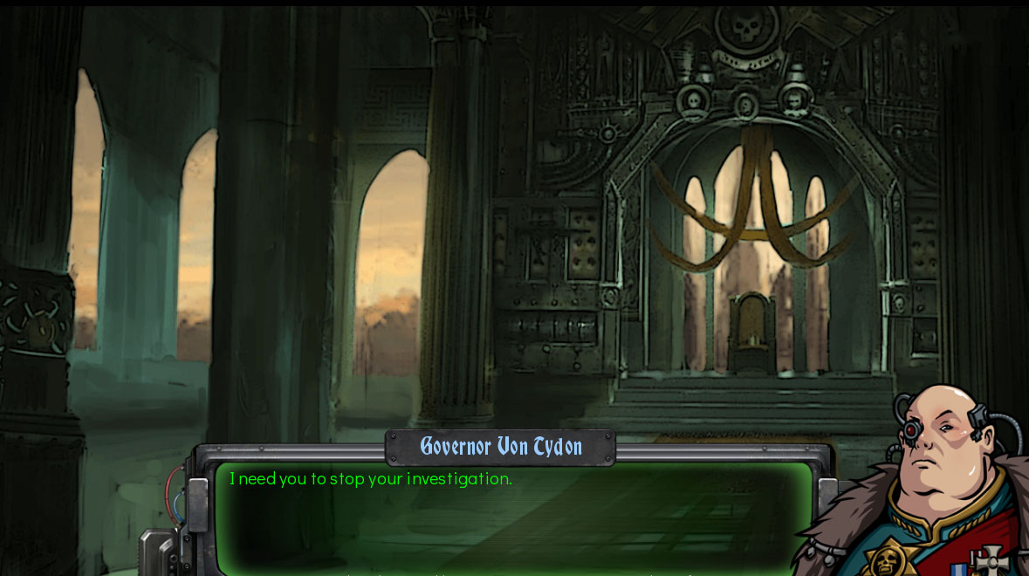
- In the morning, there will be an incoming message from the girl that you rescued. She will ask you to go to the church to get the key. Talk to the priest at church to get it. Go back to the undercity and enter the cultist hideout again.
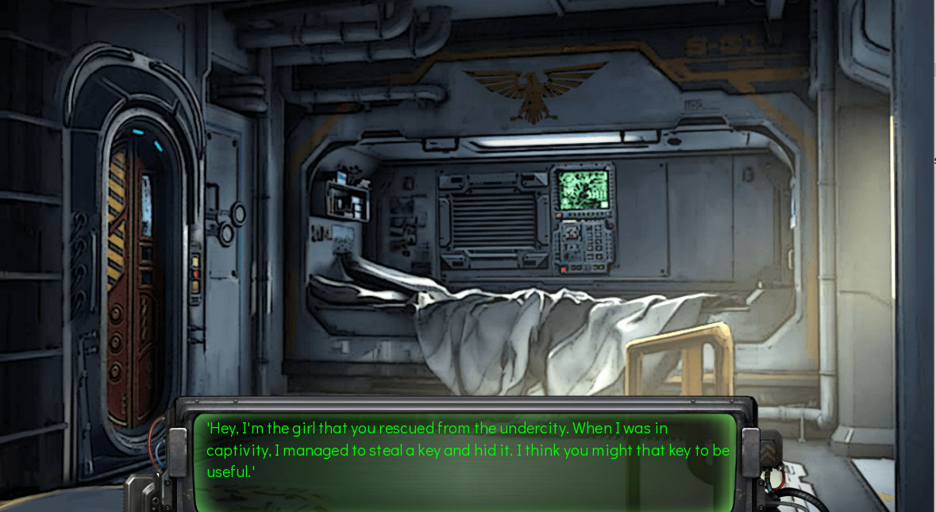

- You’ll find the missing daughter
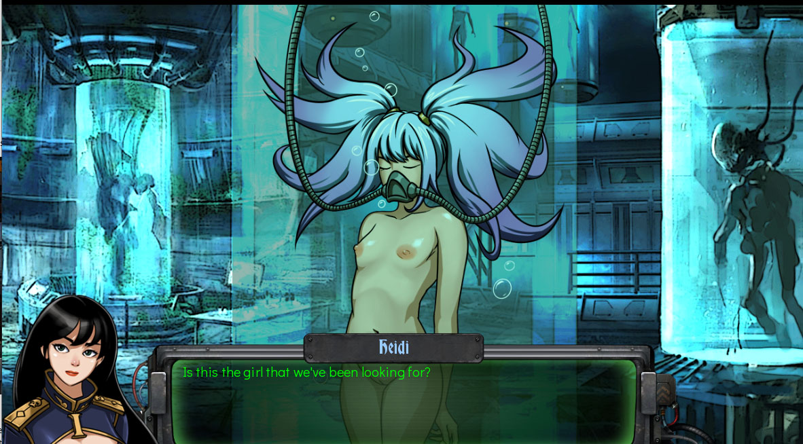
Missing Daughter Quest Part 6 (The Governor’s Plot)
- And something is happening back at the palace. Go to sleep.
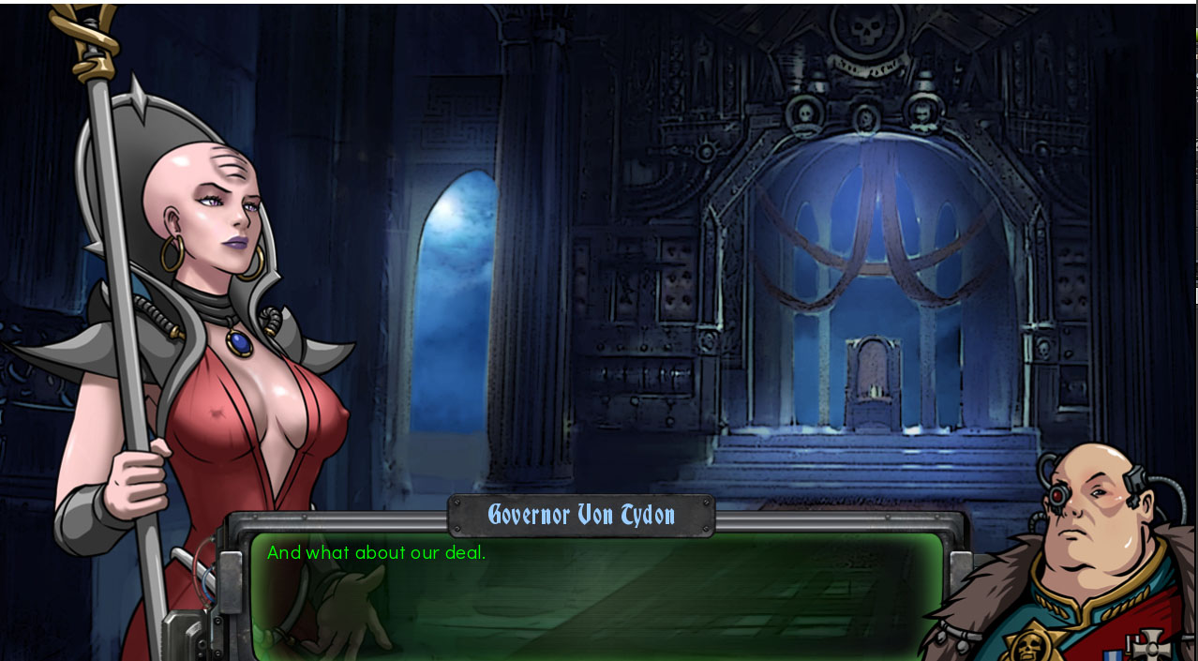
- You wake up and go to the Inquisitor Office. Report to her and choose option “They look different than human” and suggest to Cordelia to rescue the daughter to get more information about the alien threat.
Note : Don’t choose option “They look like human”, this will trigger the exterminates and the game will be over.
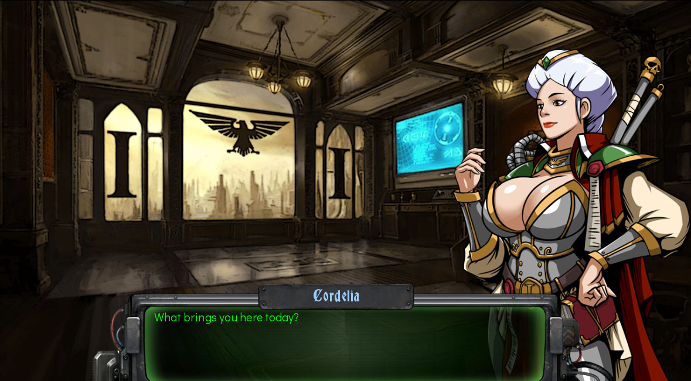

- Go to the governor palace (You need enough perversion level to talk to him). You will confront the governor. Choose “Seduce him” to escape from the situation.
Note : Don’t choose option “Resist him” or the game will be over.
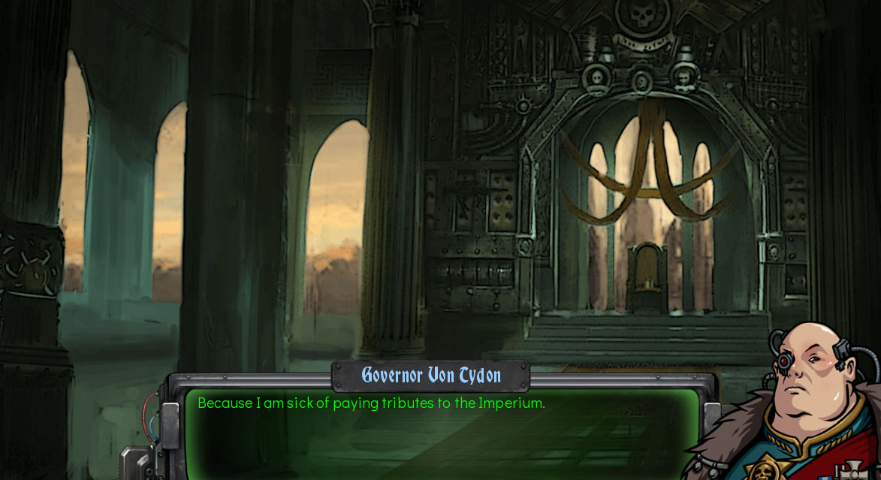
End of current content

