Accustomed
A Short Story
By Maryanne Peters

2002

James McAdam had been dating the girl for a while when she told him about the job opportunity that had amounted to nothing.

“It is a private nurse job for this super rich guy, but despite my qualifications and experience he rejected me when I met him earlier today,” she said. “It would be a great job, because is very rich, very old and very sick, and said to be very generous. But he is looking for somebody special, and it is not me. Perhaps you should apply. You don’t have a real job.”

“I’m an artist,” he said forthrightly.”

“Is that what you call it,” she sneered. “Well, you are poor. Perhaps you should offer to take on the job. Honestly, it is not like he has major needs. If you have to lift him out of bed and take him to the toilet of shower then it is better for a man to do it. He has no special medical needs. He has stomach cancer and gets all his treatment at hospital. He just takes pills. He doesn’t need a nurse – he needs an orderly I told him as much when he rejected me.”

James started to think about it, but dismissed it because he was thinking of how much lay unfinished in his studio. But a few moments later he found himself thing – ‘I am not going to get the job anyway, and even if I did there is no guarantee I would earn anything more than a bare wage. So what is the harm in asking?’

The girl did not even have the old man’s phone number, but she knew where he lived, so James decided to pay the man a call. He simply rode his motor scooter around to the address and buzzed at the gate.

“My name is James and I have come about the personal support job,” he said into the microphone. He was not a nurse and never could be, and if he now had the idea that what he really needed was something other than a nurse, James had a chance.

The frail voice on the other end paused for a moment and then invited him in. The gate buzzed open, and at the top of the drive the massive front door also opened electronically. James walked into the giant vacant entrance hall and called out.

A faint voice lead him through the house to a glass walled room that he later learned was “The Conservatory” although he had never been in a room like that before. All that he noticed was the masses of natural light in contrast to the small studio where he produced things that nobody wanted.

At the far end an elderly man lay in a contraption – and electric reclining wheelchair would be the best description. A thin blue veined hand beckoned him closer.

“Let me look at you,” the old man said. “Are you applying for the position of nurse?”

“Personal support, Sir, but it amounts to the same thing.” James stood in front of the man and smiled, intending to show good nature and enthusiasm.

“Good God. You remind me of somebody,” the man said. “You have the job if you want it. It pays very well because I was trying to attract professionals, but I take it that you have no qualifications?”

“None in this field, Sir. My calling is art, but I cared from my mother in her final days. I know what is involved caring for the aged.”

“You know I never considered myself to be aged. I turn 70 next month but until this dreadful cancer took hold of me I still felt very young and fit. Now it seems that my days are numbered. I have surgery scheduled but I am consider too weak to be operated on.”

“I can be here for you,” said James. “When would you like me to start?”

“Immediately if you can,” said the old man. “And the position is full time and live in, if you can manage that? You needn’t bring much here. I have a uniform organized. But you will probably need to make some arrangements? By the way, my name Barrett Conrad, and you can call me Barry if you allow me to call you Jay.”

James nodded. He was thing about money. He knew how much the girl he dated was making, and that this job would pay more. The sum was large. He had been momentarily shaken by being told the job was his, but the prospect of the money was welcome. Looking at the man in front of him he considered that he might be lucky if he worked for a month, including that very day.

“I can start immediately,” he said. He would call the girl to tell her. He did later that day. Now her name has been forgotten. She plays no further part in this story.

He did return to his studio for a few things and to secure it for his expected return, hopefully with not less than 2-3 weeks of the salary in his pocket. He then head back to the home of Barret Conrad which was to serve as his home for however long it too for the old man to pass.

“I have some unusual requests to make, if you are willing to indulge an old man,” Barry said. “By the way, how old are you, Jay?”

“I am 24, Barry,” said Jay, using the first name a little awkwardly the first time, but never again after that.

“Excellent. A great age. Mischief in your past and your whole life before you,” Barry’s lined face smiled. “And you said that you were an artist, so I am going to be asking for you to create a character for me to amuse me in last moments of life. When we met, I mentioned that you remind me of somebody – somebody I cared about deeply. I would like you to be that person, and if you will do that for me I will reward you handsomely on top of you wages. Would you be ready to do that?”

“Yes, certainly,” said Jay. The terms of the handsome reward would need to be settled, but he could guess that it would be enough to make him be anybody this man wanted him to be.

“Let me show you something,” said Barry. On this occasion they were in Barry’s Study near the front door and in his electric chair now bolt upright, Barry was rummaging in a drawer. He then produced two photographs.

“This is a picture of my wife Kaitlyn Emily Conrad, and this is a picture of my mother Mabel Conrad,” he said with some obvious pride. “Can you notice anything about them?”

“Well, they look similar,” said Jay. The photos were clearly taken ages apart. He would have guessed that both women were about 40 with similar ornate hairstyles and impeccable makeup, but the black and white photograph looked like it was taken in the 1950s and the color photo of the wife perhaps only 20 years before, around 1980.

“Well, some say that men look for their mother in the woman they marry. I loved them both beyond all measure, and maybe I am looking for the image of both of them.”

Suddenly Jay realized what Barry was talking about. He said, almost without thinking, his thoughts – “They both look a bit like me, I guess.”

“Would you humor an old man?” Barry gave him a warm smile – the kind of smile someone may dress a request for a great favor with.

Jay felt like laughing out loud, but he held this in check. What was he prepared to do? Basically anything. What was Barry asking him to do? Dress up as a dead woman … or two? It was nothing to Jay to do that, but what was it worth to the poor fool?

“You want me to dress to look like them.” It was not even a question. “It is an odd thing to ask, so I would expect you to agree to specific terms,” said Jay, he eyes serious but his lips betraying the humor of the situation.

“You set them then,” said Barry. “All I want is a little joy for what life I have left, and if you are to get a little joy from what I can give you in material terms, then you just name it.”

2023

Kait could not help noticing that his apartment was slightly bigger and more luxurious than hers. She was happy that it was. She had to be careful of who she got involved with. She knew that at 45 she was a very attractive women – perhaps better looking than she had ever been, because being good looking was now her main occupation.

“Can I make you a cocktail?” said Miles. At 55 he was a good-looking man, tall and fit.

“I need to be cautious until we know each other better.” She smiled with a mischievous look that she had perfected in the mirror, where she spent a lot of time. “Perhaps just a glass of wine. Chardonnay if you have it?”

“I have a Chenin Blanc from the Loire,” he said. “A good one. It needs to be drunk.”

“Ah, there is a white wine that benefits from a bit of age,” she said.

“That’s not the only thing that does,” he said, smiling at her. “Life teaches us to value maturity.” Their eyes met for a moment and Kait felt a warm feeling. It was how things were with Barry, especially towards the end.

He opened what seemed to be a panel in the wall to reveal a tall wine storage fridge, took out the bottle and skillfully opened it with a corkscrew.

“I want to know all about you,” he said, as he produced two long stemmed glasses and poured a good amount into both.

“I am not sure that I want you to know everything,” she said playfully. “A lady is entitled to her secrets.”

“I don’t think that I agree,” he said, handing her a glass. “Secrets have destroyed my past relationships, and to be clear, I know already that I am interested in a relationship with you. So why don’t we trade words of honesty tonight, you and I?”

She thought for a moment before saying – “Alright then. I feel the same way, but I wonder if it all might change when I tell you my story.”

“I don’t think that it will,” he said. “I can tell you that I have done some awful things to succeed in life, but now that I am here, I can spend some of my money to recompense. It is not that I believe in hell or karma, or guilt. It is more gratitude.

“I don’t carry any guilt either. You might say that I married money, although not straight away.”

He took a seat beside her, close enough to touch her, but he gave her space to speak.

“His name was Barrett Conrad. You may have heard of him but if you didn’t it would be because he valued his privacy. I was his nurse, not that I am qualified as that. He thought of me just as a caring person who reminded him of his wife. This sounds strange but he had me change my name to hers. I was to become the second Kaitlyn Emily Conrad. He was dying you see, and I was ready to accommodate him. My first of my two shameful secrets was that I did all of this for the money, and in anticipation that he would die quickly and I could return to my old life considerably richer. But he didn’t die. He told me later that when I came into his life it gave him the motive to extend it. He gained the energy to get healthy enough to undergo surgery that he couldn’t handle before, and that surgery, and treatment afterwards, were completely successful. So much so that he lived on for almost another 20 years.”

“Was that hard to handle?” asked Miles, with genuine concern.

“You know, for the first year I was annoyed I suppose, that my plan had gone awry. I was not annoyed that he was alive, because I learned to care about him as well as care for him, when he was at his lowest. And then when I understood that he was drawing strength from me in a way that made me stronger too, I felt closer to him than I have felt with anybody else. I think that I learned to love him. After a few years I he asked me to marry him and I did. He died peacefully in my arms just over a year ago.”

“Did his family object?” asked Miles.

“He didn’t really have any family. He had nephews and nieces who were awaiting something despite the fact that they never visited him. I say to hell with them.”

“Rightly so,” said Miles. “It sounds like you were in the right spot at the right time but that you did nothing but good for this man, so I cannot see what the second shameful secret might be?”

“Well brace for it, but when I met Barry Conrad, I was man.”

In the silence she looked at his face. The look until then had been one of curious adoration, but she braced for a sudden change. When it did not happen, she was puzzled, but relieved.

“Fascinating,” said Miles. It was like she had been telling him a story about somebody else. But there she was sitting on his sofa in his opulent apartment, her shapely black stocking legs crossed in front of her, now with his hand on one.

“And now here you are, in my apartment, by now a complete woman, I am guessing.”

“Why do you assume that?” she asked.

“Well, a year after his passing you are still you, a very attractive wealthy widow. I am guessing there is no going back.”

“You’re right, of course,” she said. “But quite how it all happened is hard to explain. I suppose that at the beginning I wanted to be Kait because that is what he needed. I tried very hard to be as feminine as possible, and to emulate the women in his life that he most admired – his wife and his mother. I even used to dress as his mother did, at his expense. He loved the look of women in the 50s and I had a local salon do my hair and makeup, and I had all the slips and dresses and high heels. I just got carried away by all of it. I used to love having my hair done. I still do. This ultra feminine look suits me, don’t you think.”

“I think that I have a lot in common with your late husband,” said Miles.

“I think I just became accustomed to being a woman. I learned that I loved everything about being a woman – the smooth soft skin, the lingerie, the dresses, the stockings, the shoes, the hair, the makeup, the nails, the accessories, the salon, the shopping, the attention of men, the camaraderie of women. I just can’t imagine life without it. This is my life now. Anything else is just not right.

“I think you’re wonderful,” said Miles.

“Are you attracted to transwomen? I think that you should know that I have had sex reassignment surgery. There is nothing down there. I never thought that I would go that far at the start. I didn’t even want to take the hormones. I was just worried about losing my hair. And then these breasts sprouted and Barry said that I would look good in a bikini at either of the beach houses or on the yacht, and … well, a bikini with a bulge just doesn’t look right. And Barry wanted to … you can guess. To be blunt, men in their 70s can still have sex, with a little blue assistance. He loved me, you see.”

“I can understand that,” said Miles. After a pause he added - “But I’m only 55.”

“Is that a proposition,” she asked. “Aren’t you concerned about the fact that … I wasn’t always a woman?”
“Is that true?” said Miles. “Or was it just that you had the wrong body? I am looking at a woman. I am looking at possibly the most attractive and sexy woman I have ever been with in my entire life. Of course it’s a proposition.”  “Miles, I am happy to say yes. That is another thing about being a women that I have become accustomed to – just lying back and waiting to be filled and sent into orbit. But you need to understand – I have known love as a woman. I am still looking for that. I have become accustomed to that as well, and I am finding it hard to be without it.  He stood up and took her delicate hand in his.  “Darling, your search is over,” he said.  The End  © Maryanne Peters 2024 | 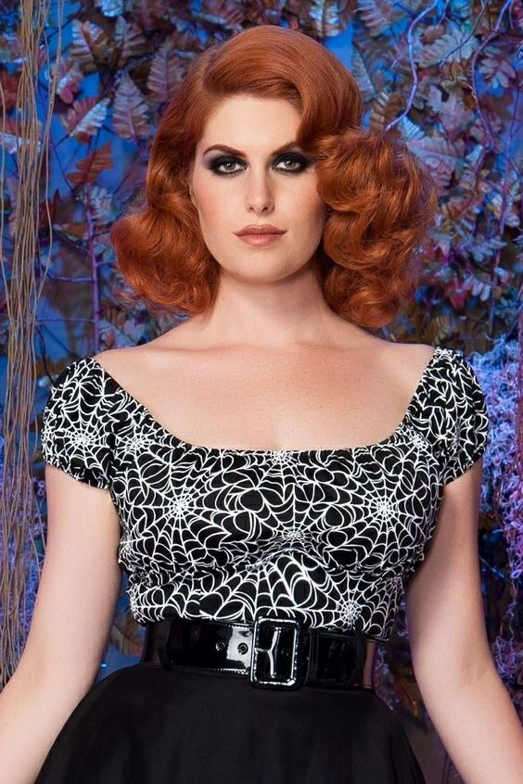

Author’s Note: This story is down to something posted on FM MB early this year by pantyhoseboy - “Subject: Can someone write a story: I would love to have someone to write story about a young man named Joe that is presented with an offer to inherent an elderly mans’ fortune. The stipulation is that he must live as a woman named Kailin Emily Conrad, the old man’s wife and be feminized at the whim of the old man. The young man thinks that the old man must surely pass away within a year or two and decides to accept the offer believing that he will be able to return to being a man after he inherits the money. Twenty years go by before the old man finally passes. The young man, now a middle aged woman, has been feminized beyond the point of return. He, now she, would not be able to pass as a man even if she wanted to, but does she even want to be a man again? She has lived virtually her entire adult life as a woman. She has worn nothing but women’s clothing, lived as a woman for over twenty years, and has friends and a life as a woman. She doesn’t even know how to live as a man. She has become so accustomed to wearing dresses and heels that she doesn’t feel properly dressed unless she is wearing pantyhose or nylons and she feels absolutely naked without her makeup on, not that she needs it now that she is so feminine and beautiful. In the end she is relieved to find out during the reading of the will that her contract in fact stipulates that she must remain a woman for the rest of her life.”

Not surprisingly given the chosen name the request was for “lots of lingerie, pantyhose, heels, slips, and dresses’ which is not really my thing, but also “maybe romance and Kaitlin's acceptance and love of being a feminine woman” which definitely is.

