The Beta Male  Inspired by a Captioned Image  by Jennifer  By Maryanne Peters  I cannot quite recall when I finally discovered that my husband was a beta male, but from the moment that I did, his slide into sissidom seemed inevitable.  I had never thought of him as an alpha type, but I always said to him that I found men who seek to dominate as being a turn-off.  Isn’t it strange that sometimes we women want our men both pliant and assertive? We like those who are meek to us but are expected to stand up to anybody else. | 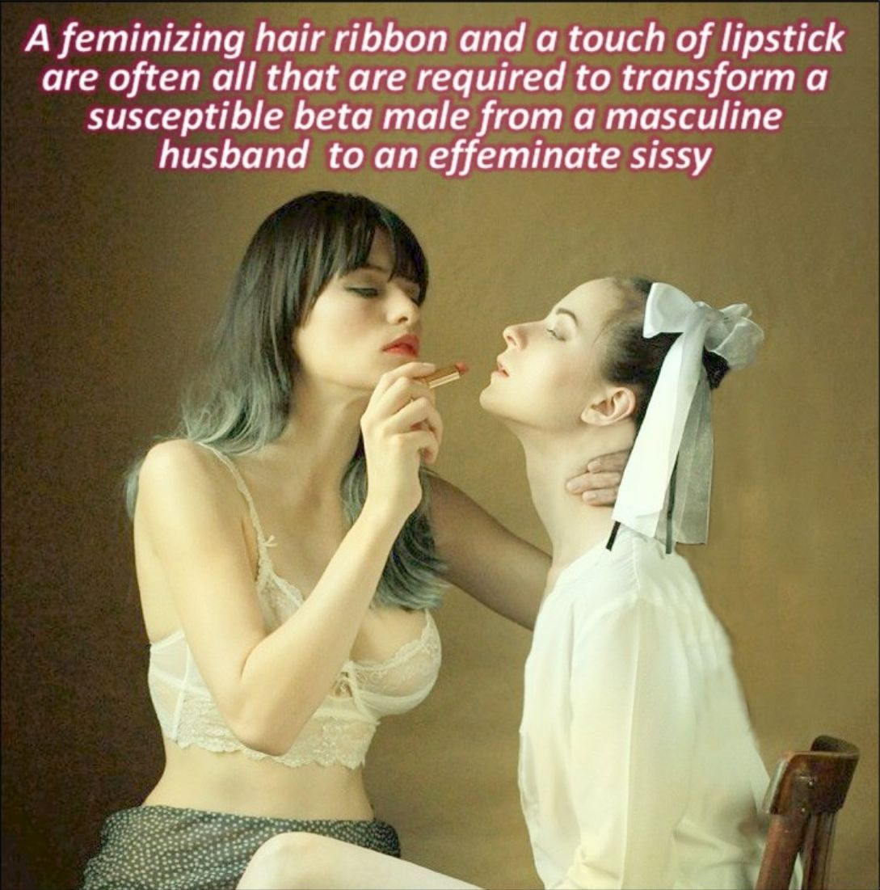

When we got married we used those old fashioned vows, but I switched them about so that he swore to “love honor and obey” me. It was just a joke, but he kept on talking about it afterwards. I accused him of being passive aggressive when he did, but her said – “No. Just passive”.

I thought that the first signs of sissy behavior were a similar strategy. He would flit around the house with a feather duster held in a limp wrist humming “I Feel Pretty”.

“If you are going to behave like that, then I will get you something suitable to wear,” I said. He now wears at least the white stockings and the frilly panties every day - previously under male clothes – but now he avoids that.

So, one day I worked it out, or it may have been gradual, but now I know for sure. My husband was just a susceptible beta male but now he is a sissy. He wears his hair in a bun, sometimes with a ribbon or a bow. His eyebrows are plucked, and he just loves to wear lipstick. There are no breasts under the white blouse, but he would like to take hormones.

Of course, that is up to me. I make the decisions. But I cannot help thinking that when we get what we demand we have to accept the consequences. I cannot see him ever going back.

What should I do?

The End

Finding my Place
Inspired by a Captioned Image by Jennifer
By Maryanne Peters

I was just supposed to be a slave. Yes, slavery exists, but without the chains these days. There are other shackles that bind – drugs and shame.

The first drugs numbed my mind and then after that came the feminizing drugs that tore away my manhood, leaving me totally emasculated, probably permanently so.

When you are like that shame is your prison. What man would set foot outside looking the way I do?

So as the drugs that affected my mind ceased to have effect I started to consider how I might escape.

I said that I wanted to be pretty. I explained that all aspects of manliness were now a burden that I wanted to rid myself of. My hair was long enough to be styled, and I could have my eyebrows properly shaped and my nails done. It would mean setting foot outside – just a short trip to the beauty salon.

I was accompanied on that first trip as I expected I would be. But when I got back I fizzed with excitement about my new hairdo and my bright red nails. I would have to wear a headscarf and gloves to do my chores and keep looking attractive.

It was clear that I had been changed. I had become a true sissy – passive and trusting. That is just what a sissy should be. And pretty too. Nobody likes the idea of an ugly sissy even if I am only there to serve.

As I explained it, I was happy in my submissive role, just with an occasional trip to the salon as a modest diversion.

It was only a matter of time before they let me go there unattended. I could grab a cab and I could be at the salon in less than 20 minutes. I could have my hair and nails done and maybe a leg wax. It was almost like freedom. All I needed to do was make a break for it. That’s all.

The problem is that I am a sissy. Who would look after me if I was on my own out there in the big wide world? I am pretty though. Maybe somebody will come along looking for a sissy just like me. I would submit myself to that person totally. That is what sissy’s do.

The End

© Maryanne Peters 2021

Descending  Inspired by a Captioned Image by Jennifer  By Maryanne Peters  It was to be a “coming out” of sorts. I made the dress specially – in virginal while with crocheted over skirt and sleeves. I had his hair pulled back and the bun will only get bigger as his hair grows longer – as it will over the months to come.  Can you see the little lacy flap in the front? That is my own special touch. It is so that his friends will be able to see what lies beneath – a tiny little penis and even tinier balls in a pink plastic cage | 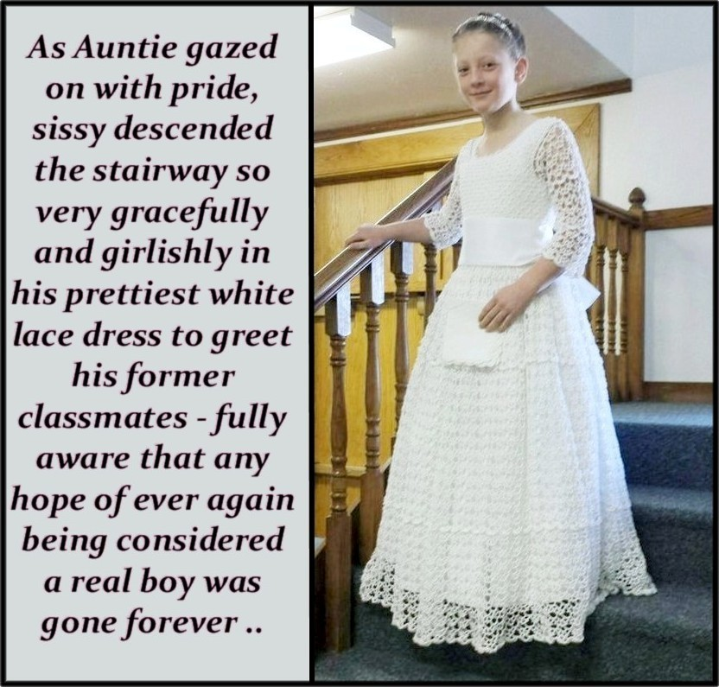

One thing that will never descend are those small nuts. I will make sure of that.

And the unexpected thing in this photo, was that he was smiling. There were initial protests that faded as he slipped on his training bra and white stockings. I assumed that I had just bullied the boy out of him, but then I was suddenly struck with the notion that he might really be looking forward to this.

I turned around to see the boys ready to view this sissy boy. They were all sniggering except one. The boy right in the front with his eyes on my nephew. And I could see that the sissy was looking back at him a if there was nobody else in the room except the two of them.

This was intended to bring him down to a low point, but instead I saw that it would be nothing like that at all.

The End.

Look at Me  Inspired by a Captioned Image by Jennifer  By Maryanne Peters  Look at me. This was the moment of realization, or close to it. When Mommy set up my new room with my Edwardian bed head and lacy bedcover, and had me dressed in that nightie top, with my special pants that tucked me in so tightly. | 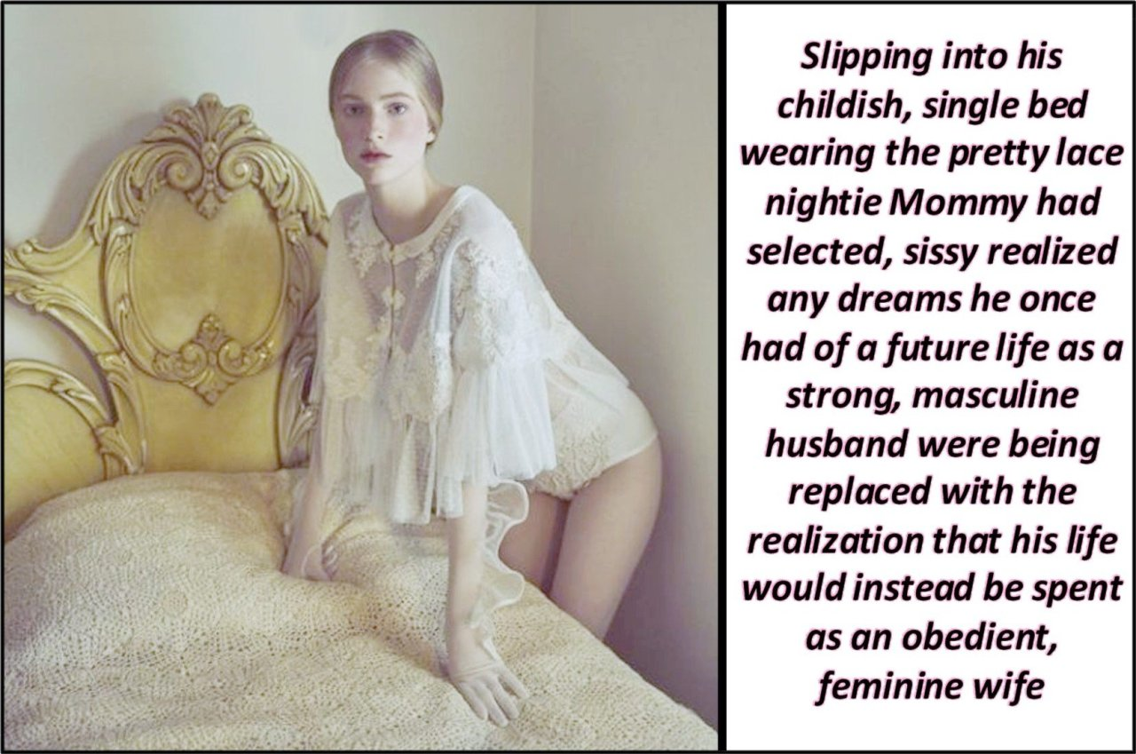

There is not a lick of makeup on me. Months indoors and a skin program have left me with that pale alabaster complexion that make my lips seem so red and my cheeks pink, and has dyed eyelashes and brows stand out. That is natural beauty. Girlish beauty. It is not that face of a boy, let alone a man. Look at me.

My hair has grown long too, throughout tis ordeal. I wear it parted in the middle because it is right for my face, and tied back for bedtime, but I can play with curls too. The truth is that I like playing with my hair. I would like it longer so that I can do much more.

I play with makeup a bit too. Mommy encourages it. It is just that I would never use too much. When you are as pretty as I am you need to let the natural beauty come through.

Look at me. What kind of a man could I ever be looking the way I do? What kind of woman would fall for me? I look pale and weak … because I am. Pale and weak is good in a woman.

Mommy says that I have the kind of look that attracts the right man. Men could see in me goodness and passivity. They could see in me an obedient and feminine wife. I cannot offer them motherhood, but Mommy says that I have the kind of body that should never be wracked with childbirth, and the right man will understand.

She says that I just need to get rid of what is left of my manhood, because looking at me, they would expect me to have a vagina.

Standing in front of the mirror naked, with my soft smooth skin and the tiny titties Mommy’s hormones have created on my chest, and my bits tucked away between my closed legs, make me realize that Mommy was right all along. I will never be a husband. I should concentrate on becoming a wife.

I mean, look at me.

The End.
Like a Princess  Inspired by a Captioned Image by Jennifer  By Maryanne Peters  I never thought that it would happen to me. I liked the rough and tumble of being a boy. Like to play sport, and climb trees and wrestle with the guys. Maybe I liked that last thing a little too much. I suppose that I knew I had feelings that I was not supposed to have, but maybe that was just the way I was brought up. | 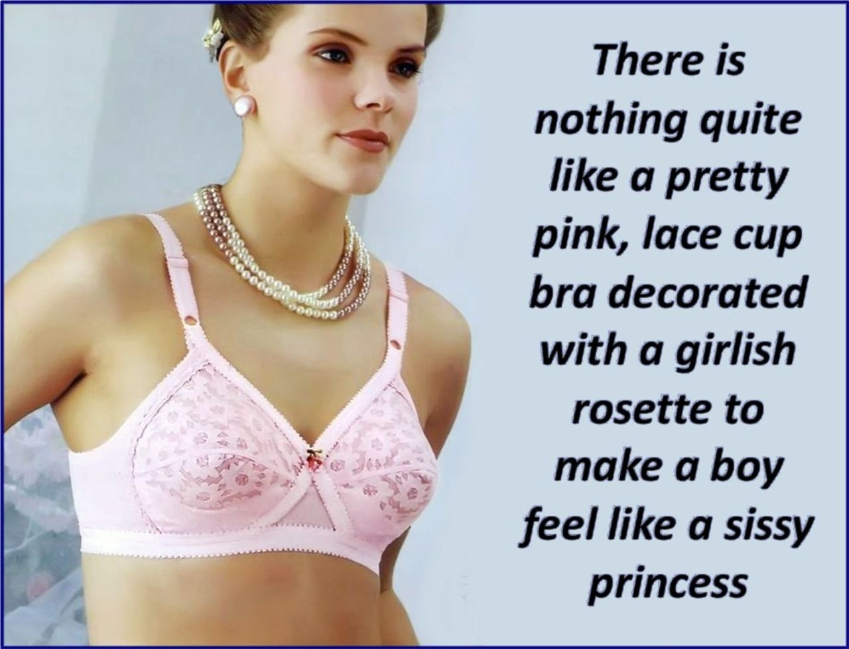

But I liked pretty things too. I used to like looking at girls just like the rest of the guys, but I knew that I was looking at them in another way from all the guys. The others were looking at breasts and butts, and I was too, but wondering what it would be like to have a body like that. And I was looking at hair and makeup, and clothes and shoes, and looking at what looked good, and what didn’t. And earrings, and beads around the neck, and bangles and hair ornaments. Girls just had so much pretty stuff and boys had nothing.

Every girl wants to be a princess, and I wanted to be a princess too – it was just that I was a boy.

Never make the mistake of assuming that people like me don’t have courage. Lots of the things that I did as a boy required courage, and I had plenty of it. It is a brave thing to say to all of your boy pals, as well as your parents, that I wanted to live my life as a sissy.

“It is a way of life and it is my choice,” was how I explained it. “I want to live my life dressed as a very feminine girl and I want to be made love to by boys, but I am still male.”

Not everybody understands but there are enough of us out there who do.

Somethings you can do straight away to announce to everybody that you are a sissy, I could not wait to grow out my hair and get on to hormones. It seemed to take ages for things to happen but now I finally feel that I can claim to have achieved sissy princess status. My hair is pull up in a gorgeous bun and my new bra is filled completely by my own flesh. I feel so pretty and so happy.

As for boys, well my old pals drifted away when I took my big step, but now they are back and more than curious. What am I like in bed? Well let me tell you, a sissy princess cannot be beat when it comes to sex. Try me.

The End

© Maryanne Peters 2022

