Forged in Battle
A Vignette
By Maryanne Peters

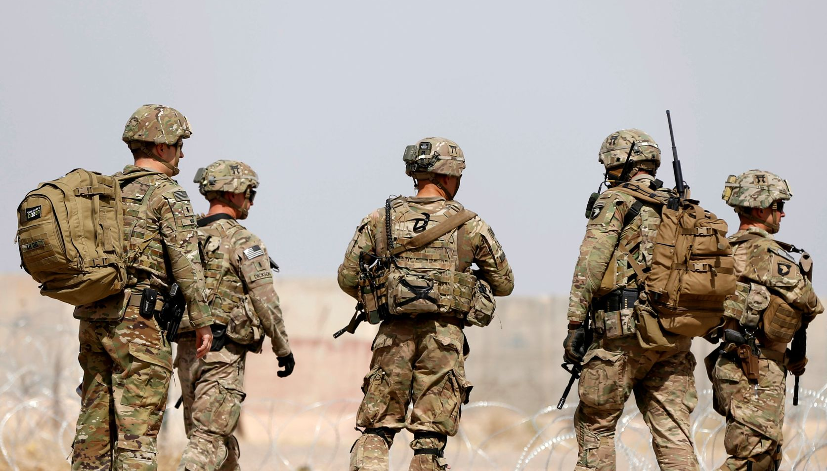

“Sometimes I can’t believe that I put up with this bullshit,” said Bo, feeling as mad as all hell. “So, you saved my life. But that does not mean that you take advantage. Even a lifesaver can be a stubborn dickhead sometimes, deserving of a good tongue lashing.” Bo’s tongue shot out.

“Have you never heard of the Chinese proverb that saving a life is an obligation on the guy who was doing the saving, to see that life made good – meaningful and happy,” said Cal. I am not looking for gratitude. You owe me nothing. I look out for my men. I looked out for you. I would have done it for anybody.”

“I don’t doubt it,” said Bo. “You were the perfect sergeant, weren’t you? But, would you have listened to another? I begged you to finish me off, remember? I thought that life was not worth living, with my manhood blown away completely. There was no future for me. Even if you had not used your pistol, leaving me would have seen me bleed out in minutes. But you had to stuff me full of expanding dressings. You had to carry me those two miles to the aid station. Why?”

“I guess there was something about you that led me to believe that you needed to be cared for,” said Cal. “I still see that. I could never work out why you joined up in the first place.”

“Hiding from myself, maybe?”

“That must be it,” said Cal.

“What I can’t understand is why you did three tours. What was that about?”

“I had nothing else,” said Cal. “I had no purpose in life. The army gave me purpose and reminded me of it every waking moment. I wasn’t hiding from anybody. I was doing my duty.”

“So was I, right up until my dick and balls were blown off!”

“That is all behind us now,” said Cal. “Leave it. Plenty of people came home with worse. Plenty of people want to swallow a bullet even all these years after. People who could not handle the injuries – physical or mental. That is not you, is it.”

“You know the answer to that question,” said Bo. “You have given up your purpose now.”

“I have purpose, and you know what that is.”

Bo’s shoulders dropped. Why were they arguing? It never mattered. It just felt good to be emotional sometimes.

“If you’re angry with me then all can offer is make up sex.”

Cal looked across at Bo. With one hand she was dragging her blond curls across her face, and looking at him seductively. The other hand was drawing up the hem of her floral embroidered nightie, revealing the smooth thighs, still bearing long faded scars on the inside, only near the very top. And there, finally revealed, was the masterpiece of the surgeon’s work – a vulva and a vagina fashioned from her perfect flesh and made even perfect by Cal’s worship and constant use.

“I could never refuse you even if I wanted to,” said Cal. He moved towards her across the expanse of the bed covering the no man’s land with his usual skill. He took her feminine body into his arms. There was no sign of the soldier Bo had once been – only the pretty Bo-Jean he had married.

“Just try to hush that ecstasy of yours when I am deep inside you,” he said. “We don’t want to wake up the boys.”

“No, we don’t,” she purred, just before that kiss of pure love.

The boys were asleep down the hall, in the house they had moved into a month after their wedding. Both the boys had been adopted from the same orphanage not far from the battlefield where it had all started, which somehow made them part of that. An explosion, a serious injury, but a perfect family forged in battle.

The End

© Maryanne Peters 2023

