The Other School  Inspired by a Courtney Cap  By Maryanne Peters  If you are a late bloomer you will do almost anything to be one of the big boys, including becoming a girl.  The plan was crazy. We had a big game coming up and our cheerleading team was way worse than the West Side High School team. The plan was to get somebody on that team to sabotage the performance. None of the girls at East Bank were willing to do it, so what could they do. Well, try to find a guy to do it – a guy who can pass as a girl.  I never thought I could pass, but they said that I could get help. I had some gymnastics background so all that was needed was for me to go to the salon for a makeover, get some fake papers together and get enrolled at West Side High School before tryouts for their team. | 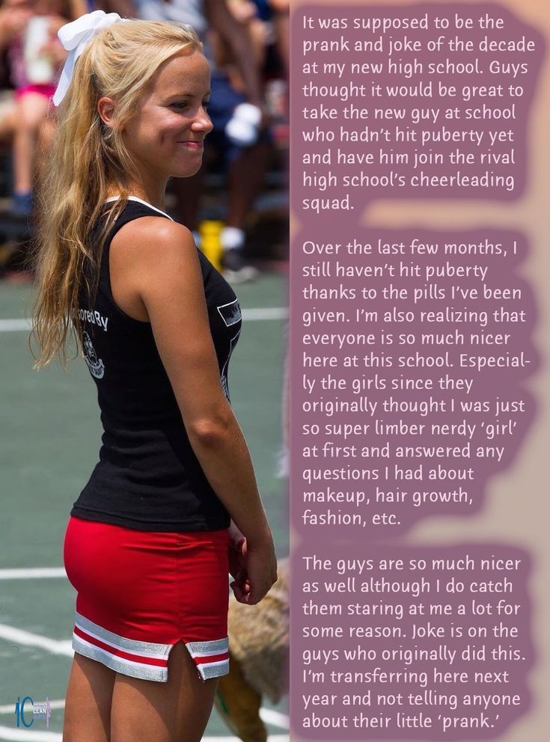

I went to the salon and had the hair extensions put in and the facial and makeup as well, but what the guys did not tell me was that the vitamins they had given me to keep up my female appearance would prevent male puberty from happening. The last bloomer was just supposed to become a non-bloomer but I ended up blooming in another way.

Now, looking back on it, it seems to me that they really did not care what happened to me. I was new at East Bank High School, and I never really fitted in. At West Side High School, it was different. Everybody just seemed nicer, or was it the fact that I was a girl?

Not just a girl, but a pretty girl too. The dimples in my cheeks looked weird on a guy, but on a girl it had all the boys smiling. What is it about dimples?

The idea was that with my background I would be able to infiltrate the West Side Cheerleaders, even though they had a top team. I was able to get in, but when I did I just asked myself why would I sabotage them? If East bank want to win the competition then they would have to work harder.

The fact is that I am not prepared to work much harder, so I will probably be dropped from the squad. The thing is that there is so much more happening at West Side High School, and I just don’t have the time. You see, I have discovered boys!

The End

Billy’s Desires
Requested by Billy and Inspired by one of Courtney’s Caps
By Maryanne Peters

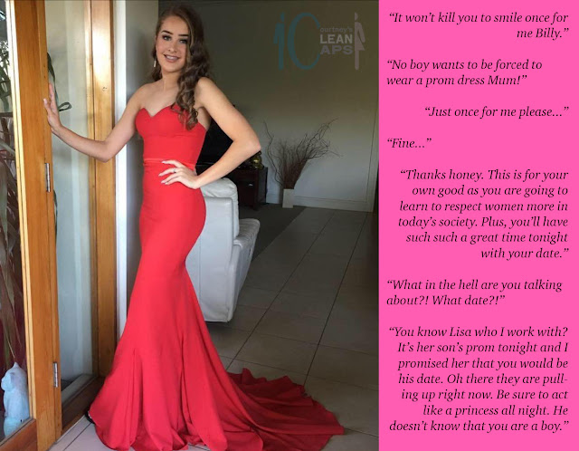

I had convinced myself that being born male was the best thing in the world. I mean, men run it – the world I mean. Men are in charge. Women have babies. Women are meant to look pretty and look at their men adoringly, but they offer nothing when it comes to leadership or innovation – that was my position. Somehow it seemed that the more I said it out loud, the truer it became.

All it did was piss my Mom off. I understand why. It was for me. It was to assure me that I really wanted to be male.

So then her punishment was this prom thing. How ironic is that? Well, maybe not so much. It was intended to say – “if this is what you think being a woman is all about, you try it for a day. You experience a full being pretty.”

She worked in a salon, and she had a dress. It had been abandoned by the girl who was to wear it to the prom, who tossed it at my mother after a fight with her boyfriend. My mother brought it home and started talking about how a dress like this had to be worn and admired. She looked at the sizing and she looked at me, as I was ranting at her about some stupid girls on TV. I had no idea what was going on in her head. Not until she said it out loud.

“You putting women down has to stop. If you are to stay in this household, and let’s face it you have nowhere else to go, you have to understand a women’s perspective from a woman’s perspective, and the answer is in my hands. This dress. It will fit you perfectly, if we shape your body a little. It’s a prom dress and I will find a prom to go to.”

“I am not going to my school prom in drag!”

“Not your school, no,” she said. “But I am serious, Billy.”

She was, and I was fucked, and I knew it.

But the crazy thing was that the dread I felt of losing my masculinity evaporated so quickly that I wondered if it was ever there in the first place – not the dread but the masculinity.

She had me shave my legs and arms. It is a small thing, but it made me feel so strange. She made me try on underwear which was called a bustier corset. It seemed to change my sex. It gave me a waist and breasts and took away my male genitals. I should have been horrified, but instead I was enthralled. Then she had me squeeze into the red dress – just to check the fit. It was perfect. I was perfect – at least from the neck down.

“Tomorrow is prom night, and I will get you into the salon early to get you hair and makeup done. I will need to get you a day dress to where until you are ready to put this on,” Mom said. “And we will need to get you shoes.”

“I can’t go to this prom alone,” I said, my eyes wide in the mirror.

“Don’t worry,” she said. “I would never let that happen.”

I had the weirdest dream that night. I dreamt that I woke up and I had breasts and a vagina and long hair! And worst still, I was so pleased that I had all those things. I just danced around my room naked until my mother knocked on my door holding a box of lacy underwear and a long red dress.

In the morning I resolved that I was ready to do this – just for that day.

“Do your worst,” I said out loud, but to nobody in particular.

The day of prom night is a busy one in my Mom’s salon, so she was in early and I was seated for hair extensions and a makeover. She had me wear a salon robe. The hair was fixing and she shaped rather than aggressively plucked my brows, but they still looked like a girl’s. She had one of her girls do my nails.

She had found a day dress for me, and she had me wear that and sandals and help at the salon with moving equipment and replenishing supplies. And then she had me fill in for the lady on reception.

“You will need to introduce yourself as Beth so you had better sound like a girl when you answer the phone,” Mom said. “ You had better go out back and practise on your voice recording app. You would not want to embarrass yourself.

When she took her break, we sent to buy shoes.

“I will never be able to walk in heels like that!” I told her.

“Well, get some practice in. But don’t worry, I will get you a second pair with a lower heel in a neutral color. You can never have to many pairs of shoes.”

I wore those shoes to lunch at the mall restaurant. Mom was correcting me on my posture with special reference to the angle of my elbows.

I kept working at the salon right up until it was time for me to get fully dressed and head home. I had to practice how to walk in the heels, how to lift my skirts, how to climb and descend stairs, how to get in and out of a car. I was concentrating so hard, even when we got home.

“It won’t kill you to smile once for me, Billy,” she said. She took the photo of me by the patio doors.

That was when she told me about her friend Lisa’s son Rod and that it was his prom I would be going to as his date. She and Lisa would only being going briefly. Lisa was coming over and Rod was looking forward to meeting his date.

I have to say it, to that point I had been having a great time. I had been doing exactly what my mother wanted me to do – I had been living my day as a female – working in the salon with only women for company, learning about beauty and style, shopping, sharing lunch with my mother, understanding just how different women are, and just how happy they can be.

But then I was filled with fear. I was a woman, and a man would be coming near me. Would he be like me? Would he be nasty and cruel like Billy? It seemed as if I could see the person I was for the first time when faced with the view from the other side.

The other side? Had I really crossed over that easily? Everything had seemed so much easier than it should have been. Even the heels under the dress felt comfortable, and the seemed to change the way I carried myself. But the voice, and the mannerisms – they seemed to have been picked up as if they were second nature. I had even been sitting down to pee all day. It just seemed right. What was I?

When Rod walked in behind his mother Lisa, I knew.

Nobody but a woman could have felt the way I felt when I first laid eyes on him. He smiled at me as if to tell me that he liked what he saw – or even more than that. I smiled back. Something happened. The universe shifted. Everything changed, or was it that it had always been that way and I had just never seen it before?

The words that my mother had said to me moments before he walked in seemed to ring in my ears – “Be sure to act as a princess all night. He doesn’t know you’re a boy.”

I am not acting. I am a princess – or that night I was. Am I a boy? As I explained to Rod as we kissed for the 100th time – “I am a girl, but I do have a problem. It’s a small one but an ugly one.”

“There is no problem that we can’t get past, Baby,” he purred, in a way only he can.

And the truth is that by that point nothing was going to stop him, not even that. He just went right past it as if it wasn’t there. Oh my God! His name is Rod, and I know why.

The End
Dream Job
Inspired by a Captioned Image by Courtney
By Maryanne Peters

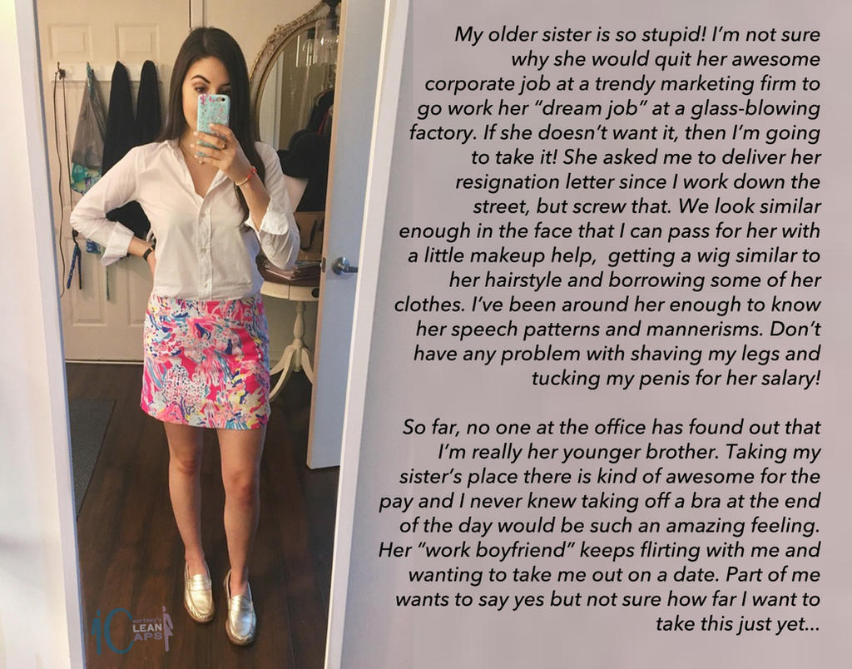

Glass-blowing. What is that? I suppose that it is art. She always had a hankering for art. I always had a hankering for money.

Rather than take the transfer across to the HR division she was prepared to hand in her resignation and just never go back. I needed the money, so I took the job myself. From HR I could finalize her termination from her point of view, but stay on the payroll and collect her salary into a new account I opened in her name. There are two of us now, but I am the one with the steady job.

What is HR anyway? It is just personnel records and the occasional hiring and firing. I can do that, and what I learned quickly was that if I can’t, then I bat my eyelashes at Ryan, and he will help me to get it done. He is my “work boyfriend” as I call it. I have basically learned that if I want to stay in my job then I need to keep in with him. I can only get away with it because he is the only guy in HR who knows her. He was the guy who transferred her across, and (as it turns out) the reason why she quit. It turns out that “work boyfriend” is not always a good thing.

He was disappointed at first. He said to me – “Who the hell are you? You’re not Joanna, but you are claiming to be her.”

“I am her little sister,” I told him. “But I really need the job.”

“How badly do you need it?” is all he said, giving me a weird look.

I called it flirting. That was how it started, anyway. Just suggesting that we get together after work. But that seemed like a bad idea. I had to say no. I just decided to keep that no sound more like a “maybe”, just to keep in with him.

But then he started to get pissed by the rejections, however soft I felt that I was making them. He started calling me “a cock-tease”, and threatening to out me as being an imposter.

I have to say that even after a few weeks I had got used to be my sister Joanna. The job was a breeze, and I was popular with everybody, and I had money in my purse … and I was spending a bit of that on dresses and cosmetics, and getting to like the way I looked too.

“Okay,” I told Ryan one day at work when he was getting heavy and starting with the threats again. “You’re right, I am a cock tease, so I guess that the time has come for me to tease that cock of yours, maybe in the personnel records room in ten minutes?”

I suppose I figured that I had been playing with my cock most of my life, so what was so different about fiddling with another one.

The difference is that he was in control. He started to insist that I get on my knees. He wanted me to put it in my mouth. I was not about to do that, but I got down eye level to the thing, and worked it hard to get the job done and get him off my back.

He reached down and took hold of my head. I suppose that happens, but what is not supposed to happen is for him to pull my wig off.

“Hey, what the fuck?!”

It could have all ended there. Maybe it should have? He would have gone limp and I would have put my wig back on and gone back to my desk. He could try to get rid of me then.

“I took Joanna into a secure room to give me a blow job but I discovered she is really a guy, so she needs to be fired, pronto!” How does that go down?

But after a moment of shock on his face as I look up, I see his open mouth start to shake and the next thing I know my face is covered with his jizz. It turns out that he had just had the orgasm to end all orgasms.

I don’t know whether Ryan knew before then that he would be turned on by boys dressed as girls, but after that experience, there is only one girl for him, and that would be me.

The funny thing is that … I am okay with that. The End
The Woodland Fairy
Inspired by a Captioned Image by Courtney
By Maryanne Peters

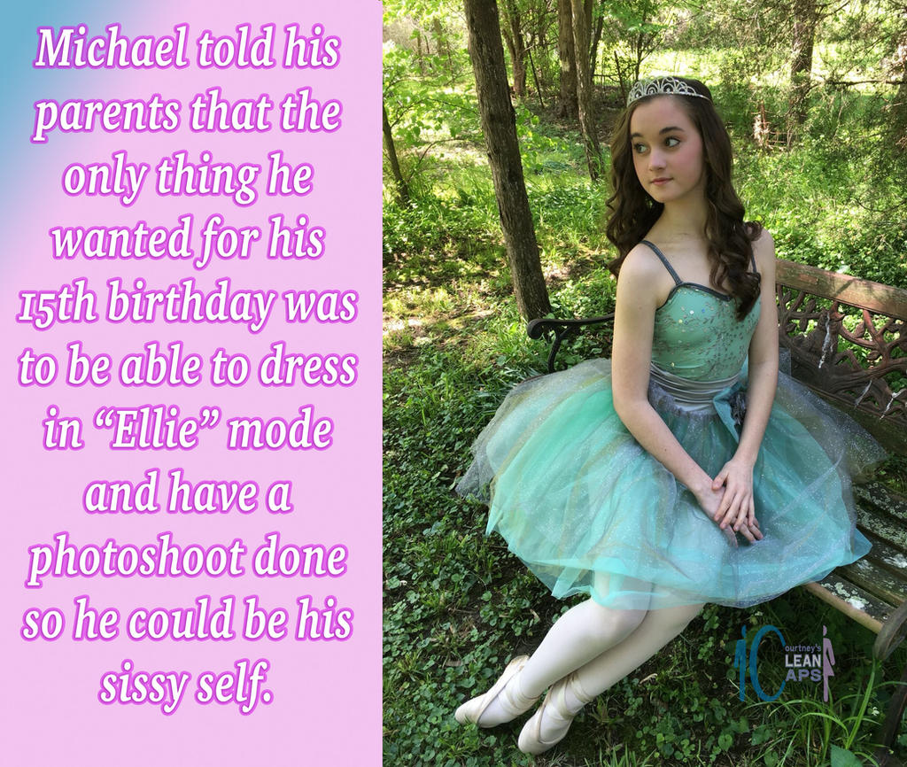

I grew up with fairy tales. We all did – right? We all wanted to be princesses – didn’t we? It was just that I was a boy called Michael.

I suppose I am lucky to have been an adolescent in an age when transgender people are understood and tolerated. I never underestimate how hard it must have been for those born in the last millennium when they might would be sneered at or abused. That was how my parents saw things. They were worried about me.

I did my best to stay under the radar to reassure them. I grew my hair but I kept it tied back. I never demanded hormone therapy as some in my position might. I just accessed androgen blockers on the black market and so I developed mild gynecomastia in my teens. But I stay living as Michael until I felt that I was old enough to be taken serious and no longer your enough to have not gone through male puberty.

That was the point when my parents asked me what I wanted for my fifteenth birthday and I told them.

“I want to come out as a girl,” I said. “I want to have curls in my hair and have my face made up and I want to have some photographs taken. Not glamor shots, but in a fantasy scene. I want to dance through the forest in ballet shoes and green tutu.”

Sometimes wishes really do come true.

The End

Marrying For Money
Inspired by a Captioned Image by Courtney
By Maryanne Peters

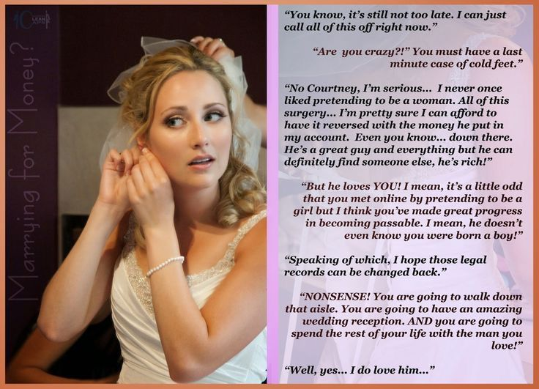

Is it in the Bible? The love of money is the root of all evil – is that what it says? Well, I love money, I admit it. It has brought me no evil that I can think of. It has brought me love.

Not just my adoring and wealthy husband, although God knows that is love. No, I am talking about Courtney as well. My best friend. My bridesmaid. My girlfriend when I was a man.

We have so much in common Courtney and me. We shared the love of money, both of us.

It was when she met her husband that this all started. She met him on line through a site that managed super yachts for wealthy owners. It was a great idea. Only the super wealthy access sites like that, or those providing services. She just went on as an interior decorator and she met the man she is now married to.

She felt bad about throwing me on the scrap heap to marry money. She said – “If only you could do the same thing.” It was like a challenge.

I suppose that being without her I needed the diversion. Like I said, I never liked the idea of pretending to be female, it was just that was how she got her big break. I offered a different service. Arranging ports and berthing in the Mediterranean – a way to use my knowledge of languages and Google. I never thought it would amount to much, but then Pavel contacted me.

I used a voice filter at first, but then I trained my voice to match. The feminizing visual filter was needed for zoom was just as easy, but as Courtney said, I needed to do better, especially when I actually started doing the work. Courtney helped me. I started to take on the appearance of the woman I was pretending to be, little by little.

The money rolled in, and with each port he arrived at, I came up with some reason not to be there, so that we could never meet.

It could not go on that way. We were falling in love. Or he was falling in love and I was so in love with his money that I could not escape.

The last time I told him that I was in hospital and could not make it the city his boat had docked in. He offered to pay my medical bills. As I said to Courtney, it seemed a pity not to take advantage of such an offer.

“Get some facial feminization surgery and breast implants,” she said. “It is all reversible. But if you have a private surgeon do a good job, money no object, at least you will be able to meet him. You can’t dodge him forever.”

It seemed to me that she was right. I had everything done. Even some work to hide my male genitals so that I could wear a bikini and he could even see me naked without knowing.

So I finally met Pavel. I went aboard his super yacht and I had a few days living the life I always dreamed of. I was in love, that was for sure, with that life, and with money.

“My darling, I am sorry, but we cannot make love,” I told him. “I have a deformed vagina. I cannot bear children. I cannot even take a man inside me.”

“Modern surgery can fix anything,” he said. “I want to marry you. I want you to be my wife.”

He put money into my account. I cannot even remember asking him to do it, but he did it anyway. It was more money than I had ever earned in my lifetime – more than many would ever earn in a lifetime, but for him it was less than he earned in a day.

That is a photo of me on my wedding day, with Courtney adjusting my veil. Yes, I had misgivings on that day. It was my last chance to pull out. I talked about it. It was like she said – I felt that I was going too far and that I was only motivated by the money. I felt that it was wrong to deceive him – he had no idea that I was not a real woman.

But for the first time Courtney made me realize that I was in love with Pavel. I wanted to spend the rest of my life with a man – this man. I never thought that could ever be true, because I was not really a woman, even after all the surgery. But how can you not fall in love with somebody who loves you more that life itself? At least that is what he tells me.

We got married and now I have had the “corrective surgery” and we have a full sex life.

We are having his children by a surrogate mother – he can afford it.

Courtney has married her billionaire too. Our hardest job is deciding whose superyacht we should cruise on next year, or maybe we will take both a cruise in convoy. Decisions, decisions!

The End

© Maryanne Peters 2022

