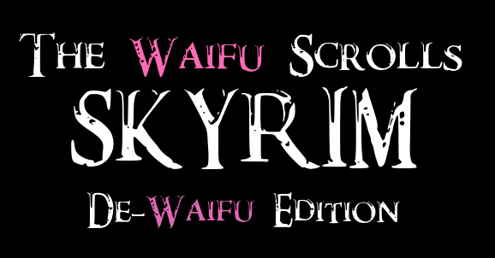

Part 7
I stared into Lydia’s eyes, and she stared… in my general direction.
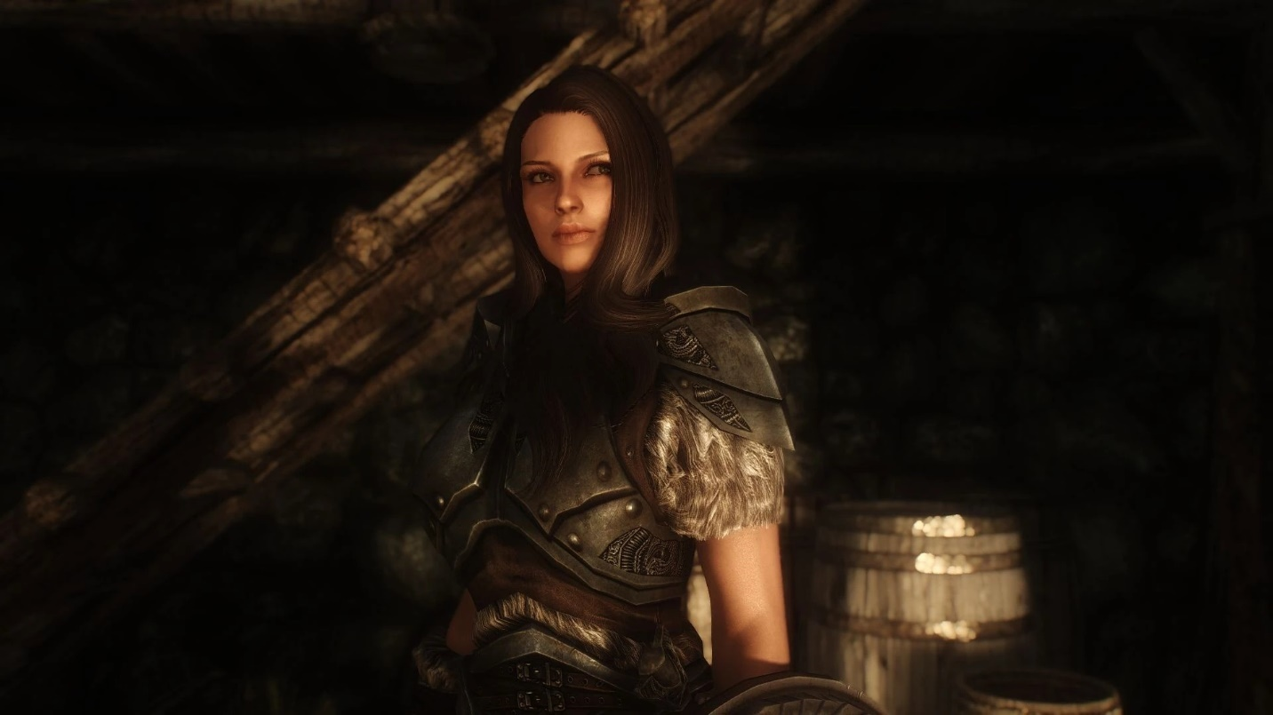
“What am I going to do with you?” I mused, standing inside the house I’d gotten, having been stupidly flush with cash from grinding the fuck out of my skills and killing well over a thousand ‘bandits’ while stripping them, and their camps, down to their foundations, to sell everything I could in the hopes of upping my Speech Skill, so I’d immediately bought it, and the ‘furniture packs’, even though that wasn’t what they were really called, just to see if it would instantaneously be furnished, which, yes, of course it fucking was.
“I am your sword, and your shield,” the NPC Companion replied.
“Yeah, you’ve said that a dozen times already,” I remarked, reaching out to poke her in the cheek, a move with provoked absolutely zero response. More out of annoyance than perversion, I poked her in the lips, which were soft, then the neck, then, fuck it, poked her in the armored boob, and… nope. No reaction. Not even the repression of a reaction. Just… nothing.
“You know, some people out there would really like this situation,” I sighed, as, for better or worse, I wasn’t among their number.
“Honor to you, my Thane,” the fake woman declared, which… didn’t help me with my dilemma.
I’d originally planned on teaming up with the Dragonborn but she was in the wind, and having backup would help, but… Lydia was an NPC.
Sighing, I opened a portal and went home, made some tea, grabbed some of the scones I’d made earlier, leaning a little on Faerie Feast to help, but, if I turned it up too far, I likely wouldn’t be able to stomach the tasteless ‘food’ that was the norm here in Not-Skyrim. While I was doing okay with my Healing spell, the fact that I could eat a ‘sweet’ roll and heal myself without having to use any mana was something I wanted to still be able to do.
If I got too used to actual cooking?
I’d likely gag if I tried to choke down what was available here.
Bringing the plate and cup back to Skyrim, Lydia was still there, standing, waiting, looking vaguely in my direction. Having a seat, I considered her, having tea, wondering if I really wanted to do this to myself. Because she wasn’t a person, and, being alone, I worked, but, but it was easy to try and fool myself into trying to believe she was, but that delusion wouldn’t last.
“… Fuck,” I swore, deciding to at least give it a try, standing and telling her, “Come on, we’re going.”
“Lead the way!” the soulless woman smiled, and I felt a twinge, but, no, looking at the expression, which she held far too long, no, it wasn’t real.
Leaving my new house, which I’d bought just because I always did in the game, and glancing back to make sure Lydia was still following, at least the woman’s pathing was improved over the version of her I’d seen, and soon enough we’d left Whiterun, which, given how I’d explored most of the town already, meant I had a couple quests hanging in the back of my mind. That said, I knew they weren’t time sensitive, no matter what the NPCs said, and, given how one would lead me to a Redguard ambush, and the other would lead me to fighting a ton of magical hags, those were definitely on the ‘get to later’ list. I’d probably not tackle them until I was level thirty, minimum, and I wasn’t going back here any time soon.
Normally, I’d make a Shroudcycle and take off, but I had a companion now, though not a Companion, as that was a line that… no.
I refused.
But, heading to Winterhold, I’d be crossing half of Skyrim, and, thankfully, I could add a marker to my HUD’s mental map, so, at the top of my vision, I could sense it standing out in a way that’d ensure I never got last.
That said, I paused next to the carriage I’d walked by literally hundreds of times, as, while I had no Fast Travel options, unfortunately, this should work.
“Need a ride?” the driver questioned as I, for the first time, stared at him long enough to prompt him to ‘open dialogue’ with me, and, navigating the NPC’s dialogue-tree, yeah, like I assumed, there was the option to get there fast. Plus, I had, while not a King’s ransom, definitely a Duke’s, or maybe a Jarl’s, and, looking at the price, fifty gold was chump change to get where I needed to go.
Paying the fee, the driver, named Bjorlam, nodded, questioning, “Ready to go yet?”
But, as he did so, the world… shuddered.
I froze, looking around, as the sky seemed to darken, my Defenses lighting up as something tore at them, and, in the distance, the far mountains… lost focus, blurring, a wave of dissolution rapidly approaching, while the NPCs stood, unmoving, and everything continued to darken, an eclipse-like effect spreading out, the illumination patterns that of day, heavens still blue, but a faded, shadowed, fading blue, as the shuddering worsened, and-
NOPE!
Opening a Gate I dove through it, paused for a second, realizing that Lydia hadn’t followed me, but- Nope! Fuck That!
I slammed the door shut, throwing the latch, and shoving my back against it, Shroud-tendrils striking out to anchor it shut, and, for several long moments, nothing happened. Detaching the barricade from my back, and stepping away, I took several long, deep breaths, Stress Defense at work helping to keep me level in the face of… whatever the fuck that was.
Did… did I trigger a game-breaking bug?
… Fucking Bethesda.
After half an hour, with nothing happening, I dismissed the anchor, unlatched the door, and almost reached through the swirling energy, before I realized I was being stupid, and grabbed a sword from my inventory. Slowly, I poked it through, pulling it back, and… it looked fine?
Feeling it, it was a little cold, but it was like fifty degrees outside. Flipping it around, I extended the handle through, but, retrieving it, the leather grip was undamaged. Putting an arm through… no, it was fine. Hesitantly sticking my head through, everything was… normal.
“Um, hi?” I asked the carriage guy, who stared at me.
“Need a ride?” questioned Bjorlam, and there was the dialogue menu, as if I hadn’t hired him, and…
“So, we’re gonna be walking,” I informed Lydia, turning and heading down the road, and taking a left at the bridge, heading along the river, aaand, right, walking was slow as fuck.
Making my Shroudcycle, Lydia didn’t so much as blink, because NPC, and, concentrating, I extended it out horizontally, putting together a basic sidecar, making the frame, seating, wheel, the last of which, given that it operated through magical bullshit, could also turn on its own, which might actually make me faster.
“Alright, Lydia, take a seat,” I informed my companion, who just stood there, staring in my general direction. “Right.”
Getting off it, I could push the woman forward, and, with a bit of difficulty, managed to get her seated, strapping her in like a particularly passive aggressive toddler, and then, walking back around and swinging my leg over the main chassis, we were off.
It took a little to get used to the slightly different handling of the changed shape, and I needed to build a suspension into the new addition, as my Housecarl was getting shaken something fierce, and, while she didn’t complain, just staring in my general direction, kind of creepily, it was the principle of the thing.
With that managed, though, we were moving faster, and, hitting the beginning of the mountains that laid between me and my destination, the trees were sparce enough that it was easy enough to thread my way through them, a wolf leaping out at me from behind a tree, but a swinging hand, equipping an Ancient Nord Axe, took it in the side of the head, not killing it, but sending it falling behind us as I kept going, not even needing to hold the handlebars to drive, though I did just as a concentration aid.
“Skyrim belongs to the Nords!” my passenger declared, pulling her blade, but, strapped in as she was, all she could do was turn a little to face the rapidly shrinking wolf, as I didn’t stop driving.
Crossing the snowline, my wheels started to spin, but re-envisioning the wheels to add texture to them let them dig in deeper, in a way that would be damaging to them normally, but as the material was self-repairing, this worked perfectly fine, as I continued, up and down, keeping my focus forward, skirting a bandit camp, and a tower full of necromancers given the black robes, almost running over a troll who’d blended in with the snow, but mostly just driving through endless hills, those incidents almost half an hour apart, catching movement out of the corner that made me slow.
As Lydia was… twitching.
Finding a fairly level, open glen, I brought he Shroudcycle to a stop, and gave the area a once over, but no one was actively pissed at me, from the lack of red smudges on my compass, so, turning to look at her, I asked, “Um, are you okay?”
The NPC, her twitching getting worse, though not yet to seizure levels, tried to open her mouth, but really more just pulled her lips back, teeth gritted, and let out an almost animal whine of distress.
Blinking, I dismissed the Shroudcycle in an instant, and the woman crumpled, still twitching, and I stared, unsure, bringing up my phone, and… fuuuck.
Because navigating my menus, I found, under Captures, was ‘LyDIa? – in progress’.
I’d forgotten that while my Binding worked off of contact, it was not necessarily skin contact, so, as she’d been sitting on my Shroud, her back against it, the straps of it holding her in place just being the cherry on top, she’d started to be Bound.
Reaching down to pick up the still twitching woman, my gear was all ‘real’, or as real as anything else was here, my Shroud underneath the metal and leather, so I didn’t make it worse as I opened the Gate and carried her Home. Putting her down on my couch, I sighed, unsure, so I made lunch. Keeping an eye on her, the NPC’s motions slowly stilled, and then she passed out, though, checking her, she was still alive, though I wasn’t sure how her vitals mapped onto a normal person’s.
Throwing my Captures tab up in the top right corner of my vision, waiting for her entry to disappear as the Binding hit zero, I left her to recover and headed back to Skyrim, re-manifesting my Cycle and making more progress, jumping a group of Bandits, who, while they hit hard, were still limited in physical ability, while, with Shroud-Fuckery, I was able to give myself the minor degree of super-speed that enhanced strength granted.
This world’s gamification meant that it didn’t matter how fast I was going, I didn’t do anymore than ‘power attack damage’ when I hit them, though physics were still enough of a thing that I could knock someone off their feet once I got to the thirty-mph range with my jump attacks. They didn’t seem to take any more damage from being tossed into a tree, but it took them out of the fight for a handful of seconds as they stood back up and ‘reset’ themselves, which let me focus on the others.
Having done this at least a hundred times by now, there was a definite order of operations to fighting ‘people’, that went Archers, then Mages, then Melee, as, while fire and lightning spells did jack shit to me, the ice mages had the tornado problem, where it wasn’t that the wind was blowing, it was what the wind was blowing.
Because the standard ‘Frostbite’ spell, other than draining my ‘Stamina’ gauge, did nothing, but the ‘Ice Spike’ fucked me up the first time I got hit by it, not from the cold, but because it was a flying spike made of ice, one that I’d not expected, having face-tanked the former spell a number of times without issue.
That said, while the arrows were slow, and almost floaty, they still hit like actual arrows should, or at least should with the stupid way that ‘armor’ worked here, and while I’d gotten used to them, they weren’t what I’d trained against, making me zag instead of zig once there were multiple ranged opponents, so they got my primary focus. I kept sending myself slipping and skidding through the snow until I reworked my boots, knowing that, if I was to do any kind of mule-kick, I’d need to retract it or the System would have a snitfit, refusing to classify it as either a weapon or ‘Unarmed’ for my Skills if the Shroud made contact first, but that still gave me the speed needed to kite the sword and axe wielding bandits once I’d taken out their more dangerous comrades.
Truly, with room to maneuver, and against anything less than a dozen normal foes, it wasn’t even fair, but having faced hundreds of pissed off draugr in very tight quarters, I just enjoyed my advantage, and, given it took fucking dozens of hits to take each one of these fuckers down, while eight good hits would fuck me up, I had no regrets cheesing the ever-living-fuck out of my capabilities to make this work.
Seriously, I remember these guys going down in a handful of good hits when I gamed, but, despite swinging hard enough to possibly fell trees outright, they just grunted and tried to swing back at me, completely ignoring the open, bleeding wounds I’d inflicted, which were always shallower than they should be.
But they still died, and as I took a several foot leap backwards, the last Bandit, a hairy man wielding a greatsword, slashed and missed, over-swinging so hard that it was child’s play to rush in on his opposite side, bringing my own axe to slam into his studded leather, actually hitting the stud, but armor here was stupid, so it still was ‘cut’, that last blow finally enough, the big man ragdolling to the crimson-splattered snow, along with the others.
Had it not been enough, it would’ve been easy enough to keep going, running past him as he re-centered and tried to swing on me again. I was well aware that this place was teaching me some terrible habits, and, once I got out, I’d need to relearn how to fight, but, with this almost certainly being a Company fuckup, asking for a refresher course before I dropped in somewhere sane would be as simple as making it part of my compensation request.
Sighing, and looking around the once more quiet glade, the crackling of the bandit’s fire the only sound, the food on it not really cooking, but in a constant state of ‘ready-to-eat’, I took the time to Loot them all with my Added Potential, not in any great rush. Heading back Home to unload, Lydia was still unconscious, her name still on the ‘Capture’ list, and, after freeing up my inventory space, I did my best to gave her as much of a physical as I could without stripping her, because, yes, she was an NPC, but… no.
The woman’s pulse was unusually rapid, though her blood pressure was low, her pupils were pinpricks, her skin cool, and a bit clammy, and different muscle groups were still twitching, not enough to move her anymore, but, feeling her arms, having stripped my gloves, I could tell her spasms had merely lessened, not stopped.
Something was certainly happening, but even shining a light in her eye wasn’t enough to wake her up, and I really hoped I hadn’t managed to put my companion in a fucking coma.
I’d almost say she was in shock, except some of the symptoms didn’t match, and, well, Shrouds were very specifically meant to reduce negative effects of Binding. After all, what was the point in Capturing someone if they then died a few seconds later?
Regardless, even though it probably wouldn’t do anything, I made sure to get two pillows, one for her head and another to lift her legs, along with a blanket, getting the shivering woman a glass of water and resting it on the side table, and finally just stood there, awkwardly, unsure, before saying fuck it and heading back out to make some more progress.
I worked my way through another four Bandit camps, a couple mountains, and a populated valley with a small town full of NPCs I didn’t recall in the slightest, unloading some loot, before, as the sun set, calling it a day. Lydia was still out of it, still partially Captured, so, after a quick-ish dinner of steak and asparagus, paying attention to the odd, tasty butter full of herbs that Faerie Feast had directed me to make, I headed to bed myself, taking a moment to shift my apartment to put a lock on my bedroom door… just in case.
Waking up, taking a nice, long, hot shower, and eventually dressed and ready to go, I headed into my main room and jumped, somehow having forgotten about the NPC in my house. And Lydia was… just standing there, next to the couch, in her NPC waiting stance, looking like she had before, and not, well, like shit as she’d seemed when I’d gone to bed. Checking my device, yeah, her bugged entry on my Capture list had disappeared, as all entries would when they hit 0%.
“Alright, let’s go,” I ordered, grabbing a banana and a packet of jerky for breakfast, and opening the door.
“Lead the way,” the housecarl replied, just as she had before, only… she didn’t move.
Turning, I looked at her fully. I was far enough away that she should’ve walked up to me, but she… wasn’t. “So… come on,” I prodded.
“Lead the way,” Lydia repeated, nodding, and… not moving.
Sighing, and Pocket Space-ing my breakfast, I walked over to her, seeing the blanket had pooled at her feet, from where she’d gone through her standing animation, and, with a bit of Shroud-assisted strength, bodily picked her up and moved her to the door. Waiting a moment… nope, still not good enough, so, gently, I took her by the shoulders and pushed her backwards, as she’d turned to face me, through the swirling vortex, and back into Skyrim proper.
Once back in her ‘home’ dimension, the NPC was able to walk correctly, her, I don’t know, fucking pathing now functional, which made me just sigh. Making a Shroudcycle just for myself, and starting to move… yeah, she’d take off running, and she wasn’t slow for a person, but… no.
Waiting for her to catch up, yeah, this wasn’t going to work, but I’d thought about it, and I hopefully had a work-around. Because while equipment counted as the person, PPE effectively useless, because it was a Conceptual tool, not a biological one, but that meant that the restrictions were similarly simultaneously counter-intuitive and perfectly logic in a child-logic kind of way.
So, popping a shield out of my Inventory, I formed the Shroudcycle’s side-car around it, so that you could stand upon it without ‘touching’ the Shroud. Then, popping out a few pairs of bandit shoes, which, thankfully, didn’t stink because the Inventory system auto-cleaned things, I was able to fit Shroud-tendrils into them, like gloves, and, reaching out with them, picked up my companion, placing her on the shield, and holding her in place.
Waiting a moment, checking my Smart Device… yep, ‘LyDIa’ did not appear. Experimentally, I added a couple Shroud-tendrils to hold her in place, and, watching the display, yes, her entry did appear. Removing them, and waiting, it took several times as long as it did to show up, but the NPC’s entry did disappear.
“Okay, we have a workaround,” I smiled, glancing at her. “A stupid workaround, but if it works, it ain’t stupid!
“I am your sword and shield,” the NPC stated.
“Sure you are,” I replied, rolling my eyes, and, yep, we were moving!

<SWE>

Okay. So. Lydia?
Really fucking strong.
Like, ten times stronger than I was.
Not in actual strength of course, but, for whatever reason, her numbers were huge. What took me half a dozen hits, she could do in one, and she could take the hits as well, though, given she fought like an angry hippo, she kind of had to.
That said, Bandits prioritized her, and while I made sure to face-tank the fire, lightning, and cold spells for her, others going for her let me dart in close and hit them in the sides and backs with several rapid blows that whittled down their health fast. Also, I was getting a lot of Restoration magic practice, as you couldn’t move the needle by trying to heal someone already in perfect health, but, while when I healed myself I could take myself from ‘fucked up’ to ‘let’s fuckin’ go!’ pretty quickly, my companion’s much larger health pool took quite a bit longer to work on.
I mean, I had to fuck with it until I could heal her at all, as the Healing spell I head only worked on me until I figured out how to tweak it, and I lost a good bit of the spell’s effectiveness in the process.
It was a bit odd, as I could feel the levelling system slowly tick up, but, at the same time, while it was content to grind and allow me to ‘get gud’, I could feel that I was doing… something, and, by working on it a little, I could get a better handle on how the spell itself worked, on a foundational level beyond ‘press X to Heal’, shifting it this way and that, and, while my effectiveness similarly waxed and waned, as well as the Magicka drain rate, just as I’d had to learn the damn spell manually, I was gaining experience manually, but not XP, which I was also getting.
Like I said, a bit odd.
Also, after hearing the NPC go “"A healing spell? Are you a priest?" dozens of times I was seriously considering just gagging the woman.
Either way, pressing forward, and climbing the next mountain, occasionally casting Clairvoyance, though given it had wanted to take me through a Giant Camp I only occasionally listened to, tearing through a pack of wolves with arrow-tentacles, managing to up my ‘Archery’ skill, finally, when, on my mental compass, a vague shape appeared, showing a Point of Interest, though what counted was odd, as the valley-town before hadn’t rated such a marker at all. Getting closer, and passing by some old, weathered, mammoth bones, I heard something faintly… whispering.
“A Word-Wall?” I questioned, well, no one, really, but I’d run across them before, and as soon as you got close, you could tell. That said, I didn’t see any Dragons flying about, so I should be in the clear, the spawn-rate not really kicking into high-gear until you say Alduin’s little ‘show and tell’ necromancy display. Reaching, not the summit, but getting close, noting the sheer-cliff face of the northern edge, I finally found the ruins, and the magically inscribed passage.
“Modir the Far raised (this) stone in memory of his brother, Oskar the Fool, whose Voice was weak and not (the) mighty Thu’um of his clan,” I read, which was… ouch, and, at the same time, the name of this place, Shearpoint, blossomed in my mind. And not just one word was glowing, but three, which… score?
Shrugging, trusting Lydia to watch my back, if only to yell a challenge if something tried to jump me from behind, I started to approach the epitaph, and the glowing words, when-
Crack!
Fwoof!
Haaaa!
And, as a nearby coffin’s lid flew the fuck off, going a hundred feet up only to crash into the ruins nearby, I realized why this was a three-for-one deal.
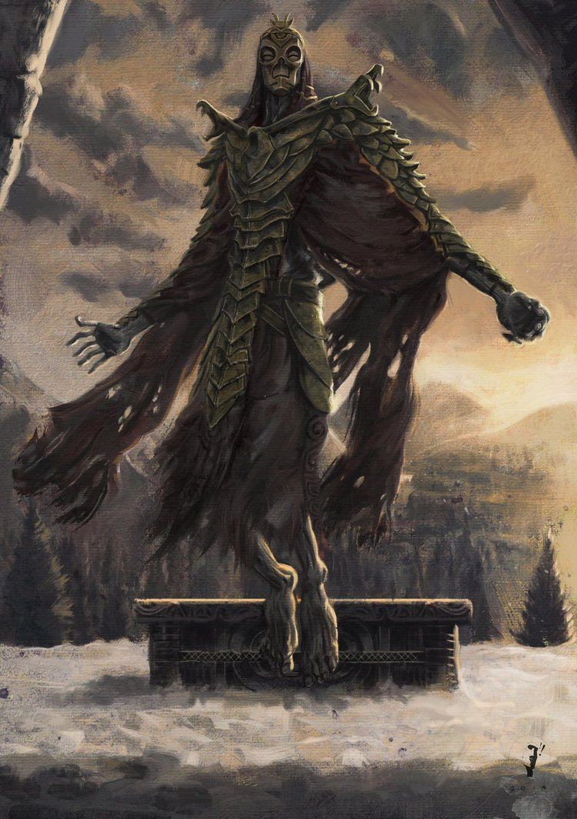
“Oh. That’s a Dragon Priest…” I remarked, as the miniboss lifted into the air, magic blooming in its left hand, as a magical staff shimmered with energy in its right. “~… fuck.~”
Lashing out with my only attack spell, the lightning bolt, a spell specifically meant to fuck up casters… I took off, maybe a fiftieth of, according to my HUD, Krosis’ undead vitality.
Opening a portal, I didn’t hesitate to grab Lydia and yeet her through it, as with a wave of the super-draugr’s weapon, a giant fuck-off fireball came blazing in, and, while I was able to dodge, it detonated as soon as it missed me, the force of the blast still picking me up and throwing me, as I clipped a bit of wreckage before I could try and right myself, only my under-layer of Shroud keeping my bones from snapping as it distributed the force, because while everyone else in this godforsaken place didn’t have to worry about physics, I still kind of did.
Getting to my feet, Krosis was already casting, and, from thin fucking air, the pseudo-lich conjured forth what I could only describe as ‘Pyramid Head On Ice!’
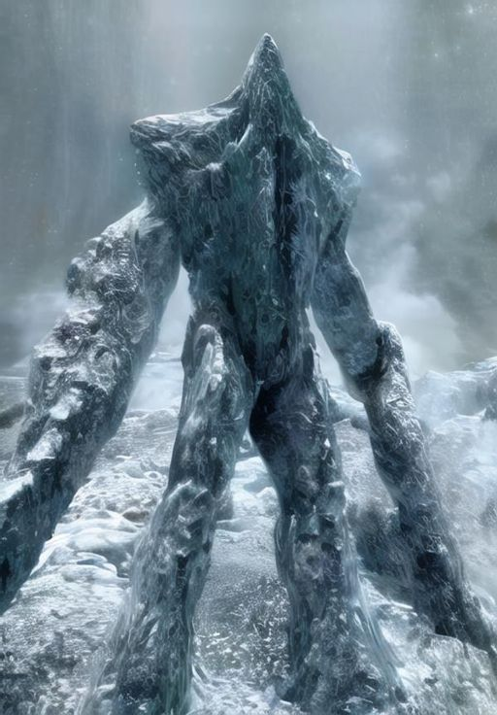
Twelve feet tall, at least, and with long, frozen sword arms it was not slow as it charged me, swinging hard, and, barely dodging out of the way, only my enhanced strength letting me leap far enough, Krosis wasn’t waiting for me to fight back, as another fireball was sent careening for my head, which, seeing it coming, I dodged by more, shooting a tendril down and throwing myself to the side, and, yeah, when it detonated, the flames harmlessly washing over me, I used the blast wave to start to make a fucking run for it.
Which is when, of course, the fucker dropped an ice storm on my head.
A blast of a hundred flying blades of ice came for me, and, with Shroud-enhanced muscles, I almost dodged it, only catching the edges, but that was enough to flay my armor and skin open, along my right side, gritting my teeth as blood poured from me wounds, only my having taken literally hundreds of smaller hits to train my Light Armor skill letting me move without blinking, though I could tell the damage was bad, even as my Shroud tried to stem the bleeding, and, if I didn’t already know it before, I knew now: It was time to fuckin’ go!
So, as another fucking fireball came for me, and the Ice Fucker charged me from behind, I did the only sensible thing I could do.
I jumped off the cliff.
“I’llll beee baaaaack!!!” I promised, flicking off the fucker with my injured right arm, flaring my Shroud out into a sled, and hitting the steep slope at the bottom of the cliff at speed, turning my deadly fall into glorious velocity, getting away ASAP, and, risking a glance back, Krosis was fucking following, the Ice-Monster -Frost Atronach, some part of me noted- having jumped after me, and was now a living avalanche that was only picking up more mass.
My only saving grace was that the Dragon Priest’s flight wasn’t fast, and, as it sent a Frost Spear at me, bigger than I’d ever seen, I sacrificed a bandit’s shield, ejecting it like fuckin’ chaff, which got hit by the spell instead, and then I had to turn, because I was hitting the tree-line, and I didn’t want to actually hit the tree-line.
Able to shift the shape of my sled on the fly, I was able to turn it this way and that, passing by trees as fast as I could, barely making it as I threaded this needle at highway speeds, my world narrowing to the next few trees, my Healing spell cutting out both from lack of Magicka and available focus, my thoughts a constant jumble of leftrightrightcenterleftrightcenterrightDUCK!
Dropping low, I barely avoided getting clotheslined by a low-branch, enormously thankful that the relatively sparse mountain forest lacked any kind of heavy undergrowth, propping myself up to more easily shift my center of gravity, not quite missing a tree, but it was a glancing blow as I struggled to remain upright-ish, a wolf looking up, lips pulling back in a teeth-baring snarl, before it looked past me, and, with a Yip! took off running to the side.
Because I was still being followed.
And the living avalanche was gaining speed while I was slowly losing mine.
Thinking on the fly, I reworked the sled, keeping my healing spell going, both grateful and worried that the mountains here were actual mountains, which meant there was irregular topography to avoid, and because I vaguely rememb-
And then I flew off another cliff.
Right. That.
Shifting the sled to a glider, I spared a glance as the very annoyed Frost Atronach fell downwards, slamming into the trees below, in a haze of displaced snow, and breathed a sigh of rel-
“~Intruder!~”
On instinct more than anything else, hearing something yell at me, I pitched myself forward, dropping down into a dive, and just dodging as something fucking big passed over, claws snapping where I used to be, and-
“~Come on! Wasn’t the Dragon Priest enough!?~” I demanded, but, the Dragon, or, really, Wyvern, was just another NPC and didn’t bother to respond, it just flew around for a second pass.
But I wasn’t going to let it, not by going Home, at the speeds I was moving at I’d probably kill myself, and not by killing this damn thing, as it could be of any of the three magical elements and I was not prepared, so, instead, I banked, and dove some more, spotting a glade which would work as just enough of a landing strip, while also not being in a straight line from the Atronach’s pursuit, if it was still chasing me, which, with my luck, it probably was.
Dropping down, I remade the sled beneath me, picked the biggest open-spot between the trees at the far end, and dove, flaring my wings, which, despite going for glider fabric in my head, were scaled themselves, at the second to last moment, evening out my flight as I got rid of them completely, hitting the snow and fuckin’ cooking as I once more started threading between the trees, only this time with the added benefit of a hunting dragon, hitting the low point between two peaks, but that micro-valley itself sloped downwards a to the right, and, splashing through the frigid icemelt stream, surprising some collie-sized frostspiders, I turned, bleeding off momentum, and shifting from Shroudsled to Shroudcycle, the near-silent vehicle magically revving as I took off, a dark shape overhead and investigating the disturbance.
“~IIZ!~” it Shouted, and the harsh crackle of flash-frozen ice told me what kind of Dragon it was, you know, other than one I couldn’t take yet, of course, as I sped away from it, driving parallel to the steam, not in it, for obvious reasons.
Pulse pounding in my ears, though my Stress Resistance helping keep my hands steady, unable to do more than occasionally glance upwards to look to see if I was being followed, I was reminded that, short of third person observational power bullshit, the eternal problem with seeing if you’d lost your pursuers was that, if you checked too hard, your pursuers would merely find you again.
Soon enough, I heard it once more above me, but not directly above me, and, given the lack of my being jumped by undead spellcasters or angry avalanches, I was fairly safe. Slowing to a stop, opening a Gate Home, dismissing my Shroudcycle, and stepping into safety.
And, yeah, Lydia was there, standing a dozen feet in, probably having just picked herself up from where I’d shoved her, but trapped by the lack of any ‘meshing’ in my Pocket Apartment.
Eh… she’d deal.

<SWE>
After calming down, I’d pulled off my armor, dismissing the Shroud that was sticking to my wounds, and took in the damage and…
It’d been close.
I’d shifted to ‘fight/flight’, hard, and pushed beyond it, but that Ice Storm spell had shredded my right side, shoulder, chest, and thigh, only my Shroud-assisted musculature likely letting me move instead of collapsing, because… oof. Thankfully, with more Healing magic, I’d been able to finish fixing my wounds, that first burst enough to stem the bleeding in my harried escape, but I wouldn’t be surprised if that single attack had taken out two-thirds of my health, and I’d been barely hit by it.
And, once more, I was reminded that while I could tear apart bandits and wolves with ease, they were practically the lowest of the low of threats I’d face here, akin to fuckin’ goblins in a weave-world, and that I was just scratching the surface of what I’d face here.
Taking a shower, the water running red for the first few minutes, I, exhausted, fell into bed, Lydia still just standing there, but she was an NPC, and she’d be fine.
The next morning, taking a moment to put away the dropped blanket and empty glass on the couch-side table, I set out once again, having started casting Clairvoyance more and more, while also either avoiding or dealing with the trouble it got me into, I had to say I… wasn’t a fan.
Yes, it’d eventually lead me to my destination, but only the next couple dozen feet of it, and the damn thing would turn on a fucking dime, following paths only it could see, and, just as before, those paths used enemy camps as focal points.
Also, going slower, I kept on running into wildlife I’d missed before, like the aforementioned dog-sized frostspiders, and the cat sized rats, appropriately named skeevers. Still, though, as going in a straight line, like I usually did when travelling in Skyrim, now that I was out of the relative safety of the valley that Whiterun was within, was apparently was a terrible fucking idea, I was more than willing to use the spell, just getting… cautious whenever an unknown marker appeared in my mind’s eye. Though, like the aforementioned Giant’s Camp, that marker was an indicator of something ahead, not a guarantee there wasn’t anything otherwise.
So I drove at a snail’s pace, switching out my Shroudcycle with a tank-treaded Shroudcar, trying to guess where the stupid magical GPS wanted me to go, and, several times, having to backtrack, but at least I was getting a fuckton of experience with it. I… wasn’t sure if it was giving me actual XP, but this blatant Divination’s workings, despite being an ‘Illusion’, almost seemed like it was casting an illusion, not to fool me, but the world itself?
Or… maybe Fate?
I was the one doing it, so it didn’t ping my Defenses, and not for the first time I wished I had someone I could talk to...
I glanced at Lydia.
Well, someone that would talk to me back, in an actual conversation, because I wanted to run some experiments on just how this thing worked. I mean, I was getting it to work, but there was a world of difference between using a soldering iron and understanding the metallurgy involved.
Honestly, I was looking for a sign that I was doing the right thing here.
Which I eventually found.
Literally.
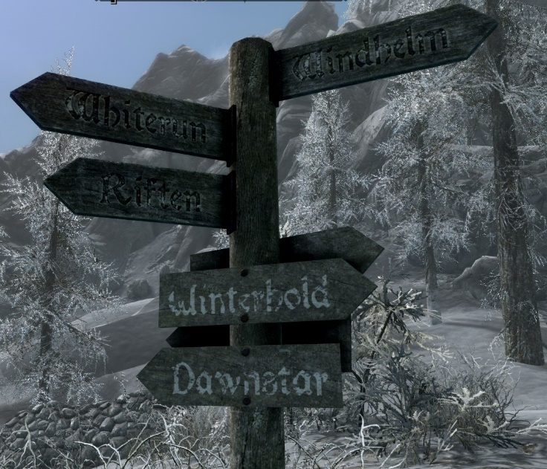
I stared at it, for, being honest here, probably more than I should’ve.
Then facepalmed.
“… Right. Roads Exist. I’m a fuckin’ moron.”
“Honor to you, my Thane,” my companion stated, almost sarcastically, except, no, don’t assign personalities to the NPC’s, Lee.
Sighing, and shifting the Shroudcar to a Shroudcycle once more, Lydia properly secured, I checked the sign, cast Clairvoyance, which, yeah, was just telling me to go down the road, dumbass, and revved the magical engine, tearing off with a renewed sense of purpose, and… yeah.
I wasn’t telling anyone about this.
Ever.

Music:
Flew the fuck off - Skyrim Soundtrack - Combat 4

