Prom Boy Princess.
A Short Story
By Maryanne Peters

Our town is different from most towns in the country, in that boys outnumber girls by a fair margin. I think that this might not be the case for the adult population, so that makes it even worse to be one of my generation here. Your chance of getting a date, let alone a serious girlfriend, is close to nothing.

It’s not that I was bad looking. You be the judge. Okay, so I looked a little grungy with the long hair and the German heavy metal T-shirt, but that was my thing.  This photo was taken only a few days before prom night. There seemed no hope that I would be going, as I had no chance of a date. Our High School only allowed couples because of some problems that blew up a few years ago – the kind of problems when there a too many unescorted guys at a function, in particular when those guys might be described as “sexually frustrated.”  That was when my mother suggested that I go to the prom dressed as a girl. I laughed out loud, and thought it was such a joke that I told my friend Tyler about it. Imagine my shock when his comment was: “That is an interesting idea.” | 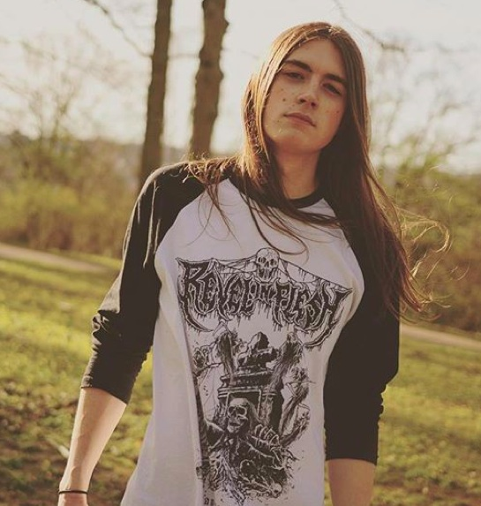

“What do you mean?” I said. “This is stupid. There is no way that the school would allow it. I couldn’t pretend to be a girl. I would never get away with it.”

“Andy, you just might,” he said. “That Halloween outfit last year showed some potential. And everybody says that your mother is a miracle worker. Her salon is doing half the girls this year.”

“So, you want me to be your date?” I sneered.

“Yes,” he said flatly. “I want to go. You do too. Everyone should get to go to the prom. It’s an American tradition. If this is how we do it, then … let’s do it.”

It seemed crazy, but somehow, he had persuaded me that it was crazy clever. If we could pull it off, then we would be laughing about it for years. But the word is “if”.

My mother was supremely confident: “We have good material to work with. Good genes are the start if I say so myself. Good face and skin we can work on, and plenty of hair. We just need to change the color of it.”

“What?” I was already worried. Or, I should have been.

“The other advantage we have is that your sister’s dress from two years ago should fit you perfectly,” she said. That means that we can get you ready at almost no cost. Except that we will need to buy you a pair of heels in your size. Not too high. We still want Tyler to be taller.

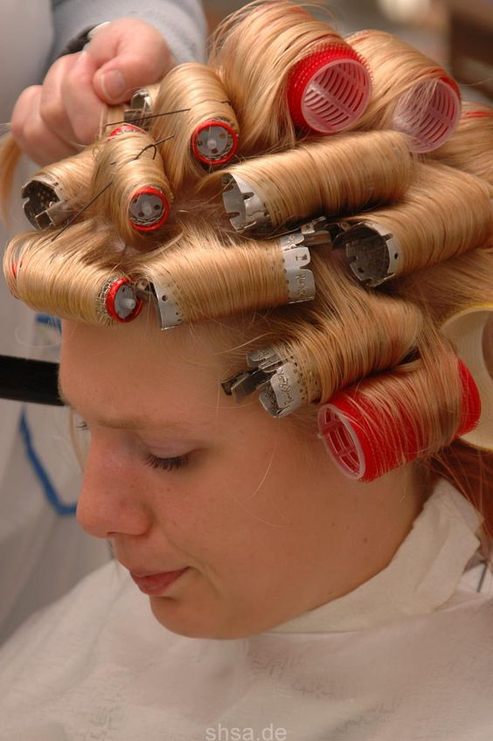 | The first thing that she did was made me go to bed with masks on my face. I mean that she painted my face with so smelly paint of some kind and then I had to wear a plastic mask over that to stop the paint coming off on my pillow. Then the next morning she peeled of the plastic and then the layer against my skin. What was left on the inside was pimple goo and little black hairs. It was disgusting.  “That was growing in your face,” said Mom.  Then Mom to me to the salon. My hair was dyed blonde and I had to wear under a ball cap until the day of the Prom.  On that day I was taken into the salon again and my hair put in curlers. By this stage I was just going with it. I had no idea how it was going to turn out. Would I still look like me?

We the answer to that is a definite “No”.

After my hair was pulled out of the curlers, I had ladies from the salon on each side of me with brushes and hair arranging tools, and a huge bowl of pins that seemed to be disappearing into the grow hair sculpture on the top of my head.  I was shocked when they first revealed it to me, but by the time that I put the dress on and they did the makeup I was getting used to it.  They had me wear a special bra which could be used to push up some flesh on my chest so it looked like I had tits. To help with that there were two inserts like little bags of Jello that could wobble around when I danced. I mean, I guess I was going to dance.  The choice of makeup was a bit over the top, looking back. Way too much in the corners of the eyes. Nothing like what I wear nowadays. | 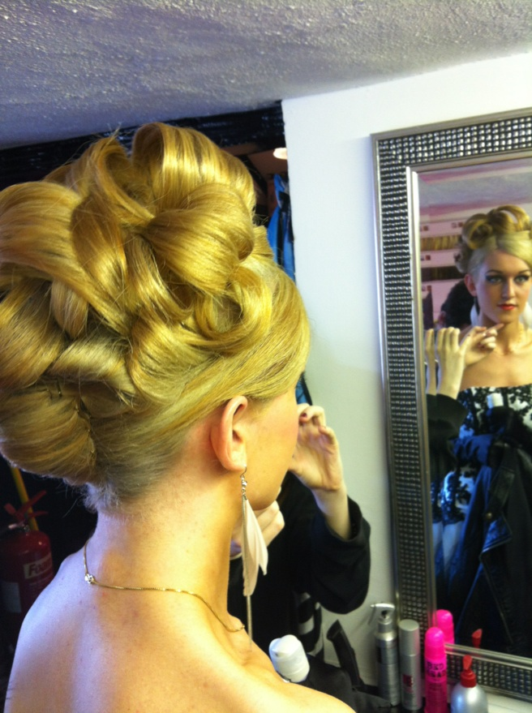

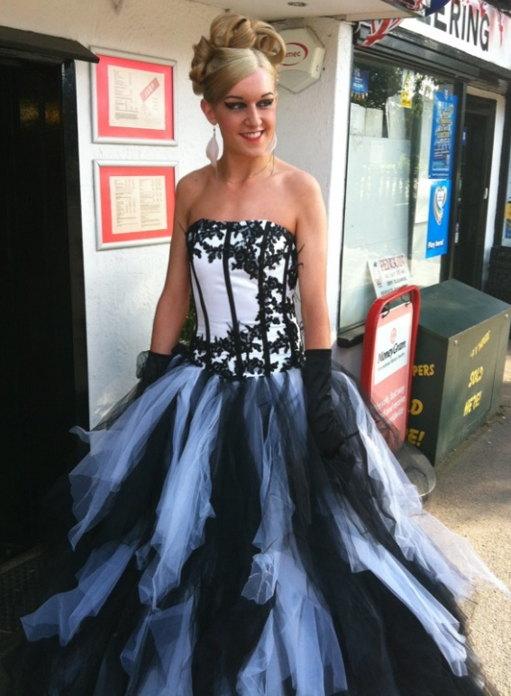 | 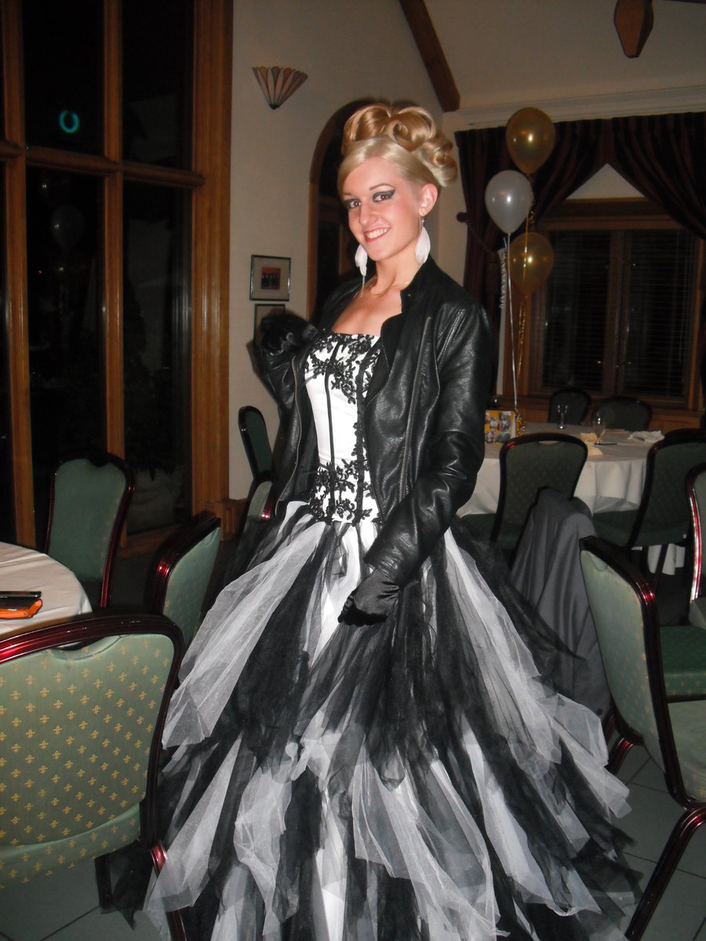

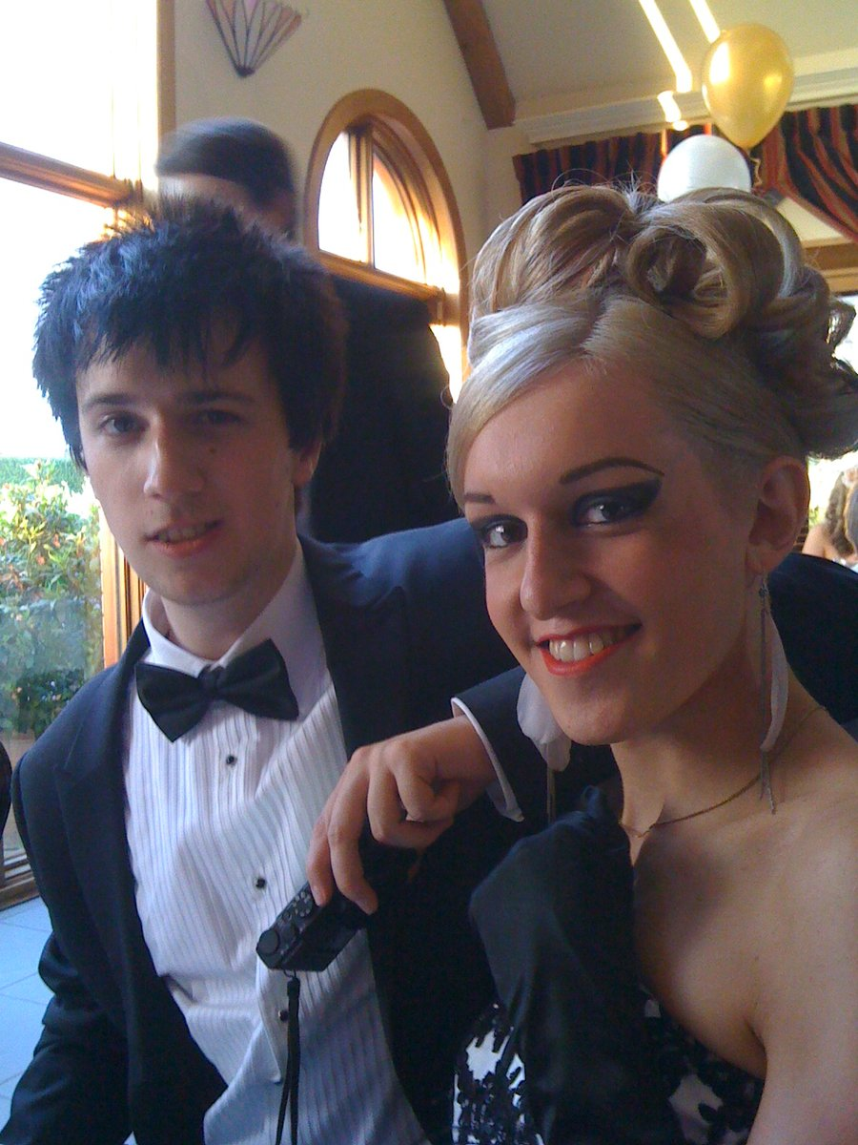
So, this is me at the Prom with Tyler. Pretty incredible Huh? Tyler is trying not to put his arm around me for these shots. I guess he wants it to look like its just him and his pal in drag. But I can tell you that when the sun went down it did not stay that way.

He was not going to have the others see him but when we were alone, he put his arm around me, sure, both of them. Luckily I had been given some lipstick to freshen myself up because we were kissing too – big time.

He said we would be laughing about this, Tyler did, me in drag and him as my date. Maybe we weren’t exactly laughing, but we were smiling. I mean we both lost our virginity that night.

I don’t know whether Mom thought that this was going to happen or not, but well, she did the work to make me the hottest chick at the prom. Who wouldn’t fall for me? Even somebody like Tyler.

OK, so I played up a bit with the movement and the giggles and the suggestive whispers, but I was a girl for the night – right?

Maybe not just for the night. It turns out that I am pretty cool as a chick. Tyler thinks so anyway. He doesn’t want to see the old me around at his place anymore. He wants his hot date, the Prom Boy Princess around there, shaking her blond curls in his face while he shows her what he can do.

The End

© Maryanne Peters

